





**Abstract**

University timetabling is a large and complex problem especially with many students, staff and rooms. Existing automated timetabling systems work well for small problem instances, but do not scale well to larger problems. This report looks at automating the process of timetabling using an evolutionary algorithm called genetic algorithms which have had more success than others at timetabling. In addition, a mathematical model has been created to organise the data for the genetic algorithm to use.

**Acknowledgments**

Main acknowledgments to Martin Serpell for his assistance in providing the mathematical model and associated code in addition to providing help with the report creation process. Acknowledgements also go to Jacqui Warden who provided useful insight into the current timetabling process at the University of the West of England (UWE), the datateam (Petter Lovehagen.(P.L.), Wojciech Lewicki,(W.L.)), to Chris Simons and Gordon Downie for their views on how the timetabling system affects them as academics and to Peter Graham for his view on timetabling in schools and the system in place at UWE.

TABLE OF CONTENTS

SECTION PAGE

1. Introduction 8

1.1. Aims 8

1.2. Deliverables 10

1.3. Relevance 11

1.4. The real world problem being looked at 11

1.5. Why it is important 12

1.6. Project schedule 13

1.7. Legal and ethical issues 13

2. Research 14

2.1. Introduction and Methodology 14

2.2. Information that wasn’t known beforehand 14

2.3. How the research was carried out 14

2.4. What is the current state of the art (technology and algorithms) 15

2.5. How other people have tried to solve it 15

2.6. What is being claimed about this project 17

2.7. Project goals 18

2.8. Success criteria 18

2.9. Problem description 19

2.10. Primary research 20

2.11. Secondary Research 24

2.12. Other notes 29

2.13. Hard and soft constraints 30

2.14. Data spreadsheets obtained from the timetabling staff 35

3. Requirements 36

3.1. Introduction 36

3.2. Project Scope 36

3.3. Project Purpose 36

3.4. Project Goals 37

3.5. Stakeholders 37

3.6. Early System Concept 37

3.7. System scope 38

3.8. How the requirements were identified 39

3.9. How requirements were gathered from potential users 39

3.10. Requirements found during research 39

3.11. How requirements have been formally expressed 39

3.12. How requirements have been prioritised 39

3.13. How requirements have been tested 39

3.14. Test data 40

3.15. How the requirements break down to produce sub-projects 40

3.16. Methodology used in development 40

3.17. Use case diagrams 41

3.18. Use case tables 43

3.19. Requirement list 46

3.20. Acceptance tests 55

4. Design 58

4.1. Alternative designs considered 58

4.2. High-level diagram of the project 58

4.3. High-Level diagram of the timetable creation process 59

4.4. Class diagram 61

4.5. The Pre-processing stage 62

4.6. Description on LC matrix and RC matrix 63

4.7. The Mathematical Model 63

4.8. The GA structure 64

4.9. Design decisions (Design log file) 65

4.10. GUI Designs 66

4.11. Reasons behind the chosen design 70

4.12. How different components of the design have been identified 70

4.13. How the design has been described 72

4.14. What test data was specified 72

5. Implementation 73

5.1. How the project has been implemented 73

5.2. How implementation progress has been recorded 73

5.3. How the program has been demonstrated to show that it works 73

5.4. How will you show what has been achieved? 73

5.5. What has not been finished? 73

5.6. Implementation decisions (implementation log file) 73

5.7. Program screenshots 78

6. Testing 81

6.1. How code has been tested 81

6.2. How the tests proved the code worked correctly 81

6.3. How the test results have been documented 81

6.4. Test results 81

7. Conclusions 84

7.1. How the findings support/refute project claim 84

7.2. How the original project goals have been met 84

7.3. Product limitations 84

7.4. What thoughts do you now have about your product? 84

7.5. Future work and how the product could be improved 84

7.6. How could you improve the development process? 85

7.7. What would you do differently? 86

8. References 87

APPENDIX A transcript of interview 1: Jacqui warden and martin serpell 93

[APPENDIX B transcript of interview 2: datateam petter lovehagen and wojciech   
lewicki 151](#_Toc486877114)

APPENDIX C transcript of interview 3: chris simons 168

APPENDIX D questionnaire to gordon downie 178

APPENDIX E transcript of interview 5: martin serpell 179

APPENDIX F transcript of interview 6: peter graham 185

APPENDIX G Template of acceptance tests 197

APPENDIX H Research section search results 198

APPENDIX I Other use case tables 200

APPENDIX J Other acceptance tests 212

Figure 1 a typical lecture 8

Figure 2 a lecturer preparing to begin 9

Figure 3 SITE PLAN OF UWE FRENCHAY 10

Figure 4 this shows the general use case diagram for the project 41

Figure 5 this shows the second version of the use case diagram for the project 41

[Figure 6 this shows one half of the final version of the use case diagram,   
showing the timetablers use cases (except timetable viewing) 42](#_Toc486877128)

[Figure 7 this shows the second half of the final version of the use case diagram,   
showing the remaining use cases 42](#_Toc486877129)

Figure 8 Project High-level diagram 58

Figure 9 Project High-level diagram of the timetable creation process 59

Figure 10 Project class diagram 61

Figure 11 design of the chromosomes 65

Figure 12 the initial designs for the “lecturers” template 66

Figure 13 initial designs for the “rooms” template 67

Figure 14 designs for a “class” template and the “module” template 68

[Figure 15 designs for a “Skills” template, a “Resources” template and a template   
to view the timetables 69](#_Toc486877137)

Figure 16 this is a screenshot of the original student template 71

Figure 17 this is a screenshot of the original staff template 71

Figure 18 this is a screenshot of the original rooms template 72

Figure 19 this is a screenshot of the “lecturers” template 79

Figure 20 this is a screenshot of the “rooms” template 79

Figure 21 this is a screenshot of the “modules” template 80

Table 1 requirements list 51

Table 2 Implementation test sweep 83

Table 3 Template for implementation tests sweep 197

Table 4 Research search results 199

# Introduction

## Aims

The aim of this project is to help timetablers at the University of the West of England (UWE) with the demands of timetabling students, staff and rooms. As timetabling for the entire university would be too great a task for this project, therefore only the Computer Science and Creative Technologies (CSCT) department has been timetabled.

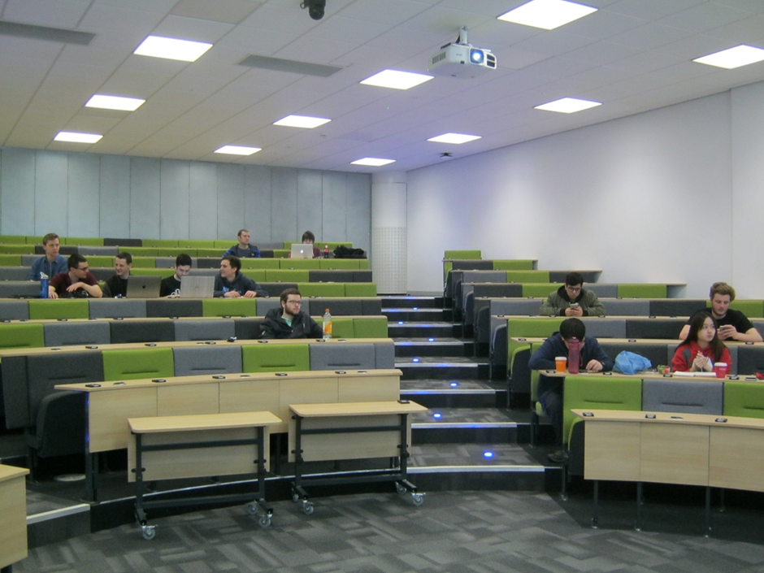

Figure 1 a typical lecture

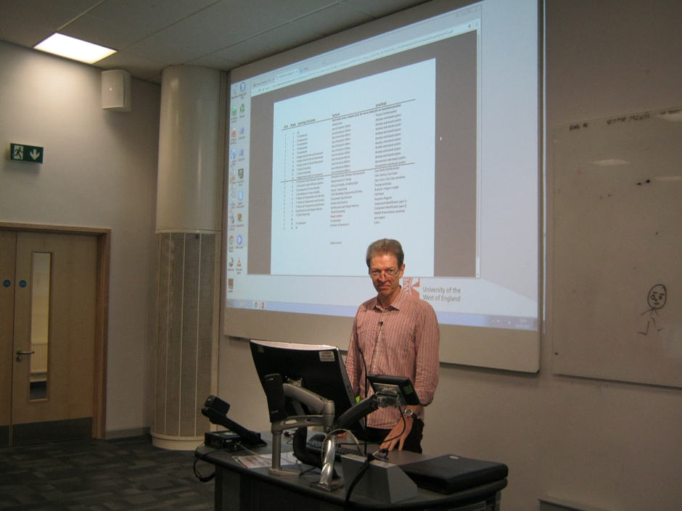

Figure 2 a lecturer preparing to begin

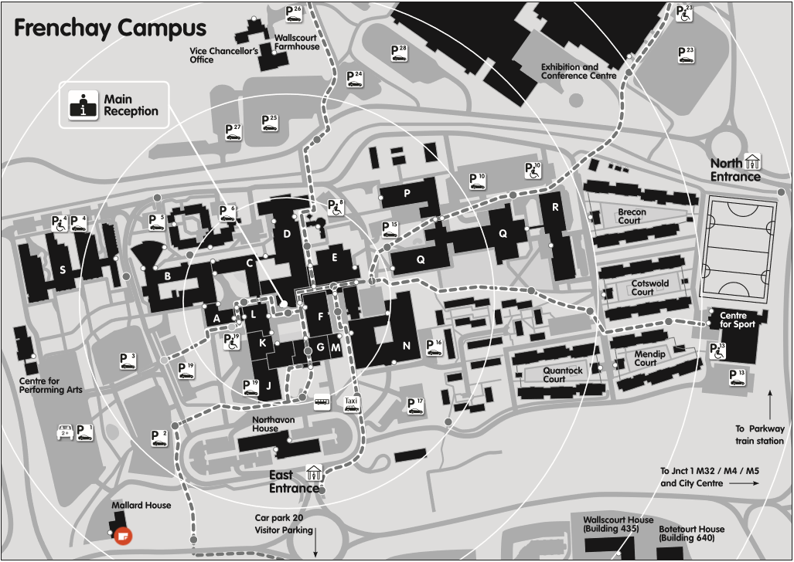

Figure 3 SITE PLAN OF UWE FRENCHAY

The CSCT department is mostly based in Q block. Some lectures for CSCT do not take place in Q block but in other locations on the campus such as B, N and R block. Large lecture theatres are a shared resource across the whole of Frenchay campus. These are obtained on a bid basis.

## Deliverables

A program has been created that allows timetables to be generated for staff, rooms and students for the CSCT department at UWE. This uses a genetic algorithm or a variant of this to create the timetable, bearing in mind various constraints such as staff, room and student availability (students and staff cannot be in more than one place at once), specialisations of staff (staff may prefer to teach some modules rather than others), staff preferences, module delivery requirements and other related constraints. This report is one of the deliverables and discusses previous approaches to timetabling via the use of mathematical models and other forms of evolutionary based artificial intelligence.

The deliverables are as follows:

* This report
* A demonstration of the software
* A CD/DVD which contains:
  + A copy of the report
  + The program software written in Java
  + Original code written in C by the project supervisor Martin Serpell
  + Excel spreadsheets obtained during research
  + .csv files of the data used by the program

Refer to section 2.14 for a detailed list of all the files on the CD/DVD.

## Relevance

University timetabling is a NP-Hard problem Kohshori et al. (2011) which makes it difficult to produce suitable timetables via direct, mathematical methods. Although small timetables can be produced by the use of mathematical models, larger timetables which are needed by university departments cannot be solved this way in a suitable length of time. The use of non-deterministic techniques provide a way of overcoming this limitation by producing timetables that are “good enough”, satisfying hard and most or all soft constraints that are put upon them, and doing so in a reasonable length of time. The project makes use of genetic algorithms, an artificial intelligence technique, to provide this non-deterministic method of timetable problem solving.

## The real world problem being looked at

University timetabling is a large-scale, complex problem, which needs to ensure that the students and the lecturers are all in the right place at the right time with the right resources.

Universities and schools need to have a timetabling system that allows students to seamlessly undertake classes without disruption. A system that does not take a long length of time to produce a set of timetables and also one which allows changes to be made easily.

For an appreciation of the scale of this problem, UWE currently has about 24,000 students, four faculties, 1923 staff and operates across four campuses in Bristol and Gloucester.

On the Frenchay campus, there are 369 rooms with numerous other rooms and facilities at the other three sites.

The FET faculty has 110 teaching rooms in total. When student numbers exceed certain levels for lectures, they need to use one of the 14 large lecture theatres. These theatres have to be considered as a shared resource facility and are not strictly owned by FET. This applies a constraint for the availability of these rooms which need to be planned well in advance.

The CSCT department have 114 members of staff and the programmes of study amount to between 20 and 30.

In the past, each faculty had their own timetabling department which from discussions made it seem like communications with timetabling staff were easier and quicker to resolve any issues. UWE has recently centralised the timetabling department to encompass all the above and it may have resulted in some consideration of remoteness by some people. Others have found that it works well.

Module leaders have a requirement to input preferences for module delivery into the current UWE system. For an ideal system, a user template for the module leaders should be provided to create and submit module delivery requirements which would be submitted prior to the creation of the following year’s timetable. Time and circumstances has not permitted this to be created and would be considered for future work. Refer to the future work section of this report (section 7.5).

The current timetabling system comprises of multiple applications which suffer from awkward interfaces between the various products. This has been caused by the use of several different third party products which are incomplete for the current users. As a result, some in-house developed applications have been added to connect these various applications which do not work together all the time. The current system does provide means for automatic timetable creation but it is not very successful at producing the best results. Manual intervention is more often used to smooth over any difficulties.

## Why it is important

Effective and efficient timetabling is important for the smooth running of university departments and courses. Timetabling is an NP-Hard problem and requires much computational effort to achieve near optimal timetables in reasonable time that satisfy all hard and most if not all soft constraints. A faster and more efficient timetabling application would save time for the timetabling staff. With regards to re-timetabling, solutions must cause a minimum amount of disruption.

## Project schedule

Project start date 19-09-16

Research 19-09-16 to 03-07-17

Requirements 09-03-17 to 03-07-17

Design 07-04-17 to 03-07-17

Implementation 30-05-17 to July 2017

Report delivery 10-07-17

Demonstration Mid to end July 2017

## Legal and ethical issues

The project uses simulated student and staff data, because real data in the UWE timetabling system is confidential. However, existing constraints from the university system can be used, along with existing room information and course/module information. This avoids any legal or ethical issues.

# Research

## Introduction and Methodology

This section provides the results of the research which was carried out for the project. It includes primary research involving interviews with the timetabling staff and academics. In addition, secondary research has been done to find out how other researchers have solved the problem. This covers work done using GA’s, mathematical models and other evolutionary techniques. The secondary research covers peer-reviewed journals, academic papers and conference papers, which were sourced from the UWE library, the IEEE Xplore and Elsevier databases.

The information gathered from the research has been used to develop the design and provide the raw data to be loaded into the program during the implantation phase. The information has also been used to structure this report.

## Information that wasn’t known beforehand

Information that wasn’t known before the start of this project includes; current methods and programs used for university timetabling, along with methods for the use of genetic algorithms and their variants to solve this problem. In addition, any other artificial intelligence techniques that have been used to solve the timetabling problem.

User requirements and preferences (staff, timetablers, etc…)

At the start of this project, information that was needed as follows:

* Student properties, constraints and preferences
* Staff properties, constraints and preferences
* Rooms and their properties
* A list of modules and the courses which include them with IDs.
* Course/module delivery requirements

## How the research was carried out

Primary and secondary research has been undertaken to gather information needed for the project. Primary research involved interviews with the:

* Timetabling staff who use an existing timetabling system at UWE
* Academics who provide their preferences and module delivery requirements for module teaching and related concerns.
* Finding out personal preferences of students

The interviews were recorded on a dictaphone and were transcribed to enhance information recovery. Minutes of each meeting have been produced to control actions. The transcriptions have been inserted in the appendix and a summary of important points has been placed in the research section of this report.

Secondary research involved a literature review of peer-reviewed papers, journals and conference papers written by academics who have already approached and tackled the timetabling problem. Only peer-reviewed papers were selected and used in order to ensure that the high quality of this report has been maintained. Online databases have been used such as IEEE Xplore and Elsevier which have access to such papers. A record was kept of how many papers were found for each set of search terms, along with duplicates, and papers which proved interesting for reference. This record has been included in the report.

The research section of this report contains information on the algorithms used, the constraints considered, the authors’ results and a note on their conclusions. In addition, a search has been made of existing timetabling software products and market providers.

## What is the current state of the art (technology and algorithms)

Primary research was done to find out what timetabling system was used at UWE. Secondary research was carried out in the form of a literature review of algorithms that have been used by various academics. In addition, a web search was undertaken to find other suitable timetabling software used by other universities.

Primary research: This showed that the algorithms used by the current UWE timetabling system, according to the timetabling staff, are proprietary information to Scientia and are therefore not known.

Secondary research: Refer to section 2.11 which covers the algorithms used by researchers to solve timetabling problems.

## How other people have tried to solve it

A number of companies have approached this problem and have developed a number of solutions to assist timetablers with this task. These include companies like Scientia, and include open source solutions such as UniTime.

Timetabling has been carried out using the following methods:

* Pen and paper
* Excel spreadsheets and Access databases
* Computer programs

Currently, UWE uses the software Student Allocator and SyllabusPlus by Scientia. In a case study for Scientia by UWE, Student Allocator was first used by the Bristol Business School, the School of Law and the School of Life Sciences for online module allocation in 2006.

UWE reported back to Scientia that the use of the software resulted in increased student involvement because it allowed them to make their own module selections. This would result in increased student satisfaction. This was part of what Scientia call their self-service application, which reduces time taken to administer and check the choices made by students. This also resulted in the reduction of staff work effort to administer that aspect of the process.

The Scientia Student Allocator application provides the facility for student option selection. When students have made their option choices via the online process, this allows the staff to review, approve and if necessary modify those choices all online in the same application. It can also use existing timetable choices and ensure timetables produced are clash free. The Student Allocator application provides a web portal which saves additional time and resources to develop. The application also interfaces with other timetabling systems.

The software was subsequently rolled out across the entire university in 2009.

Another Scientia package used by the staff at UWE is SyllabusPlus Enterprise Foundation. It can provide a user interface allowing users to see where there are free slots in a timetable and allow for users to search for free timeslots and available rooms. The package allows for the creation of hard and soft constraints such as rooms having specific equipment and allows two groups of students on different modules to be co-taught by the same member of staff in the same room at the same time without the need for dual booking.

SyllabusPlus has an automated scheduling system which can be used to generate timetables. The application can be taught what constitutes a good timetable. It provides room and resource booking facilities for the students and extra-curricular activities. Timetables can be viewed side-by-side, cascaded or in separate tabs which can be useful in determining the knock on effect of changes to the timetables.

The application allows for the personalisation of GUI views and remembers such choices made by the user. The software can generate reports for users and can be used to send information to a printer or to various file formats. (Scientia, 2017)

Other timetabling solutions:

“UniTime is a comprehensive educational scheduling system that supports developing course and exam timetables…” The software uses a search “based on an iterative forward search algorithm” which is similar to a local search. The software has won two tracks out of three from the International Timetabling Competition 2007. (UniTime, 2017)

## What is being claimed about this project

The claims of this project are that it shall be capable of:

* accepting non-personalised data and simulated personalised data
* allowing users to load, edit, search and save student/staff/room/module data
* automatically generating a timetable for the UWE CSCT department
* presenting information in an intelligent and user friendly way

The existing system consists of multiple products, which are both in-house (homebrew design) as well as from third party vendors. This project shall produce a standalone product which shall overcome the issues seen with the existing disparate systems. It is suggested that the current system suffers from incompatible interfaces between products, which causes loss of data and system crashes. It is also possibly a cause for the lengthy time needed to save edited or new data in the current system. It is considered that the use of an artificial intelligence method within a standalone product shall provide more efficient and effective results.

The project is a standalone single entity and does not suffer from the instabilities that the existing system has. It also does not lose data or suffer from system crashes. It should also work faster than the existing system with regards to editing and saving changes.

## Project goals

The project goals were to create an effective and efficient university timetabling application for the CSCT department at UWE with an extension to the application that allowed re-timetabling of a created schedule. Through research, the intention was to gain knowledge of key users requirements and preferences for a timetable system. During implementation, the objective was to be able to incorporate those requirements and preferences in a standalone product, with the goal of ultimately saving the user time and effort. The goal was also to create a software program which used the latest AI methodologies within the permitted timeframe. The concluding goals were to demonstrate the product and produce and issue a comprehensive report.

**The goals of this project were to:**

* Carry out primary and secondary research
* Transcribe interviews
* Receive and reformat data from timetablers
* Create templates (GUI) for staff, students, rooms, etc…
* Create random generators to produce dummy data.
* Create dummy data.
* Store dummy data in program
* Create GA and mathematical model
* Define requirements
* Create acceptance tests
* Create project code
* Carry out acceptance tests on the project code
* Carry out an overall application test
* Deliver a comprehensive project report

## Success criteria

An application should have no or minimal bugs, and should produce optimal or near-optimal timetables for students, rooms and staff that do not violate any hard constraints and should ideally minimise the number of soft constraints violated. When the application was run, the level of its success was determined by meeting the stated requirements.

Another measure of meeting the success criteria was the ability that the application was able to produce such timetables in a reasonable amount of time, preferably faster than current applications already in use. The application GUI displays timetabling in an efficient way and allows timetablers to edit and save information on lecturers, rooms, and modules.

The re-timetabling component of the application is a future phase of this project and a measure of its success shall be that it should minimise the number of disruptions caused to the existing timetables and should be able to determine optimal or near-optimal alterations in reasonable time.

A measure of success was the fact that the report contained a list of successful acceptance tests. (note: some of the acceptance tests were excluded because they were considered for future work).

The code was designed and developed in small blocks which were iteratively tested successfully.

A key success criteria was the project’s approval by key users when the finished application was demonstrated to them. Beyond the members of the reviewing and marking staff, the timetabling staff also asked for a demonstration when the project was completed.

Ultimately, the final success criteria were determined by the reviewing and marking staff.

## Problem description

Timetabling at academic institutions can be demanding and is a challenging, repetitive task. Kohshori et al. (2011). At this time there is no known deterministic polynomial time algorithm for this problem – the problem has been determined to be NP-hard. Kohshori et al. (2011).

There are two types of constraint: hard and soft. Hard constraints must be satisfied under any circumstances. An example of a hard constraint is only a single event can take place in any given timeslot. Kohshori et al. (2011). A soft constraint is one that can be violated, but there is a smaller penalty for doing so. An example could be no lectures in the last timeslot of the day.

## Primary research

This section presents the primary research done for this project. Six interviews were conducted, two with the timetabling staff and four with academics. Of these six, five were carried out face-to-face and one was carried out by email correspondence. Shown below are the comments and notes for these meetings. The full interviews can be seen in the Appendices.

### Interview 1: Jacqui Warden (J.W.) and Martin Serpell (M.S.)

Interview with the timetabler Jacqui Warden (J.W.). In addition, the academic Martin Serpell (M.S.) was also present for the first half of the meeting

M.S. and J.W. stated that an optimal solution [for a timetable] could not be used due to length of time it would take for the program to run to reach an optimal solution and another aspect was that it was not possible to meet everybody’s requirements.

M.S. and J.W. agreed that all undergraduate courses, all postgraduate courses and continued professional development for CSCT and EDM (Engineering Design and Mathematics) should be covered.

Students at level 1 do not have option choices so their timetables have fewer constraints

J.W. provided files containing pertinent information for the project. This included lists of subjects, modules, student numbers, rooms and other constraints.

In the software used by the timetablers currently, there were no upper limits to the number of students that can be managed.

J.W. stated that there are about 110 rooms usable by the CSCT department.

There is an electronic process whereby module leader state their requirements and constraints for their teaching for a particular year.

It would be useful for lectures to be done before practicals

Templates are necessary to input data into the system

Refer to Appendix A for a copy of the interview transcript

### Interview 2: Datateam (Petter Lovehagen.(P.L.), Wojciech Lewicki,(W.L.)

The datateam discussed Course Planner and mentioned that it took as input various constraints such as curriculum data, teaching delivery data, number of hours, the type of activity, and a number of others. The system also has an algorithm for managing the constraints.

Various screens presented tuneable strengths for various constraints, ranging from 0 to 10. These included such properties as “Preferred Usage”, whereby weightings could be set to indicate what times of the day were most suitable for teaching.

Staff have constraints such as overtime and “Load Balancing”, where activities could either be clumped together or spread apart. There is a constraint for minimising travel between campuses, but as this project is focusing on just CSCT this can be ignored.

The timetables generated can be favoured towards the staff, students or even towards maximising the usage of rooms.

The workings of the algorithm used to manage the data was not available as this is proprietary knowledge.

Refer to Appendix B for a copy of the interview transcript

### Interview 3: Chris Simons (C.S.)

The system uses codes and tags, making it very “systemy” – there is a bit of a learning curve involved.

As a module leader, he states that 9am lectures are a “non-starter” and anything after 4pm, people are asleep.

States that it would be nice for a module such as Enterprise Systems Development to have both the lecture and the practicals on the same day

He states that sometimes student have to be shuffled about from one practical to another if there is an uneven balance of students present.

Refer to Appendix C for a copy of the interview transcript

### Email questionnaire: Gordon Downie

States that timetabling responds quite well to staff preferences

States that there were problems with some constraints surrounding length of lectures. If a lecture was 1.5 hours this would introduce more constraints due to room unavailability.

Refer to Appendix D for the email correspondence

### Interview 5: Martin Serpell (M.S.)

Likes the ability to choose when he is free to do teaching on the days he prefers.

States that there is an issue with a student only having one practical at the end of a day and nothing else that day.

States that currently, he is not teaching his own CSI students for CANS.

Suggests that a staff member could enter his own constraints into the system

Refer to Appendix E for a copy of the interview transcript

### Interview 6 – Peter Graham (P.G.)

Finished his timetabling career at a comprehensive secondary school in Bristol in 1995.

Used a manual system of timetabling which he states was faster than the computer based systems being introduced at that time.

States that each year it was necessary to sit down and think about how your blocks worked for the staffing and pupils. The ease of doing that manually very much depends on the people who are available to do the timetable. (Authors note: an automatic system would probably be better as it avoids mistakes made by doing the timetabling manually – also it does not depend on the timetabler’s skill).

Stated that it was necessary to find out from the senior (staff) colleagues what pattern of education was required. This proved to be very difficult to get them (members of staff) to make precise statements. To write a computer program finding out what clients want can be the most difficult thing to have to do, because they (the clients) don’t understand what you are after.

Said that finding out what people wanted was the most important thing.

Second importance how many lessons they had each week and how long each lesson took.

After all the data had been gathered, a blocking system was set up, whereby a block was a single subject. Years 7-9 were dealt with first as they had no optional subjects. Then blocking of teachers was carried out, depending on year group requirements. For example, year 10 had 120 pupils whereas year 9 had 180, so year 10 needed one or two less maths teachers. Blocking all of the maths teachers didn’t do the job, especially as some teachers were more suited to teaching certain years groups than others.

If there was a teacher that could handle bad classes of years 9 and 10, that teacher would also be given the top performing students in order to balance the workload.

States that the head of the maths department (for example) would decide which teacher taught which class.

The school had a lack of maths classrooms available to allow teaching of 7 or 8 maths classes at the same time. In this case, other classrooms were used to teach maths.

In order to handle staff sickness, there were two cover teachers assigned.

Stated that the timetabling system at UWE was better when the timetablers were decentralised.

Said that at the school, there were usually extra teachers, rather than too few. This removed the need to bring in supply teachers which cost more. The teachers would share the workload amongst themselves. This is important because there needs to be supervision about stress levels amongst teachers.

Refer to Appendix F for a copy of the interview transcript.

## Secondary Research

The secondary research for this project was carried out to find out the methods used for timetable applications. These have been shown below:

* Genetic Algorithms (GA)
* Harmony Search
* Memetic Search
* Particle Swarm Optimisation
* Big Bang-Big Crunch Algorithm
* Artificial Bee Colony
* Ant Colony Optimisation

Yang and Jat (2011) mentioned a number of types of algorithm for solving the timetabling problem. These include graph colouring methods, metaheuristic methods like, simulated annealing, great deluge algorithm, variable neighbourhood search, and hybrid and hyperheuristic approaches. These approaches will not be covered in detail in this report. With regard to graph colouring methods, the events are represented by vertices, and the conflicts by edges, Ahandani and Baghmisheh (2011). However, (Fong et al. 2014) state that such approaches to the problem performed poorly and usually deteriorated as the problem size increased.

In their paper, Lewis and Paechter (2005) “generally accepted that evolutionary algorithms [such as GAs] are very good at coarse-grained global search but are rather poor at fine-grained local-search.” In addition, they noted that a number of existing algorithms fall apart when applied to larger problem instances. Junaedi and Maulidevi (2011) also stated that there is a trend for researchers to use nature inspired algorithms due to the inefficiency of classical algorithms in solving optimisation problems of a significant size.

A GA is a heuristic based algorithm which takes inspiration from the theories of evolution and natural selection. Alsmadi et al. (2011). Initially, a random population of individuals, called chromosomes are generated. These are then tested for fitness, individuals are then selected and then have their information crossed over and mutated to form the next generation. In the selection process of Alsmadi et al. (2011), the individuals in the population are ranked according to fitness, and then individuals are selected at random to form a subpopulation for crossover. The authors then used single point crossover, along with mutation. Alsmadi et al. (2011). In some cases, the best individuals are copied over to the next generation unchanged. This is called elitism and was used by Alsmadi et al. (2011) and Yang and Jat (2011).

The genes of each chromosome can be represented in different ways. In the GA of Alsmadi et al. (2011), each chromosome consisted of genes with five parameters: subject, course, instructor, time and room. Najdpour et al. (2010) use a direct encoding approach, whereby each gene is a course that has an assigned teacher, timeslot and room number.

Chinnasri et al. (2012) show that “order crossover” works better than others for producing feasible timetables, and cycle crossover is suitable for finding the optimal feasible timetable. However, the algorithm as a whole uses a permutation encoding, which is not suitable for this project as timetabling is not a permutation based problem. Najdpour et al. (2010) also use a cycle crossover to ensure that all of the hard constraints of an individual are still met. Lewis and Paechter (2005) use a “recombination operator” which works by injecting parts of one timetable into another and removing duplicates. They observed that this operator added significant power to the algorithm by producing solutions with much greater quality. However, the operator was more costly in terms of time than the mutation operator.

There are many variants of the basic GA. One of which is a Steady-State GA which was used by Kohshori et al. (2011), Jat and Yang (2008) and Jaengchuea and Lohpetch (2015). In this variant, only one offspring is created which replaces the worst chromosome in the population.

Two selection operators for a GA are roulette wheel and tournament selection. The results produced by Chinnasri and Sureerattanan (2010) indicate that a GA with roulette wheel selection works better than others to produce feasible timetables. However, Mousa and El-Sisi (2013) showed that tournament selection performs better than roulette wheel selection.

Alkan and Ozcan (2003) state that using a pure GA system, individuals become too similar, causing premature convergence. They point out some approaches done by other authors in order to overcome this. These include crowding using heuristics, hyper-mutation and using subpopulations of chromosomes. Rossi-Doria et al. (2002) also state that GA’s on their own do not give good results and must be enhanced or modified in order to do so.

The basic GA algorithm can be extended by incorporating ideas from other aspects of nature Two groups of researchers, Liu (2011) and Zheng et al. (2009) combined GA with methods inspired from quantum mechanics and found that their algorithms produced high quality results. Phuc et al. (2011) combined a GA with influences from Artificial Bee Colony algorithms – further papers on this are shown later on. Shi et al. (2009) use ideas from biological immunity to enhance a GA. They state that their algorithm could overcome the premature convergence of the GA and ensure population diversity.

Kohshori et al. (2011) used fuzzy sets in the fitness function to measure soft constraint violation as they can handle imprecisely defined parameters. They also use a local search method to improve on solutions. They state that “this algorithm always accepts an improved solution and a worse solution is accepted with a certain probability.” They describe three types of exchange:

1. Randomly swap the timeslot of two subjects.
2. Move a subject to another feasible timeslot.
3. “Select two timeslots at random and simply swap all the subjects of a specific group in one timeslot with all the subjects of same group in the other timeslot.”

Jaengchuea and Lohpetch (2015) also used a local search technique called Tabu search. The authors compared their algorithm against 17 others and found that it outperformed all of them.

Some researchers, including Kohshori et al. (2011) and Lewis and Paechter (2005) used matrices to represent data in their GA. Kohshori et al. (2011) used a 3 x s matrix where s is the number of subjects [activities]. The three rows are lecturer’s identification number, start timeslot and classroom. Lewis and Paechter (2005) used a matrix whereby rows represent rooms and columns represent timeslots.

Abdullah and Turabieh (2008) used a repair system to repair defective individuals. In their algorithm, they found that some individuals became infeasible or were outside the search space. They stated that they could:

1. Remove the infeasible timetables.

2. Apply a high penalty to the chromosome in question

3. Repair an infeasible timetable

They stated that options 1 and 2 were only feasible if a large portion of the population is made up of feasible solutions. Their repair algorithm is as follows:

1. “Find free timeslots for each room”

2. “Find free timeslots for each event”

3. “Find feasible timeslots for rooms and events without conflict.” The output is a matrix which satisfies all the hard constraints for an event.

4. “Repair infeasible course timetable.” The output is a feasible course timetable.

Genetic algorithms are not the only methods that have been used to solve the timetabling problem. One method used for generating timetables is Harmony Search. Al-Betar et al. (2012) describes a variant of this algorithm combined with a form of particle swarm optimisation.

“The results were compared against 27 other methods using the 11 datasets of Socha et al. (2002) comprising ﬁve small, ﬁve medium, and one large datasets. The proposed method achieved the optimal solution for the small dataset with comparable results for the medium datasets. Furthermore, in the most complex and large datasets, the proposed method achieved the best results.” Al-Betar et al. (2012).

Another algorithm is the Big Bang-Big Crunch algorithm used by Jaradat and Ayob (2010). This algorithm is based on a theory of universe evolution in astrophysics. There are two stages. The first is the Big Bang phase in which a random population of solutions is generated based on a small group of elite solutions from the previous cycle. Jaradat and Ayob (2010).

In the second phase called the Big Crunch phase, the population is shrunk in size to a single, high quality solution. First of all, neighbours are generated from all solutions in the population by performing simple perturbations on them. Each solution has been replaced with the best offspring. Next, the centre of mass of the population is found based on the best solution present. Then an elite pool of solutions is created whilst removing poor solutions from the population. The process is repeated until one solution remains. Jaradat and Ayob (2010). In their paper, they state that their algorithm gave comparable performance when compared to other population-based approaches.

Memetic Algorithms (MA) are a class of meta-heuristic methods. They combine population-based global search with individual local search, Jat and Yang (2008). They also state that MA’s are a kind of evolutionary algorithm that integrate approximate knowledge about the domain such as heuristics. MAs are also referred to as Hybrid GAs, Genetic Local Search, Lamarckian GAs and Baldwinian GAs, Budiono and Wong (2011).

Jat and Yang (2008) presents two exploitive local search algorithms which improve the exploratory aspect of a GA used for solving the problem. They used five matrices to define various interrelationships between various sets used to define the problem (events, timeslots, rooms, students, and features) and each of these matrices were used to assign events to rooms and timeslots. The solutions to the problem were represented as a list of ordered pairs, where the index of a pair is the ID of an event.

Jat and Yang (2008) describe two local searches which are based on three “neighbourhood structures” that include:

* An operator that moves an event from one timeslot to another
* An operator that swaps events
* An operator that permutes three events

The algorithm achieved good results in most of the tests it undertook. However, it performed poorly on the large problem instance it was given. Jat and Yang (2008) suggest that the neighbourhood structures may need adjustment to perform better.

Budiono and Wong (2011) use an MA that includes a GA and a hill climbing algorithm. Their algorithm used two swap functions. One moves an event from one room to another while keeping the time the same. The other changes the time of the event but keeps it in the same room. Budiono and Wong (2011) show that if the density of events in the timetable is very high, the algorithm will not converge. They conclude that the two swap operators are not sufficient to produce good results.

Particle Swarm Optimisation (PSO) is an optimisation algorithm inspired by the movement of flocks of birds in the natural world. The algorithm consists of particles, each one a potential solution to the problem. They have a position and velocity, which is updated each generation. Ho et al. (2009). Qarouni-Fard et al, (2007) adopted a local version where each particle’s update is based on its neighbours rather than on the global best. Oswald (2013) states that standard PSO on its own does not give optimised results, thus he used a hybrid version of PSO, incorporating Local Beam Search alongside the PSO as one variant and in another version, using Adaptive Tabu Search. Irene et al. (2009) report that PSO performs better than GA-CBR (Genetic Algorithm-Constraint Based Reasoning).

The Artificial Bee Colony algorithm mimics the behaviour of honey bees. “Honey bees use some mechanism such as the waggle dance to optimize the location of food sources and find new sources.” Junaedi and Maulidevi (2011). In the algorithm, bees fly around in a multi-dimensional space. Two types of bee, worker and onlooker, prefer food sources based on the information of their neighbours. Some bees fly around randomly and select a food source without basing it on experience. Local search is carried out by the worker and onlooker bees and global search is carried out by the onlookers and the scout bees. Junaedi and Maulidevi (2011), (Fong et al. 2014)

The algorithm of Junaedi and Maulidevi (2011) was used to solve problems from the International Timetabling Competition 2007 (ITC-2007) dataset. They found however, that it did not perform better than the best algorithms that have been run against these tests.

Bolaji et al. (2011) state that Artificial Bee Colony algorithm has been used to tackle a variety of problems. These include structural and concrete analysis, protein folding, quadratic knapsack problem, job shop problem, lot-streaming flow shop scheduling problem, digital IIR filters and reconfiguring distribution networks. This algorithm has also been used by other researchers to solve scheduling in code signing and exam scheduling.

Ant Colony Optimisation algorithm is a swarm intelligence based approach which is inspired by the foraging behaviour of ants who communicate indirectly by leaving pheromone trails. The amount of pheromone present on a particular trail “reflects the collective search experience” and guides the ants to find the shortest route to find food. Ayob and Jaradat (2009). Ants construct solutions based on global information (the pheromones) and local information (some form of greedy criterion). Nothegger et al. (2012).

Nothegger et al. (2012) used two types of pheromone, represented by two different matrices. One was a matrix of events and timeslots, the other was a matrix of events and rooms. This avoided the use of more complex pheromone representations such as using individual values for all slot/room/event combinations. In addition, a three-dimensional matrix would be sparse and mutual dependencies between event-room and event-timeslot matrices. The authors state that “assignment to a room is typically less critical than the assignment to a timeslot.”

Mathematical models have also been used to solve the timetabling problem. (MirHassani, 2006) use a 0-1 integer approach to represent the problem as a form of mathematical model. Integer programming is a tool used in operations research, but it must be handled carefully as some formulations require large amounts of processing time.

The authors use a 4D array of values to represent a lecturer teaching a class on a particular day at a particular time. These values are either 1 or 0, although not all combinations of the four components are valid. Their objective function penalizes redundant and non-preferred times, along with minimising the number of soft constraints violated.

In their conclusion, they state that constraints of the model could be relaxed if the solver (AIMMS) was given more time to run.

For this project, (MiHassani, 2006), (Daskalaki, 2004) and (Boland, 2008) were used by the project supervisor to help construct a mathematical model. More details on this can be found in the Design section.

## Other notes

Timetabling – skill sets of staff need to be appropriate to the courses they teach.

## Hard and soft constraints

This section shows the hard and soft constraints gathered from papers collected as part of the secondary research. Not all constraints were considered in the final program, but some of the more important ones were.

### Hard constraints

The following hard constraints have been identified from the secondary research:

1. Each instructor [lecturer] can take only one class at a time. (Kohshori, 2011) (Jaengchuea, 2015) (Phuc, 2011) (Alsmadi, 2011) (Najdpour, 2010) (Deng, 2011) (Chinnasri, 2010) (Khonggamnerd, 2009) (Chinnasri, 2012) (Zheng, 2009) (Shi, 2009) (Ahmed, 2010) (Karami, 2012) (Ghaemi, 2007) (Budiono, 2011) (Fong, 2014) (Bolaji, 2011) (Junaedi, 2011)

2. A classroom can have only one subject assigned to it at a time. (Kohshori, 2011) (Jaengchuea, 2015) (Phuc, 2011) (Alsmadi, 2011) (Najdpour, 2010) (Deng, 2011) (Lewis, 2005) (Chinnasri, 2010) (Mousa, 2013) (Lewis, 2007) (Yang, 2011) (Abdullah, 2008) (Khonggamnerd, 2009) (Chinnasri, 2012) (Zheng, 2009) (Ahmed, 2010) (Karami, 2012) (Ghaemi, 2007) (Al-Betar, 2012) (Jat, 2008) (Budiono, 2011) (Ahandani, 2011) (Fong, 2014) (Qarouni-Fard, 2007) (Jaradat, 2010) (Ayob, 2009) (Nothegger, 2012) (Fong, 2015) (Bolaji, 2011) (Ghasemi, 2015) (Junaedi, 2011)

3. No student can be assigned to more than one course [activity/event] at the same time. (Najdpour, 2010) (Deng, 2011) (Lewis, 2005) (Chinnasri, 2010) (Lewis, 2007) (Yang, 2011) (Abdullah, 2008) (Khonggamnerd, 2009) (Chinnasri, 2012) (Shi, 2009) (Ahmed, 2010) (Karami, 2012) (Ghaemi, 2007) (Al-Betar, 2012) (Jat, 2008) (Budiono, 2011) (Ahandani, 2011) (Qarouni-Fard, 2007) (Oswald, 2013) (Jaradat, 2010) (Ayob, 2009) (Nothegger, 2012) (Fong, 2015) (Ghasemi, 2015)

4. Clashes should not occur between the subjects for students of one group. (Kohshori, 2011) (Phuc, 2011)

5. Each subject must be assigned to a classroom that satisfies its features/capacity. (Kohshori, 2011) (Jaengchuea, 2015) (Phuc, 2011) (Najdpour, 2010) (Deng, 2011) (Lewis, 2005) (Chinnasri, 2010) (Mousa, 2013) (Lewis, 2007) (Yang, 2011) (Abdullah, 2008) (Khonggamnerd, 2009) (Chinnasri, 2012) (Zheng, 2009) (Shi, 2009) (Ahmed, 2010) (Karami, 2012) (Al-Betar, 2012) (Jat, 2008) (Budiono, 2011) (Ahandani, 2011) (Fong, 2014), (AYOB, 2009), (JUNAEDI, 2011) – as soft constraint] (Qarouni-Fard, 2007) (Oswald, 2013) (Jaradat, 2010) (Ayob, 2009) (Nothegger, 2012) (Fong, 2015) (Ghasemi, 2015)

6. Each subject must be assigned to an instructor that he/she is interested in that subject. (Kohshori, 2011)

7. Each subject must be assigned to a timeslot that the instructor is attending. (Kohshori, 2011) (Bolaji, 2011)

8. The number of a course's consecutive lectures in a day must be in the range of [minConsecutiveLectures, maxConsecutiveLectures]. (Phuc, 2011)

9. All lectures of all courses must be assigned. (Phuc, 2011) (Fong, 2014) (Bolaji, 2011)

10. The pre-assignment of any course must be respected. (Phuc, 2011)

11. Courses that have the same teacher or class cannot be overlapped. (Phuc, 2011)

12. Each classroom must have its own availability schedule. (Chinnasri, 2010) (Chinnasri, 2012)

13. A course should be carried out n times a week (at least n=1). (Mousa, 2013)

14. There are a specified number of periods for each course. (Mousa, 2013)

15. Specific time-slots have to be closed or blocked, (no course hour is assigned) (Zheng, 2009)

16. Some of the time-slots are closed for each of the teachers [lecturers]. Consider a ten hour long practical experiment. (Zheng, 2009)

17. If a subject is having credit n, then it should have (n+1) hours allocated in a week. (Oswald, 2013)

18. Where speciﬁed, events should be scheduled to occur in the correct order. (Nothegger, 2012)

### Soft constraints

The following soft constraints have been identified from the secondary research:

1. A class hasn’t been scheduled in the last timeslots of a day. (Kohshori, 2011) (Jaengchuea, 2015) (Deng, 2011) (Lewis, 2007) (Yang, 2011) (Abdullah, 2008) (Chinnasri, 2012) (Zheng, 2009) (Karami, 2012) (Al-Betar, 2012) (Jat, 2008) (Ahandani, 2011) (Qarouni-Fard, 2007) (Jaradat, 2010) (Ayob, 2009) (Nothegger, 2012) (Fong, 2015) (Ghasemi, 2015)

2. No student should sit more than two classes in a row. (Lewis, 2007) (Yang, 2011) (Abdullah, 2008) (Chinnasri, 2012) (Karami, 2012) (Al-Betar, 2012) (Jat, 2008) (Ahandani, 2011) (Qarouni-Fard, 2007) (Jaradat, 2010) (Ayob, 2009) (Nothegger, 2012) (Fong, 2015)

3. Subjects for each student group should be scheduled uniformly in such a way that they total about four to five hours of subject teaching a day with a minimised amount of intervals between the different subjects. (Kohshori, 2011) (Jaengchuea, 2015) (Phuc, 2011) (Najdpour, 2010) (Khonggamnerd, 2009) (Chinnasri, 2012) (Zheng, 2009)

4. The idle time between consecutive courses in the same session for a teacher should be avoided. (Phuc, 2011)

5. A subject should not be allocated to a timeslot that an instructor doesn’t demand. (Kohshori, 2011) (Ghaemi, 2007)

6. Same subjects should not conflict. (Kohshori, 2011) (Phuc, 2011)

7. Students should not have to attend only one event in a day. (Jaengchuea, 2015) (Lewis, 2005) (Lewis, 2007) (Yang, 2011) (Abdullah, 2008) (Chinnasri, 2012) (Karami, 2012) (Al-Betar, 2012) (Jat, 2008) (Ahandani, 2011) (Qarouni-Fard, 2007) (Jaradat, 2010) (Ayob, 2009) (Nothegger, 2012) (Fong, 2015) (Ghasemi, 2015)

8. The movement of a teacher between two buildings [or travel time] in the same day should be avoided. (Phuc, 2011) (Chinnasri, 2012)

9. The movement of a class between two buildings [or travel time] in the same day should be avoided. (Phuc, 2011) (Chinnasri, 2012)

10. Courses should be assigned to periods that are preferred. (Phuc, 2011)

11. The number of periods that a class is assigned in a day should be equal or less than maxStudyingPeriods. (Phuc, 2011)

12. The number of sessions that a teacher was assigned to should be as small as possible. (Phuc, 2011)

13. The number of days that a class was assigned to should be as small as possible. (Phuc, 2011)

14. All courses that belong to the same curriculum which are scheduled to the same session should be assigned to the same building at that session. (Phuc, 2011)

15. Instructors have preferred timeslots and rooms. (Alsmadi, 2011) (Najdpour, 2010)

16. A professor wants gaps between his lectures. (Najdpour, 2010)

17. The capacity of a classroom should try to match the total number of students assigned to it as close as possible. (Deng, 2011) (Shi, 2009)

18. For some special teachers, such as professor and associate professor, their demands are considered prior. (Deng, 2011)

19. The classroom of each course for one class should be the same. (Deng, 2011) (Fong, 2014) (Bolaji, 2011)

20. The teachers’ demands should be satisﬁed as much as possible. (Deng, 2011) (Zheng, 2009) (Shi, 2009) (Oswald, 2013)

21. One course should be scheduled before or after another. (Mousa, 2013)

22. In each day, period 3 or period 4 should be vacant for students’ lunch space. (Khonggamnerd, 2009)

23. There should not be more than 4 continuous teaching periods occupied for lecturers in a day. (Khonggamnerd, 2009)

24. A lecturer may have his/her own available schedule. (Chinnasri, 2012)

25. Time gaps within the schedule of each classroom should be minimized. (Chinnasri, 2012)

26. Time-slots of the same lesson should be distributed uniformly over the week. (Zheng, 2009) (Shi, 2009)

27. Some teachers wish to have a specially equipped classroom, for example, the multimedia classroom. (Zheng, 2009)

28. The schedule of a class should be distributed as equally as possible in a week. (Shi, 2009) (Fong, 2014) (Bolaji, 2011) (Junaedi, 2011)

29. Succeeding event(s) of each group should be assigned on same venue. (Ahmed, 2010)

30. Day events for each group should be fixed in succession. (Ahmed, 2010)

31. Number of lectures per lecturer should not go over two per day. (Ahmed, 2010)

32. No subject should be allocated to a time period that heads of department don't demand because of other work. (Ghaemi, 2007)

33. The second time for each subject should not be in the consequent day. (Ghaemi, 2007)

34. Lectures that are under the same curriculum group should be adjacent to each other. (Fong, 2014)

35. A faculty should have at least one theory hour in forenoon or afternoon if there is no lab. (Oswald, 2013)

36. A student should not take more than two courses in one day… (Ghasemi, 2015)

37. All lectures of a course should take place in the same classroom. If not possible then it should minimize the number of rooms used. (Junaedi, 2011)

38. Lectures belonging to the same curriculum should be scheduled in consecutive periods. (Junaedi, 2011)

## Data spreadsheets obtained from the timetabling staff

The following list of spreadsheets were provided by the timetabler, Jacqui Warden. They contain information on all rooms and their resources, the programs of study (courses) in CSCT, the module delivery requirements and the numbers of students taking the modules These were then used to create the .csv files which were used by the project software.

* CSCT Module Delivery 1617
* CSCT Project Data_Peter Derrick
* Staffing 1718

The .csv files are:

* Lecturer skills
* Lecturers
* Modules
* Room resources
* Rooms

# Requirements

## Introduction

This section presents the requirements for the project. It includes use case diagrams, use case tables, requirements lists and acceptance tests. The software has been programmed in the Java programming language because the system was easier to design and construct in an object orientated language.

In this section of the report, the software requirements are described which provide the scope of the problem. This section covers:

* Purpose and Scope of the project
* Requirements gathering
* Requirements specification
* Testing

## Project Scope

From the research presented in section 2, there has been much effort to provide acceptable algorithms to solve the timetabling problem. However, at UWE, timetabling is still done by hand, because the automatic feature provided by the software used by the timetablers produces poor solutions.

If the project is successful, it should help to reduce the amount of time the timetablers need to create a feasible timetable at the start of the academic year. There is also the aspect of rescheduling and was mentioned as important in the interviews with the timetablers and academic staff. However, this is considered as a “Phase 2” development of the project, looking ahead at future work.

Regarding input data, real world data for modules has been used as much as possible. It was not possible to use all the data due to differences in course structure between the academic years. Therefore, in such cases, data has been randomly generated to fill in the gaps. Real world data was not used for student identities. Dummy data was created and used to avoid legal and ethical issues arising.

Real world data was used for staff identities as they are in the public domain, however, staff skills were randomly generated along with generic names for skills.

## Project Purpose

Provision of an automated solution for the UWE timetablers for timetabling of events for the Computer Science and Creative Technologies department.

## Project Goals

The following project goals have been identified:

1. The ability to add into a database information and constraints on staff, students, rooms, programs of study (courses) and modules.
2. The ability to automatically create timetables using the information in the database (including constraints) and to display finished timetables.
3. The ability to manually move selected events around within the timetable and display information about the validity of such movements.

## Stakeholders

### Clients

The UWE timetabling staff

The UWE academic staff

### Other stakeholders

UWE students

## Early System Concept

### Graphical User Interface (GUI)

The system will have a GUI which will allow for ease of interaction between the users and the software. This will include the ability to display timetables for students, staff and rooms and the ability for timetablers to alter the location/time of activities.

The users (timetablers) will also be able to input new data into the system via various templates (GUI windows specific for a data type such as staff, room, student, etc…).

### Generation of timetable data

The system will allow for the generation of random data for staff, students, etc. This is in lieu of using real data currently used by the UWE timetablers, because this data is confidential.

### Manual input of specific data

The system will allow a timetabler to input new data into the systems. A GUI window will appear that will allow for the input of a particular data type (new student, new staff member, etc.). This window, the processes and data accompanying it has been referred to as a template.

### Generation of timetables

The system will generate timetables for staff, students, etc. using a genetic algorithm (GA). Students has been grouped together in cohorts – for example a group of 80 students taking a particular module has been placed into 4 groups of 20. This has been done to ease the burden on the GA and allow for results to be generated quicker.

### Manual movement of activities in a timetable

The system will allow for a timetabler to move an activity from one timeslot or room to another. The GUI will display valid move locations, and the system will alert the timetabler if a particular move is not possible.

### Program running order

On program start-up or when the GA is run a pre-processing stage is carried out where lecturers, student groups and rooms are assigned to classes. More information on this can be found in section 4.

After this, when the user selects “Create Timetables”, the genetic algorithm is run and results are then stored in memory. The user can then choose a timetable to view. In future work, manual movement of events can be carried out by the user (usually the timetabler).

## System scope

What the software does:

* The application is only present on one machine
* The application provides timetables for staff, students and rooms.
* The application is a standalone, Windows application
* The application takes in data from .csv files
* The application provides templates for manual data entry and editing.
* The timetable creation is an automated process based on a AI algorithm

What the software does not do:

The application is not a multi-user system

What the software may do in the future:

Refer to section 7.5 for a discussion of future work

## How the requirements were identified

The requirements were identified through primary research with academic staff, timetabling staff and secondary research, i.e. literature review, and from personal understanding having spent two years of this current period of study plus previous experience gained during another undergraduate course.

## How requirements were gathered from potential users

Interviews were arranged and held with the timetabling team, datateam, and academic staff. Meetings resulted in some actions which were followed up with the receipt of data (spreadsheets, screenshots, etc…). Subsequent questions led to more data recovery.

## Requirements found during research

A large number of requirements constraints were found as a result of primary and secondary research – refer to section 3.19.

## How requirements have been formally expressed

The project requirements have been formally expressed in a table in section 3.19 in which each constraint has been represented as a single requirement. In addition, use case tables in section 3.18 have been created from a use case diagram in section 3.17 which gives an overview of the software to be created.

## How requirements have been prioritised

The requirements have been prioritised using the “MoSCoW” system. This covers for different priorities of requirement: Must do, should do, could do and won’t do. The “must do” requirements have the highest priority as leaving any of these out would be detrimental to the software. The “should do” requirements are a lower priority – they are not essential but include important features. The “could do” requirements include features that are useful to the software. Finally the “won’t do” requirements are features that could be included as a “Phase 2” to the project but won’t be included in the initial version.

## How requirements have been tested

The functional requirements each have an acceptance test assigned to them. These are simple tests that have a simple pass/fail output assigned to them. In addition, incremental testing has been carried out on the code as it was written to ensure that it works correctly.

## Test data

Test data for the project was provided by the timetabling staff in the form of .xlsx spreadsheet files. The relevant data in these files was then analysed, rearranged and saved as .csv files to be loaded into the program.

Lecturer skills and module teaching requirements have been randomly generated by a short program written in Java. This program then saves the data to .csv files to be loaded into the main program. This avoids having the main program create such data itself.

The raw files can be viewed on the accompanying DVD.

## How the requirements break down to produce sub-projects

There are two sub-projects. The first is a pre-processing phase in which the raw input data for the lecturers, rooms, modules and classes is processed to produce two suitability matrices. These are then used by the GA to produce timetables.

## Methodology used in development

The project has been created sequentially in iterations. Testing has been carried out on the code as it is written, with acceptance tests being done when each method has been written in code and can be tested.

## Use case diagrams

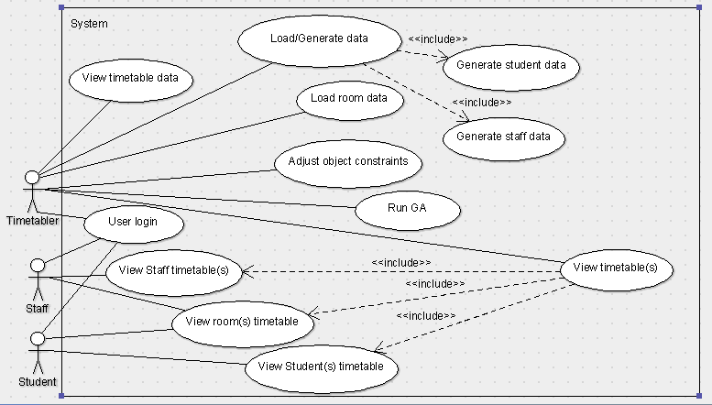

Figure 4 this shows the general use case diagram for the project

This is the diagram of the initial version of the project.

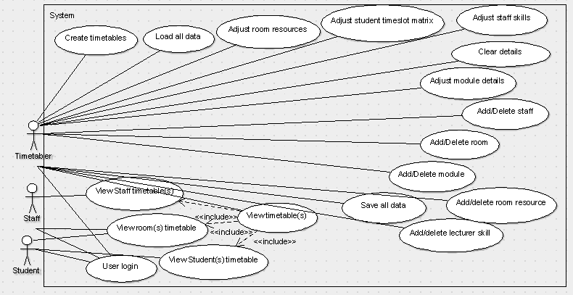

Figure 5 this shows the second version of the use case diagram for the project

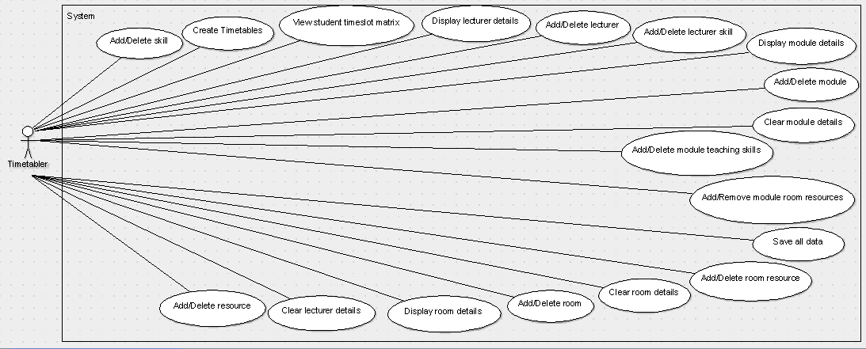

Figure 6 this shows one half of the final version of the use case diagram, showing the timetablers use cases (except timetable viewing)

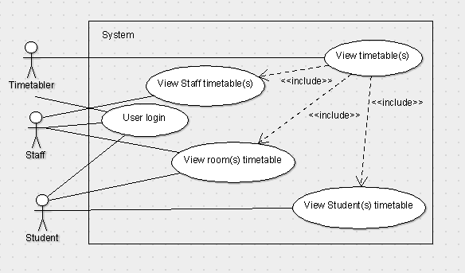

Figure 7 this shows the second half of the final version of the use case diagram, showing the remaining use cases

## Use case tables

The tables below show a more detailed description behind each use case shown in Figures 6 and 7. The first 9 are displayed here, the remainder can be viewed in Appendix I.

|  |
| --- |
| ID and name UC1: Log in to system Initiator Timetabler, Student or Staff member (all “users”) Goal To enable the user to log into the system Precondition - Post-condition - Main menu for the specific user is displayed Assumptions - Main success scenario 1. User enters username and password  2. The main menu for that type of user is displayed |

|  |
| --- |
| ID and name UC2: View Student [Class] Timetable Initiator Student Goal To enable the student to view his/her timetable Precondition - Post-condition Timetable allocated to student displayed on screen Assumptions - Main success scenario 1. Student selects “Display Timetable”  2. The timetable is displayed |

|  |
| --- |
| ID and name UC3: View Staff Timetable Initiator Staff member Goal To enable the staff member to view his/her timetable Precondition - Post-condition Timetable allocated to staff member displayed on screen Assumptions - Main success scenario 1. Staff member selects “Display Timetable”  2. The timetable is displayed |

|  |
| --- |
| ID and name UC4: View Room Timetable Initiator Student or Staff member Goal To enable the student or staff member to view a room’s timetable Precondition - Post-condition The selected room’s timetable is displayed Assumptions - Main success scenario 1. Student or staff member selects “Room Timetable”  2. The student or staff member selects a room  3. The timetable for the room is displayed |

|  |
| --- |
| ID and name UC5: Timetabler to View Timetable Initiator Timetabler Goal To enable the timetabler to view any timetable Precondition Timetabler has selected “View timetables” Post-condition Timetable displayed on screen Assumptions - Main success scenario 1. Timetabler selects “View Timetable”  2. Timetabler selects either “Lecturer”, “Room” or “Class” tab  3. Timetabler selects a lecturer/room/class  4. The timetable for that lecturer/room/class is displayed |

|  |
| --- |
| ID and name UC6: Load all data Initiator System Goal To enable the system to load in all data and constraints to be used by the genetic algorithm to create timetables and also to be displayed to users. This includes data on all lecturers, rooms, modules and classes, students, skills and resources. Precondition - Post-condition Associated program data is loaded and stored Assumptions - Main success scenario 1. On program start-up, the data files are loaded and parsed  2. The data is then stored in memory |

|  |
| --- |
| ID and name UC7: Save all data to external file(s) Initiator Timetabler Goal To enable the timetabler to save all data about lecturers, rooms, modules, lecturer skills, room resources and the student timeslot matrix to an external file. Precondition Timetabler selects “Save all” from the menu Post-condition All data is saved to a file Assumptions The external file cannot be chosen by the user – in future work this will be allowed Main success scenario 1. Timetabler selects “Save all”  2. The system saves all data to external files |

|  |
| --- |
| ID and name UC8: View student timeslot matrix Initiator Timetabler Goal To enable the timetabler to adjust the timeslot matrix for all students Precondition Timetabler selects “Students…” menu item Post-condition The timeslot matrix for all students is displayed Assumptions - Main success scenario 1. Timetabler selects “Students…”  2. The student timeslot matrix is displayed |

|  |
| --- |
| ID and name UC9: Display lecturer details Initiator Timetabler Goal To enable the timetabler to adjust a lecturer’s details Precondition Timetabler selects “Lecturers…” menu item Post-condition All lecturers are displayed, along with their skills and their timeslot matrix preferences Assumptions - Main success scenario 1. Timetabler selects “Lecturers…”  2. The template for all lecturers is displayed |

## Requirement list

| **ID** | **Requirement** | **Description/Reasons** | **MoSCoW** |
| --- | --- | --- | --- |
| UC1, R1 | Shall allow a student to log in | Students should be on the lowest tier of the program access ladder. Students should only be allowed to view room timetables and their own timetable. | Could |
| UC1, R2 | Shall allow a staff member to log in | Staff are on the middle tier of the program access ladder. They should be able to view their own timetable, room timetables, and be able to set room preferences for teaching classes. | Could |
| UC1, R3 | Shall allow a timetabler to log in | Timetablers are on the highest tier of the access ladder. They should be able to have complete access to all features of the system. | Could |
| UC2, R4 | Shall allow a student to view his timetable. | Students should be able to view their own timetables | Must |
| UC3, R5 | Shall allow a member of staff to view his timetable. | Staff should be able to view their own timetables | Must |
| UC4, R6 | Shall allow a student or staff member to view a room’s timetable | Staff and students should be able to view room timetables | Must |
| UC5, R7 | Shall allow the timetabler to view any timetable | Timetablers should be allowed to view any timetable | Must |
| UC6, R8 | Shall allow the timetabler to load in data and constraints from a file. | This is an additional feature of data input to the program, alongside the program automatically loading in the files at start-up. | Could |
| UC6, R9 | Automatically load student timeslot preferences from a file | Load in the student timeslot matrix of preferred times to do activities | Must |
| UC6, R10 | Automatically load all staff data from .a file | Load in data on lecturers including their teaching skills and timeslot preferences | Must |
| UC6, R11 | Automatically load all room data from a file | Load in room data from a pre-prepared .csv file | Must |
| UC6, R12 | Automatically load all module data from a file | Load in module data containing a list of modules and their properties | Must |
| UC6, R13 | Automatically load all lecturer skills from a file | Load in all lecturer skills from a file | Must |
| UC6, R14 | Automatically load all room resources from a file | Load in all room resources from a file | Must |
| UC7, R15 | Save all database information to external files | Save all information about lecturers, rooms, modules, lecturer skills, room resources and the student timeslot matrix to external files | Must |
| UC8, R16 | Display student timeslot matrix | Display the student timeslot matrix which has weightings for when activities should be timetabled throughout the days and times. | Must |
| UC9, R17 | Display list of lecturers | Display a list of lecturers and their skills | Must |
| UC10, R18 | Add lecturer | Adds a new lecturer to the database | Must |
| UC11, R19 | Delete lecturer | Deletes a lecturer from the database | Must |
| UC12, R20 | Add lecturer skill | Add a new lecturer skill to a lecturer | Must |
| UC13, R21 | Remove lecturer skill | Remove a lecturer’s skill | Must |
| UC14, R22 | Clear lecturer details | Clears all lecturer details | Could |
| R23 | Lecturer search | Search for a lecturer by name | Could |
| UC15, R24 | Display list of rooms | Display a list of rooms and their resources | Must |
| UC16, R25 | Add room | Add a new room to the database | Must |
| UC17, R26 | Delete room | Delete a room from the database | Must |
| UC18, R27 | Clear room details | Clear all room resources | Could |
| UC19, R28 | Add room resources | Add a new resource to a room | Must |
| UC20, R29 | Remove room resources | Remove a room resource | Must |
| R30 | Room search | Search for a room by room ID | Could |
| R31 | Adjust room capacity | Adjust the size of the room in terms of the number of seats that it has | Must |
| R32 | Room constraints: | Below this table is a list of constraints that should be part of the program | Must |
| UC21, R33 | Display list of modules | Display a list of modules and their associated skills and resources needed to teach them (lectures/practicals/tutorials) | Must |
| UC22, R34 | Add module | Add a new module to the database | Must |
| UC23, R35 | Delete module | Delete a module from the database | Must |
| UC24, R36 | Add module teaching skill requirement (lectures) | Add a teaching requirement for lectures to the module | Must |
| UC25, R37 | Remove module teaching skill requirement (lectures) | Remove a teaching requirement for lectures from the module | Must |
| UC26, R38 | Add module resource requirement (lectures) | Add a room resource requirement for lectures to the module | Must |
| UC27, R39 | Remove module resource requirement (lectures) | Remove a room resource requirement for lectures from the module | Must |
| UC28, R40 | Add module teaching skill requirement (practicals) | Add a teaching requirement for practicals to the module | Must |
| UC29, R41 | Remove module teaching skill requirement (practicals) | Remove a teaching requirement for practicals from the module | Must |
| UC30, R42 | Add module resource requirement (practicals) | Add a room resource requirement for practicals to the module | Must |
| UC31, R43 | Remove module resource requirement (practicals) | Remove a room resource requirement for practicals from the module | Must |
| UC32, R44 | Add module teaching skill requirement (tutorials) | Add a teaching requirement for tutorials to the module | Must |
| UC33 R45 | Remove module teaching skill requirement (tutorials) | Remove a teaching requirement for tutorials from the module | Must |
| UC34, R46 | Add module resource requirement (tutorials) | Add a room resource requirement for tutorials to the module | Must |
| UC35,R47 | Remove module resource requirement (tutorials) | Remove a room resource requirement for tutorials from the module | Must |
| UC36, R48 | Clear module details | Clear all module details. This includes details about module required teaching skills and room resources for lectures, practicals and tutorials | Could |
| R49 | Search modules | Search for a module by name | Could |
| R50 | Adjust lecture duration | Adjust the length of the lecture sessions for a module | Must |
| R51 | Adjust practical duration | Adjust the length of the practicals sessions for a module | Must |
| R52 | Adjust tutorial duration | Adjust the length of the tutorials sessions for a module | Must |
| UC37, R53 | Add new skill | Add a new skill to the list of skills | Must |
| UC38, R54 | Delete skill | Delete a skill from the list | Must |
| UC39, R55 | Display list of skills | Display a list of lecturer teaching skills | Must |
| UC40, R56 | Add resource | Add a new resource to the list of resources | Must |
| UC41, R57 | Delete resource | Delete a resource from the list | Must |
| UC42, R58 | Display list of resources | Display a list of room resources | Must |
| R59 | Select lecturer length of work week | Ability for lecturers to choose how many days in a week they are working | Wont |
| R60 | No Back – to – back (1 hr lec) | Prevent back-to-back scheduling of compulsory 1hr lectures | Wont |
| R61 | No Back – to – back (2 hr lec) | Prevent back-to-back scheduling of compulsory 2hr lectures | Wont |
| R62 | No Back – to – back (3 hr lec) | Prevent back-to-back scheduling of compulsory 3hr lectures | Wont |
| UC43, R63 | Create timetables | Run the GA to create all timetables for classes, rooms and lecturers | Must |

Table 1 requirements list

The following is a list of room resources that can be added to any room/module:

• A / B & C Block Rooms

• Architecture Studios & Teaching Rooms

• Art and Cultural Industries rooms

• Audio Booths

• Black Out

• Computer Lab

• Creative Technology Lab

• D & E Block Rooms

• Digital Projector

• DVD Player

• ECC and HP rooms

• Examinations and Conference Centre

• FET ALL Rooms

• FET Group Work Room

• FET Meeting rooms

• FET PAL room

• FET PC labs (any)

• FET PC labs (CAD)

• FET Surveying Lab

• Flat Teaching Rooms

• Frenchay

• Frenchay Block N

• Frenchay Block S

• Frenchay Blocks A / B / C

• Frenchay Blocks D / E

• Frenchay Blocks G / H / J / K / L / M

• Frenchay Blocks Q / R

• Frenchay or ECC

• G / J / K & L Block rooms

• Games Lab

• General Purpose Teaching Room

• General Purpose Teaching Room - rank 1

• General Purpose Teaching Room - rank 2

• General Purpose Teaching Room - rank 3

• General Purpose Teaching rooms

• Glass or White Board

• GPT + bookable specialist rooms

• GPT2 + Science rooms

• Group Work room

• Laboratory

• Large rooms 39+

• Large Screen TV

• Lectern

• Lecture Capture Facility

• Lecture Capture Rooms

• Lecture Theatre

• Meeting Room

• Meeting Rooms – Frenchay

• Music Studios & Labs

• PC Lab

• PC Lab (Comp Sci)

• PHAROS PC/Printing PC

• Piano

• Q & R Block Rooms

• Rooms suitable for exams

• S Block Rooms

• Specialist spaces not covered by other type

• Staff PC

• Studio

• Suitable for block teaching

• Suitable for interviews

• Technical Computing (GNU/LINUX)

• Technology Enhanced Active Learning

• Used for printing out weekly timetables

• Visualiser

• Voting System

• WIFI

## Acceptance tests

Shown below are 9 of the project acceptance tests. The remainder can be viewed in Appendix J. The template for running the following acceptance tests can be seen in Appendix G.

Test ID: T1

Test description: Student login with correct username and password

Requirements tested: R1

|  |  |  |
| --- | --- | --- |
| Step | Actions | Observations |
| 1 | Select “Student” from the button choices | Program should record that a student is logging in |
| 2 | Enter appropriate username and password | Program should check whether the username and password is valid and continue to the main window. |

Test ID: T2

Test description: Student login with incorrect username/password

Requirements tested: R1

|  |  |  |
| --- | --- | --- |
| Step | Actions | Observations |
| 1 | Select “Student” from the button choices | Program should record that a student is logging in |
| 2 | Enter an incorrect username and password | Program should check whether the username and password is invalid and display an error |

Test ID: T3

Test description: Staff login with correct username and password

Requirements tested: R2

|  |  |  |
| --- | --- | --- |
| Step | Actions | Observations |
| 1 | Select “Staff” from the button choices | Program should record that a staff member is logging in |
| 2 | Enter appropriate username and password | Program should check whether the username and password is valid and continue to the main window. |

Test ID: T4

Test description: Staff login with incorrect username/password

Requirements tested: R2

|  |  |  |
| --- | --- | --- |
| Step | Actions | Observations |
| 1 | Select “Staff” from the button choices | Program should record that a staff member is logging in |
| 2 | Enter an incorrect username and password | Program should check whether the username and password is invalid and display an error |

Test ID: T5

Test description: Timetabler login with correct username and password

Requirements tested: R3

|  |  |  |
| --- | --- | --- |
| Step | Actions | Observations |
| 1 | Select “Timetabler” from the button choices | Program should record that a timetabler is logging in |
| 2 | Enter appropriate username and password | Program should check whether the username and password is valid and continue to the main window. |

Test ID: T6

Test description: Timetabler login with incorrect username/password

Requirements tested: R3

|  |  |  |
| --- | --- | --- |
| Step | Actions | Observations |
| 1 | Select “Timetabler” from the button choices | Program should record that a timetabler is logging in |
| 2 | Enter an incorrect username and password | Program should check whether the username and password is invalid and display an error |

Test ID: T7

Test description: Student views timetable

Requirements tested: R4

|  |  |  |
| --- | --- | --- |
| Step | Actions | Observations |
| 1 | Select “View timetable” | Program should produce an error if a timetable has not yet been produced |
| 2 | Program should display the student’s timetable |  |

Test ID: T8

Test description: Staff member views timetable

Requirements tested: R5

|  |  |  |
| --- | --- | --- |
| Step | Actions | Observations |
| 1 | Select “View timetable” | Program should produce an error if a timetable has not yet been produced |
| 2 | Program should display the staff member’s timetable |  |

Test ID: T9

Test description: View a room timetable

Requirements tested: R6

|  |  |  |
| --- | --- | --- |
| Step | Actions | Observations |
| 1 | Select “View room timetable” | Program should produce an error if timetables have not been produced for all rooms |
| 2 | Program should display a list of rooms |  |
| 3 | User should select a room | The room’s timetable should be displayed. |

# Design

The pre-processing stage and the mathematical model used by the system was developed by the project supervisor, Martin Serpell, based from three mathematical modelling papers, (MiHassani, 2006), (Daskalaki, 2004) and (Boland, 2008). The Mersenne Twister class code used for generating random numbers was fond online.

## Alternative designs considered

Refer to the various GUI designs in section 4.8.

## High-level diagram of the project

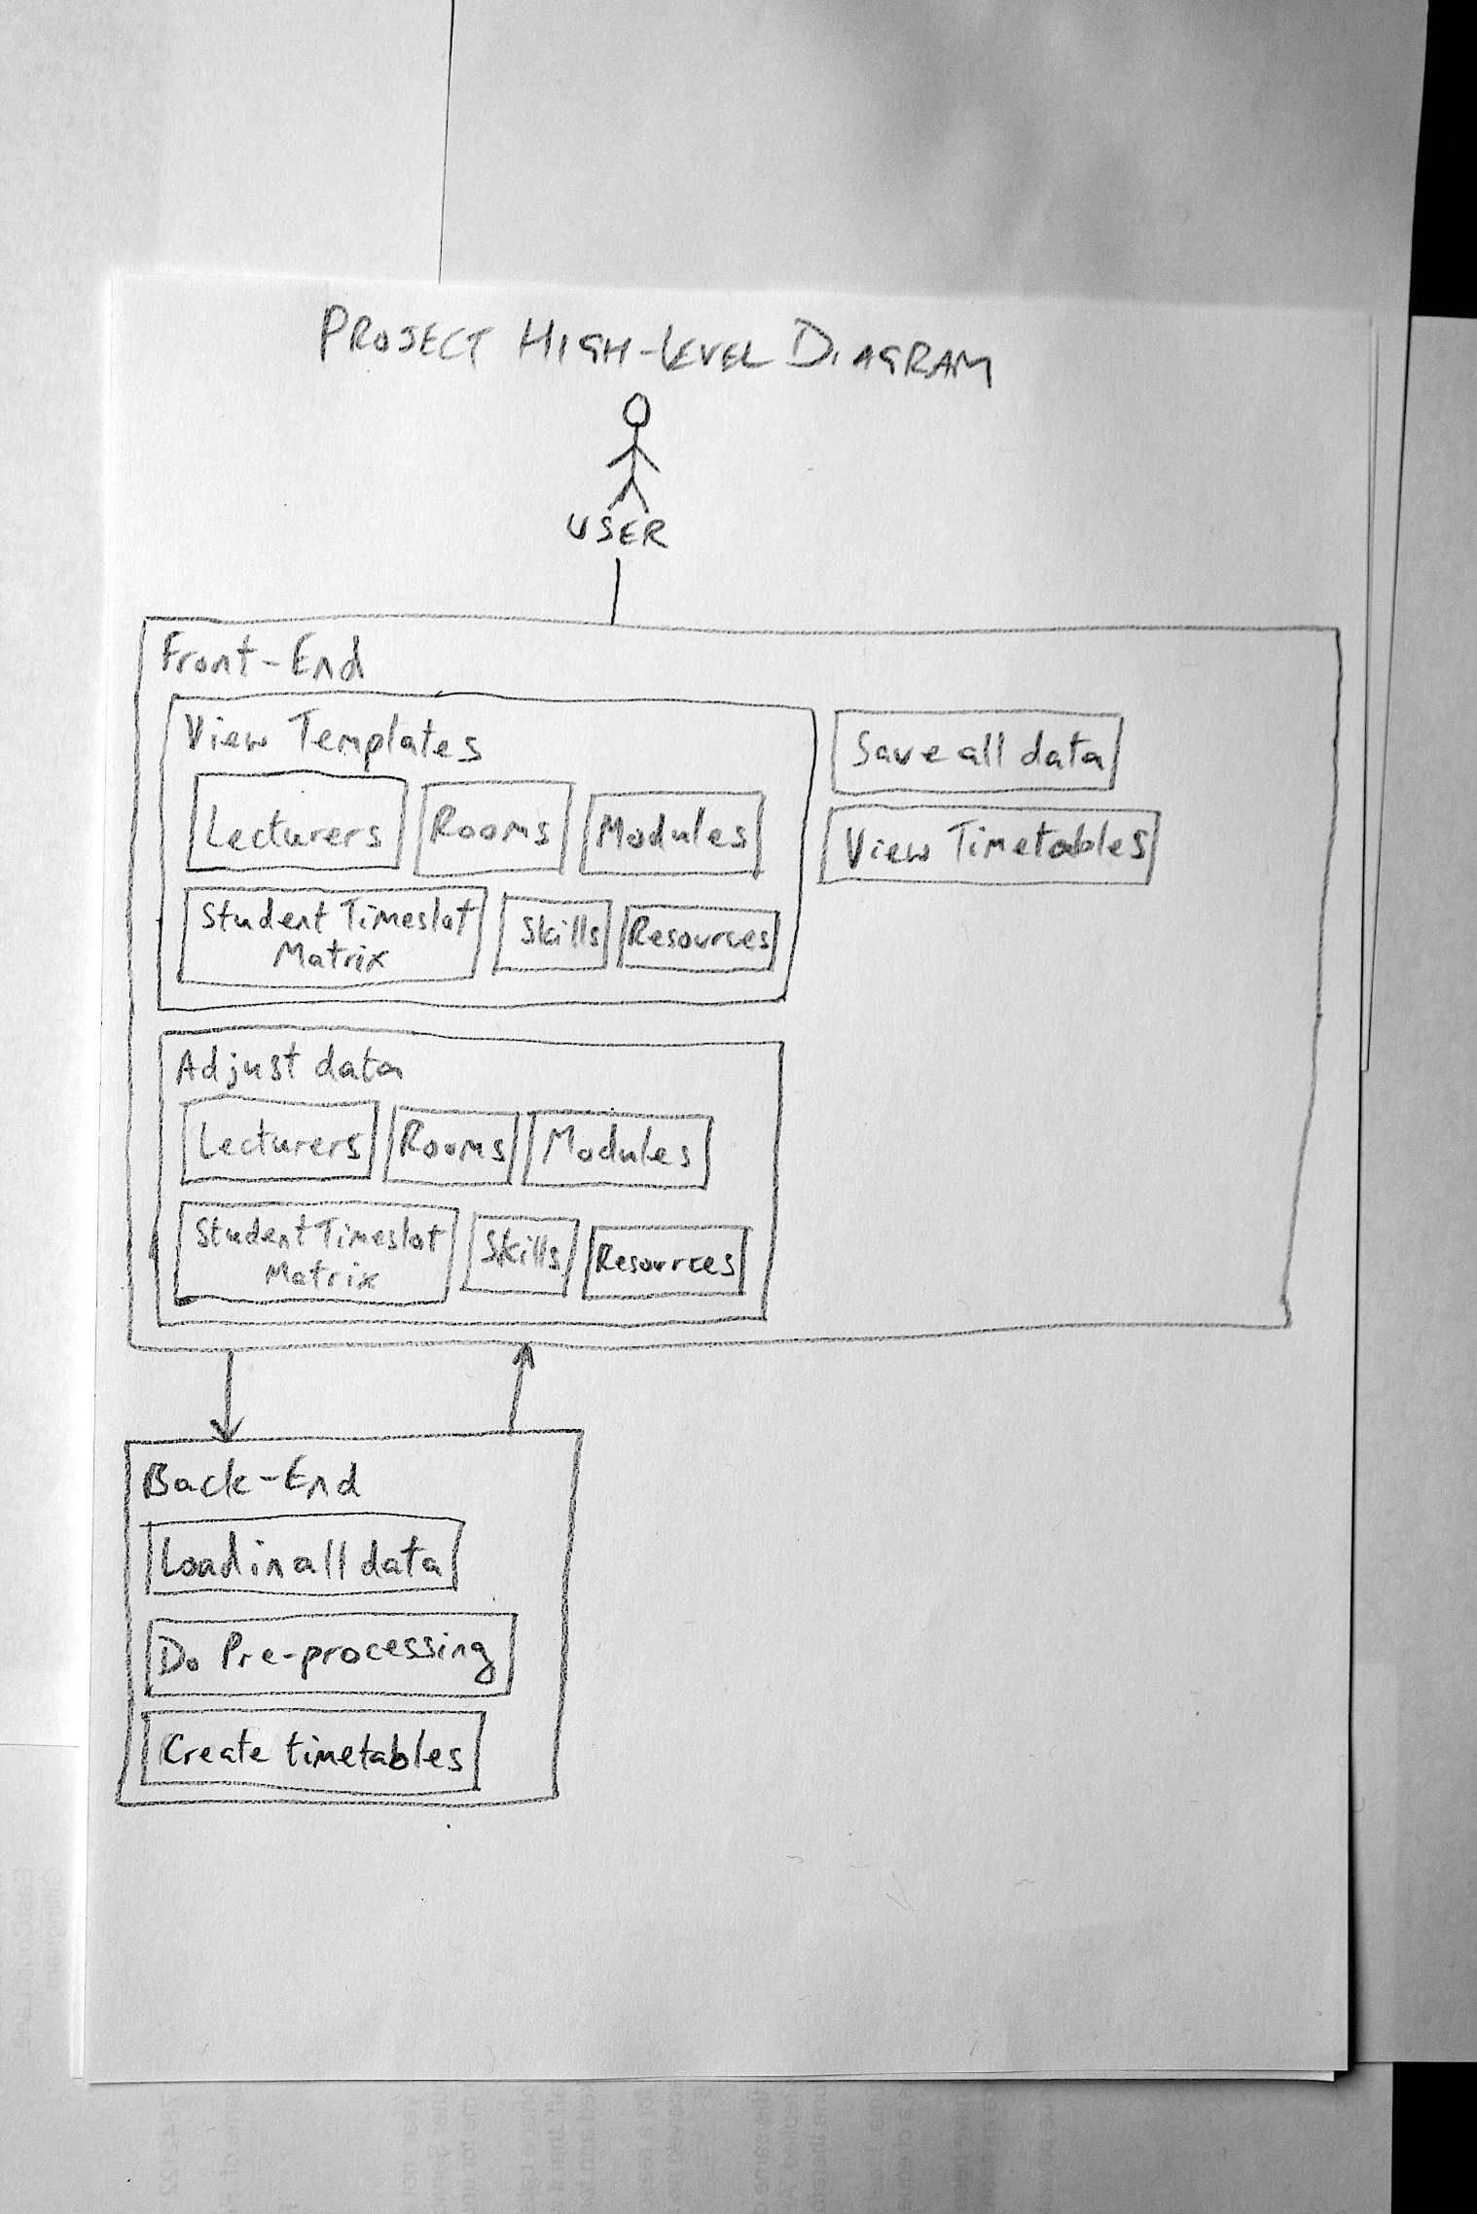

Figure 8 Project High-level diagram

The above diagram shows the entire project layout in general terms. The front-end handles all the user interaction, including actions like displaying timetables, creating new data and editing data in the system. The back end handles the loading of data into the system and the creation of the timetables using the genetic algorithm.

## High-Level diagram of the timetable creation process

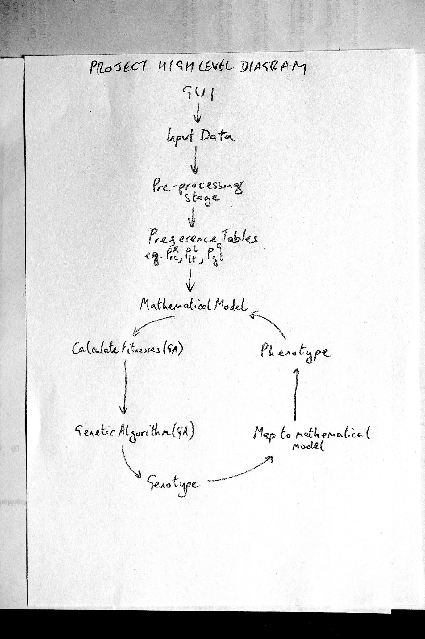

Figure 9 Project High-level diagram of the timetable creation process

The figure above shows the high-level diagram for this project. The first stage is the GUI front end, where the user interacts with the system. The user inputs data to the system such as adding lecturer skill, or room resources. This data, along with the data loaded in when the program started up, is sent to a pre-processing stage. In this stage, the matrices LC and RC are filled with information on lecture skills, class teaching requirements, room resources, and room requirement for classes. This is then used by the mathematical model to fill out three 4D arrays of data.

Then the GA chromosomes are initialised to random values and the cycle of testing these chromosomes out against the constraints is undertaken, with fitness of the chromosomes calculated, selection of parents to perform crossover and mutation and the replacement of one of the chromosomes with the offspring. This cycle continues until all hard constraints are satisfied and most or all soft constraints are satisfied. Then the timetables can be viewed by the user.

## Class diagram

The following figure shows the class diagram for the project.

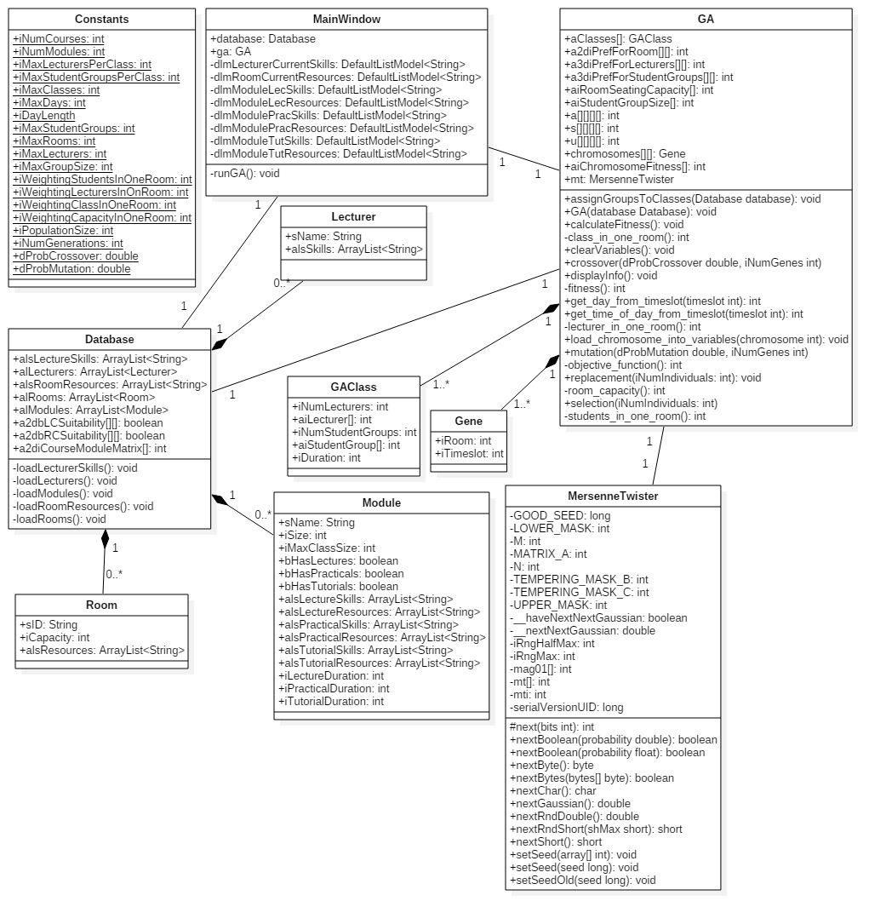

Figure 10 Project class diagram

The Constants class is universal to all the other classes (it contains global variables). The following code sections were written by Martin Serpell in C and translated into Java. These can be seen in the Timetabling v2 code included on the DVD.

The Gene structure and the GAClass structure (Class in Timetabling v2)

The three “preference” matrices

The arrays “room_seating_capacity”, “student_group_size”, and the 4D arrays a, s and u.

Methods:

* clear_variables()
* get_day_from_timeslot()
* get_time_of_day_from_timeslot()
* load_chromosome_into_variables()
* objective_function()
* students_in_one_room()
* lecturer_in_one_room()
* class_in_one_room()
* room_capacity()
* fitness()

## The Pre-processing stage

The application has a pre-processing stage in order to simplify the work done by the GA and the mathematical model.

A class, C, must be able to run in a room that has equipment suitable for the needs of the class. The class must also have one or more appropriate members of staff allocated to it. The variables to be considered are defined as follows:

R, refers to rooms

C, refers to classes

L, refers to lecturers

$X_{i}^{R}$, the set of resources (e.g. overhead projectors, computers, etc…) provided by room i

$X_{j}^{C}$, the set of resources required to teach class j

$K_{i}^{L}$, the set of teaching skills provided by lecturer i

$K_{j}^{C}$, the set of teaching skills required to teach class j

The suitability of room i to teach class j is $|X_{i}^{R}∩X_{j}^{C}|$ This is the RC matrix.

The suitability of lecturer i to teach class j is $|K_{i}^{L}∩K_{j}^{C}|$ This is the LC matrix.

The size of a class will not be constant, but will vary depending on the number of students taking the module, and the type of the class (whether it is a lecture/practical/etc…). If a module has 160 students, and a room for a practical can only hold 20, then the cohort has been broken down into groups of 20 for the practical sessions while still having 160 for the lecture.

However, in practice, the 160 students could be made up of students from different degree courses. There could be for example 83 students from one course taking the module, 62 from a second course and 15 from a third. If these are broken down into blocks of 20, the result is 10 groups. From these, the smallest groups could be combined into a single class. These classes are then dealt with separately in the GA.

On some occasions, there could be a class of over 20 students in one room. In such cases, more than one lecturer can be assigned to be in the same room, in order to maintain the ratio of 1:20 lecturers to students.

Some information such as lecturer’s skills was not available. As a result, lecturer’s skills were randomly generated.

## Description on LC matrix and RC matrix

Two matrices, LC and RC, were created in order to assist with the pre-processing stage. The LC matrix is a 0/1 matrix of lecturer skills and skills required to teach a particular class. If a lecturer has the skills to teach a particular class, then a value of 1 is assigned to that position, otherwise a zero is assigned. The RC matrix is another 0/1 matrix and looks at room resources and the resources required to teach a particular class. If a room has adequate resources to be able to host a class, then a value of 1 is assigned, otherwise a zero is assigned. In future work, cluster leaders can then select which lecturers they would like to teach particular classes. In the present version of the project, two lecturers will be chosen at random from each of the matrix’s columns. Matrix RC is represented by variable $P_{rc}^{R}$ in the mathematical model.

## The Mathematical Model

The objective function that must be maximised by the GA is as follows:

$$\sum_{r∈R}{\sum_{t∈T}{\left(\sum_{c∈C}{a_{crt}P_{rc}^{R}+\sum_{l∈L}{s_{lrt}P_{lt}^{L}+\sum_{g∈G}{u_{grt}P_{gt}^{G}}}}\right)}}$$

R is the set of rooms, T is the set of timeslots, C is the set of classes (lectures, practicals, etc…) related to the modules, L is the set of lecturers and G is the set of student groups.

$a_{crt}$ is set to 1 if class c is allocated to room r in timeslot t and is 0 otherwise.

$s_{lrt}$ is set to 1 if class c is allocated to room r in timeslot t and is 0 otherwise.

$u_{grt}$ is set to 1 if class c is allocated to room r in timeslot t and is 0 otherwise.

$P_{rc}^{R}$ is the suitability of room r for class c.

$P_{lt}^{L}$ is the suitability of lecturer l for timeslot t.

$P_{gt}^{G}$ is the suitability of student group g for timeslot t. In practice, a single timeslot matrix will be used for all students.

The objective function is subject to the set of the following constraints:

$\sum_{r∈R}{u_{grt}≤1,∀g∈G,∀t∈T}$ Each group of students can only occupy one room at one time

$\sum_{r∈R}{s_{lrt}≤1,∀l∈L,∀t∈T}$ Each lecturer can only be in one room at one time

$\sum_{r∈R}{a_{crt}≤1,∀c∈C,∀t∈T}$ Each class can only be in one room at one time

The total number of students than can occupy a room has to be less than or equal to the room capacity. More than one student group can occupy a room, as long as the combined number of students fit inside that room.

$$\sum_{g∈G}{u_{grt}Z_{g}^{G}≤Z_{r}^{R},∀r∈R,∀t∈T}$$

Where $Z_{i}^{R}$ is the seating capacity of room $i$ and $Z_{i}^{G}$ is the number of students in group $i$.

## The GA structure

A random number generator called the Mersenne Twister was used to randomly populate the GA chromosomes and to provide random numbers for crossover and mutation probabilities. This random generator was chosen as it produces higher quality random numbers than the Math.random() function provided by Java.

The structure of the GA chromosomes is made up of pairs of values. One value is the room ID and the other is the timeslot. These are arranged in a separate part of the program to form three 4D arrays of values, with room on one axis, days on a second axis, and timeslots on a third. The fourth axis depends on the array itself and is shown below:

Array $a_{crt}$ has classes on its fourth axis.

Array $s_{lrt}$ has lecturers on its fourth axis.

Array $u_{grt}$ has student groups on its fourth axis.

In Abdullah and Turabieh (2008), the chromosomes had to be repaired as they sometimes produced infeasible timetables. For this project, this does not occur as only valid rooms and timeslots are chosen. In some cases, an activity that is located in a late slot in the timetable can overlap the end of the array. In such cases, the hours off the end of the array are considered to have a penalty of -10 applied to them.

The system only needs to produce timetables covering a single week only. Activities which take different lengths of time to run on alternate weeks will not be considered. The GA will first place modules into the timetable which run over both semesters first, then schedules modules that only take place in one semester. After this the GA will then schedule any extraneous items.

The GA crossover is combinatorial based, rather than permutation based. The figure below shows the internal structure of the chromosome.



Figure 11 design of the chromosomes

The arrays, a, s and u are then loaded from the class data and the data from each individual chromosome as required. For array a, the room, day and time data are taken from the chromosome, and the class data come from the classes structure. For array s, the lecturers are loaded from the classes structure and for array u, the student groups are loaded from the classes structure.

## Design decisions (Design log file)

It was decided that all data needed for the GA and for the operation of the program in general (such as lists of lecturer, rooms, lecturer skills, room resources, etc…) should be loaded when the program starts. Adding a feature to load in such files separately via the templates was considered, and was put into the first iteration of the program. Ultimately, it was decided that loading in files manually was to be added as a feature for future work and not included in the finished application.

The combined design and implementation log file can be found in section 5.6.

## GUI Designs

The following images show the initial ideas for the GUI.

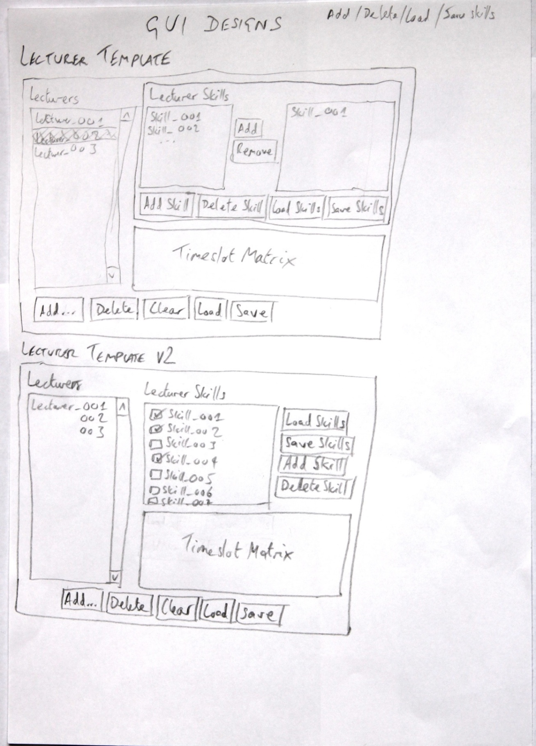

Figure 12 the initial designs for the “lecturers” template

The top design shows two lists for adding/removing lecturer skills. The list on the left, show all the skills that could be added to a lecturer. The list on the right shows skills the lecturer already has. The “Timeslot Matrix” is a table where lecturers can enter their preferences for when classes should take place. These preferences are in the range from 10 to -10, with 10 being a very good timeslot, whereas -10 is a timeslot to be avoided at all costs (such as Wednesday afternoons or late in the evening). In both designs, there are buttons for adding a new lecturer, deleting a lecturer and adding and removing available lecturer skills. There are buttons for loading and saving the list of lecturers, however, it was decided that loading of lecturers should be done automatically by the program on start-up.

In the bottom design, the list of lecturer skills is shown as a checkbox list. Although this design is more simplistic, the Netbeans IDE does not a have a ready-available GUI widget that will do this. There are ways of creating this widget, but due to time constraints, it was felt that the top design could be implemented more quickly.

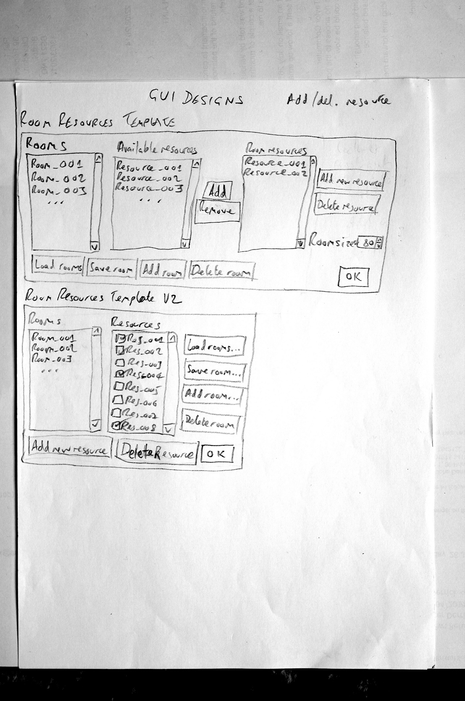

Figure 13 initial designs for the “rooms” template

Like the top design for the “lecturers” template, the top design for the “rooms” template shows two lists for room resources – the left showing available rooms and the right showing current room resources. The buttons in between allow for the addition/removal of resources.

In both designs, there are buttons for adding a new room, deleting a room and adding and removing available room resources. There are buttons for loading and saving the list of rooms, however it was decided that, like for the lecturers, loading of room should be done automatically by the program on start-up. In the bottom design, the list of lecturer skills is shown as a checkbox list. Like the lecturers template, the decision was made to use the top design due to time constraints.

One item was missing from both designs is the room capacity. This was added to the template when it was implemented in the program as a spinner box.

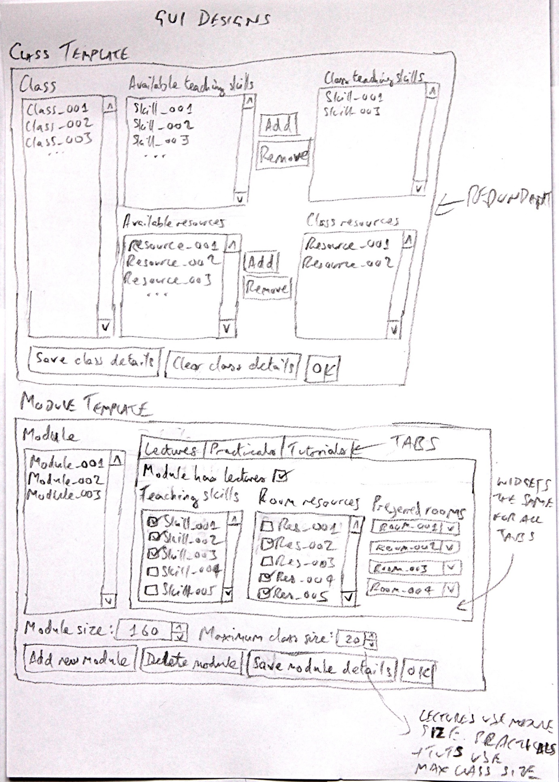

Figure 14 designs for a “class” template and the “module” template

The top diagram of the above figure shows a design for a “Class” template with different class having skills and resources assigned to them. The bottom design shows a new version of this idea in the form of a “Module” template, with modules having assigned skills and resources for lecturers, practicals and tutorials. In addition, the design also shows the module cohort size and the maximum class size for practicals and tutorials. The design shows two lists of checkboxes; in the implemented version four ordinary lists were used; two for teaching skills, and two for room resources.

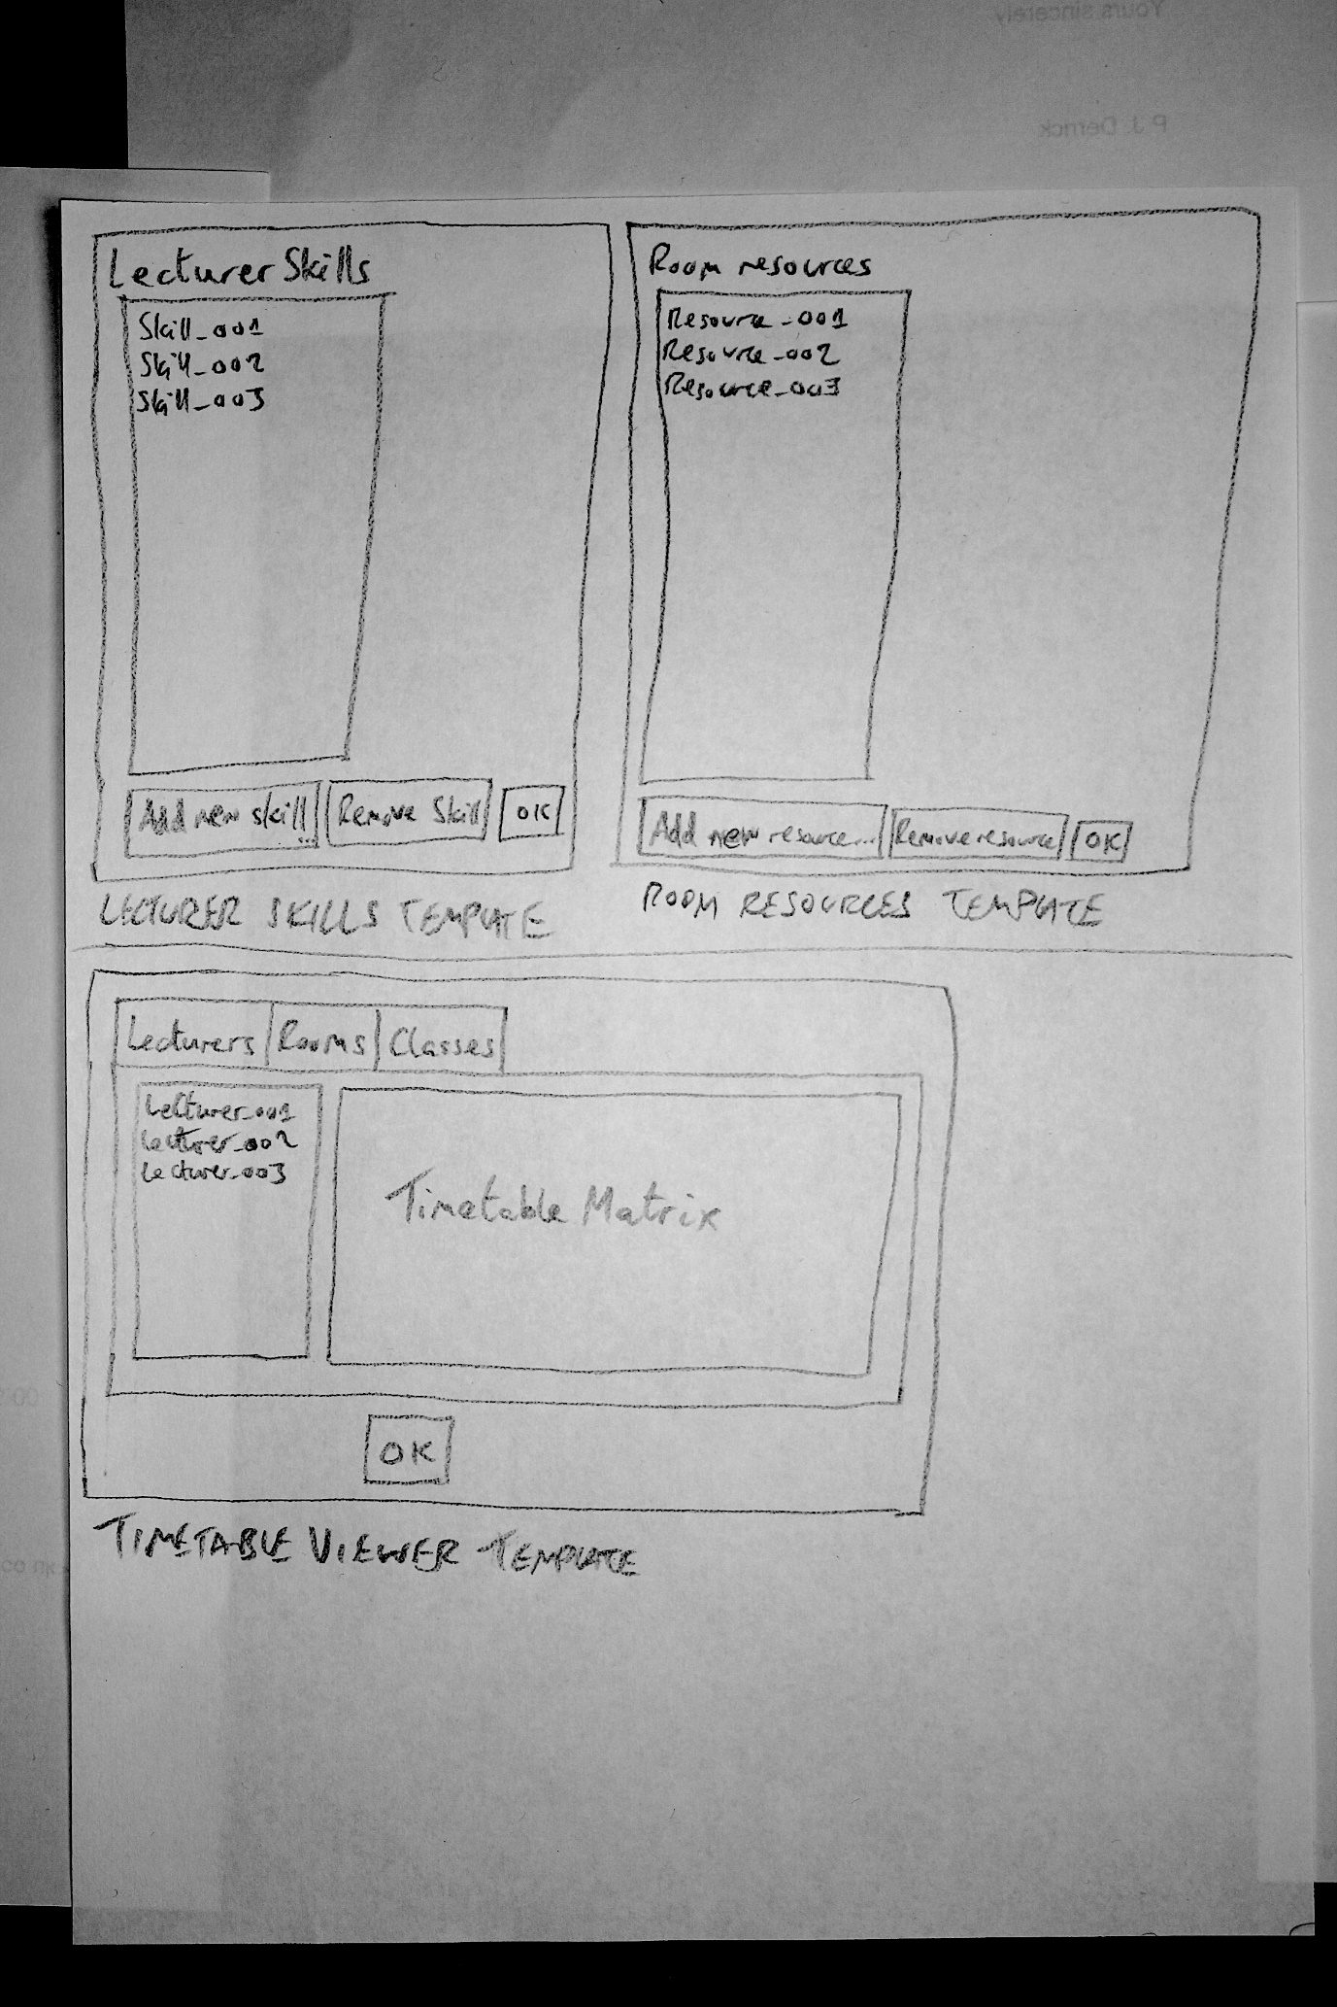

Figure 15 designs for a “Skills” template, a “Resources” template and a template to view the timetables

The above figure shows three GUI designs for skills, resources, and viewing the timetables. Originally, it was decided that the adding and removing of skills and resources on their own could be achieved by using the lecturers and rooms templates respectively. It was later decided that this added too much clutter to the lecturer, room and module templates, but more importantly, created a number of duplications of features across the templates. As a result, it was decided to move the creation and deletion of skill and resources into their own templates.

The diagram showing the timetabler viewer is intended for use by the timetabling staff rather than for students and lecturers. Lecturers and students only need to see their own timetables (along with the room timetables), not the timetables of other people. However, I this version of the program, this template will suffice to show all users their timetables – in future work, these will be separated out for students and lecturers.

## Reasons behind the chosen design

Methods for solving the timetabling problem based on pure mathematical models do not scale to large problem instances therefore an AI methodology has been chosen; the methodology chosen being Genetic Algorithms. The designs for the various parts of the application such as the GUI have gone through a number of iterations, based on decisions made in both their design and implementation (as they were coded). The final design that was chosen had all the basic features needed to run, along with certain features designed to ease the process of adding and removing elements of lists such as lecturers, rooms, etc… Features such as a login system were considered, but in the end rejected due to time constraint and due to the non-essential nature of the feature (the system is considered as a “proof in concept” rather than a clean, finished product).

## How different components of the design have been identified

The following screenshots show an early iteration of the project with personal features included for students, staff and rooms.

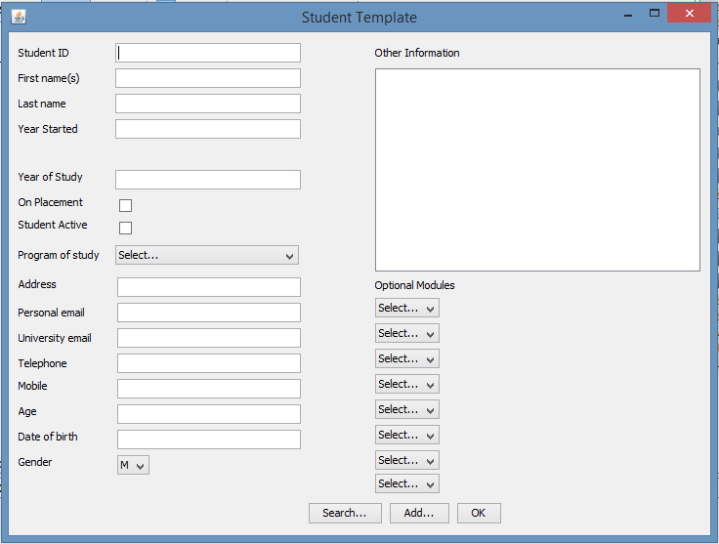

Figure 16 this is a screenshot of the original student template

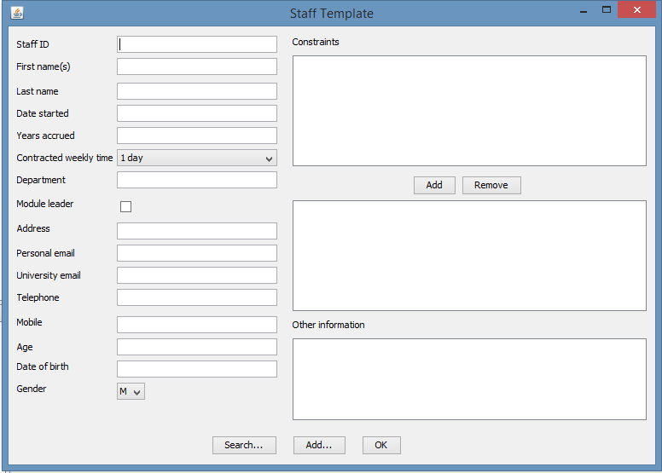

Figure 17 this is a screenshot of the original staff template

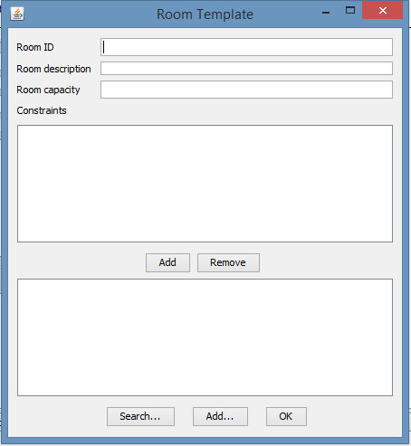

Figure 18 this is a screenshot of the original rooms template

The design has evolved on an iterative basis and components have been formulated as the design has progressed, either as new features or the reduction of features that were deemed unnecessary. For example, in the first iteration of the lecturer’s template, personal details such as email addresses and telephone numbers were added with the data for such features being randomly generated. On further consideration of the features required, it was decided that personal details were extraneous to the system and were thus removed.

## How the design has been described

In this report, there are sections describing the design of the GUI panels (section 4.6) and the GA code done by the author. The design of the GA chromosomes and the mathematical model were developed by the project supervisor, Martin Serpell (sections 4.2-4.4).

## What test data was specified

Test data for the application included raw data on staff and their constraints, courses, modules and their delivery requirements and rooms and their resources. These were provided as Excel spreadsheets. These spreadsheets were then modified and simplified for use as input data to the program (these were saved as .csv files for ease of use). These files can be found on the DVD which accompanies this report.

# Implementation

## How the project has been implemented

The project was implemented in iterative stages, in order to validate and verify the code before it become too unwieldy and the prevented the need for intensive, in-depth debugging.

## How implementation progress has been recorded

As the code developed, log files were created which detailed problems encountered in the design and implementation of the software, decisions made and questions for further consideration. A copy of the log files which have been included in the design and implementation sections refers to separate code revisions, which were held in an archive.

## How the program has been demonstrated to show that it works

The code has been tested by running acceptance tests which indicates whether a particular part has passed or failed for various reasons.

## How will you show what has been achieved?

This project and the existing system was not compared side-by-side.

A demonstration was carried out to show the project working and its operations. This provided the opportunity for current users to interact with it and determined whether it met their requirements.

## What has not been finished?

Features that have not been implemented include:

A login system for timetablers, staff and students and the subsequent greying out of features relevant to the particular access level of the user.

The ability to load in lists of lecturers/rooms/modules/skills/resources from external files manually. At present, such lists are loaded in automatically on program start-up.

The ability to search for lectures/rooms/etc…

## Implementation decisions (implementation log file)

**26/5/17**

There should only be one JFrame. If more than one window is needed then they should be dialog boxes (JDialog).

There is a "Table" widget that could be used for displaying the timetables

Add dialog boxes to the project by dragging them from the widget toolbar and onto the main form. Then select them and select "Design" and then add widgets to the dialog box.

Data loading:

Load data from .csv files

Should each class of data (student, staff, etc.) be loaded one at a time or all at once via "multiple select"?

There is data to be randomly generated such as a student's (group) modules

Some data such as constraints are fixed and loaded from outside

Generate errors if data is not present

Student data should be randomly generated

There are informal student constraints - no lectures before 9am or after 6pm for example

Staff data should be randomly generated

Staff constraints should be loaded

Should there be an ability to add new constraints?

Saving new data. Should this be done into a temp file after a new activity/student/etc.. is added or should there be a Save feature?

Ability to view a student/staff/etc. in the Template?

Search by Student ID? Name? etc...?

Will miss out "Current year" as this is universal to all students

**27/5/17**

Search boxes - one for each template rather than one for all templates

**29/5/17**

Display staff, students, etc in a table?

Search for staff, students via name as well as by ID?

Load in all data on program execution?

**30/5/17**

Deleting students - how does this affect the student ID?

Students - how to group them together in blocks of 20?

Separate databases for each object type (student, staff, rooms, etc...)

Re-randomizing data (e.g. student data)?

Static zero adding method in utility class

Year of study - 3/4 for students who went on placement? History if student went on placement or not

Include PAL sessions?

.csv files load and parse - format must be decided - subsequent changes difficult (code and .csv must both be changed).

Load in .csv files - dialog box for this task

Develop login screen

Develop flash screen

**9/6/17**

Class or module? modules?

Module cohorts are broken down into classes of different sizes. For example, there could be a lecture of 80 students and four practicals of 20 students

Modules have an overall cohort size - this needs to be set/imported by the timetablers

Lectures have different teaching requirements than practicals

Classes - you could have a "lectures" class and several "practical" classes

Modules have lecture requirements (room resources and teaching requirements) and so do practicals and tutorials

Maybe a GUI could have different areas/tabs for lecture requirements, practical requirements and tutorial requirements. There could be a checkbox to enable/disable these different areas.

**10/6/17**

GUI Design:

Lecturer constraints...add to skills list or make a separate list?

Add OK buttons to all forms

Load lecturer skills list and room resources in a separate part of the program? Access via main menu?

Load default lists of resources/skills on program start?

Classes:

Set of resources required to teach a class

Set of teaching skills required to teach a class

Classes auto-generated by modules (the spreadsheet with lectures and practicals present) - numbers per activity converted into classes (blocks of 20)

Create module template/Course template

Load in data from Staffing 17/18 spreadsheet (convert to .csv first) and chop up activity cohorts into blocks of 20.

Classes for different activities - one class for lectures, separate classes for each practical.

Optional: Add a welcome screen to the application

Modules:

Include module overall size (spinner box)

Include individual tabs for lectures/practicals/tutorials

Include check boxes in each tab...

Checkbox – has lectures (y/n)

Checkbox - has practicals (y/n)

Checkbox - has tutorials (y/n)

Maximum class size per module - different per module - user adjustable

List of preferred teaching rooms? Added to module template - 4 combo boxes - to be used in order or preference top down

**12/06/17**

Lecturers.csv to be loaded on program start-up for the time being (hard coded). An option to load a file will be added later.

**19/06/17**

Working on implementing GA in the program

Having difficulty with accessing array lists in different classes - having to use global constants to bypass these issues.

**20/06/17**

GA - replace a random individual or the worst individual in the population?

**26/06/17**

Doing work on pre-processing

Generation and update of LC and RC matrices to occur...

1. On program startup

2. When the GA is run

**28/06/17**

Saving of data such as lecturer skills to memory can be done as the user adds and removes skills, rather than having a separate button for saving such changes before moving on to another lecturer or elsewhere.

Miscellaneous entry: The timeslot matrices were implemented as Java tables. These have the ability to allow users to input data by selecting individual cells and entering the data accordingly.

## Program screenshots

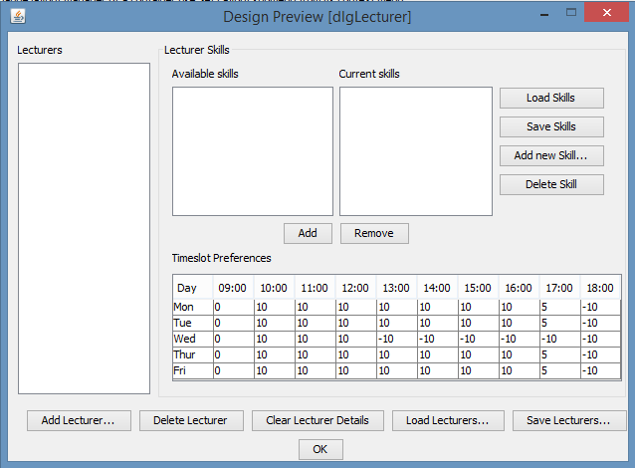

Figure 19 this is a screenshot of the “lecturers” template

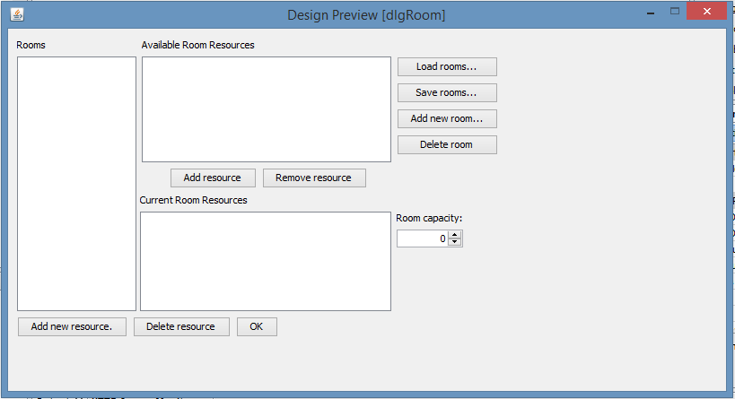

Figure 20 this is a screenshot of the “rooms” template

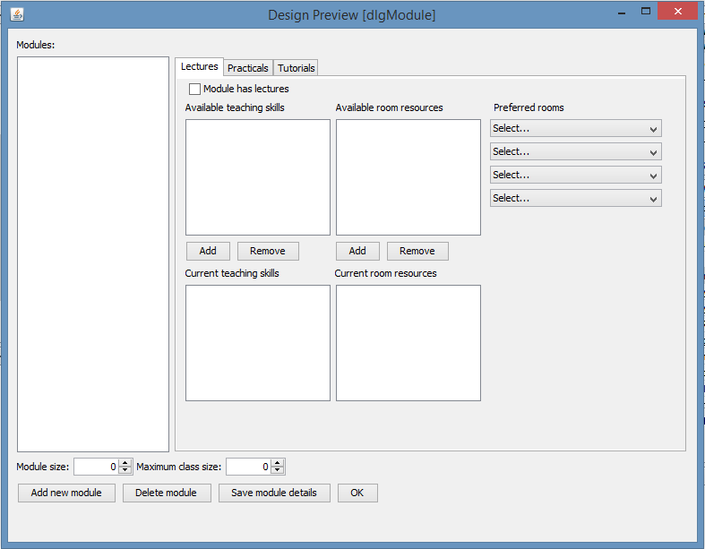

Figure 21 this is a screenshot of the “modules” template

# Testing

## How code has been tested

By iterative testing and by running acceptance tests to ensure that code works as expected. The program was built up in small sections over time. These were tested to make sure that no bugs were created and any that were created were resolved.

## How the tests proved the code worked correctly

The tests produced timetables for staff, students and rooms which were presented on a screen in the required format (i.e. per day, week, month, semester etc…). The timetablers and members of staff were allowed to interact with the GUI for their opinions.

## How the test results have been documented

Acceptance test results were recorded for each test and included in section 6.4.

## Test results

The following test results show one iteration of the project’s code which took place 28/06/2017:

| **Test** | **Pass/Fail** | **Comments** |
| --- | --- | --- |
| 1 | Fail | Feature to be included in future work |
| 2 | Fail | Feature to be included in future work |
| 3 | Fail | Feature to be included in future work |
| 4 | Fail | Feature to be included in future work |
| 5 | Fail | Feature to be included in future work |
| 6 | Fail | Feature to be included in future work |
| 7 | Fail | Not yet implemented |
| 8 | Fail | Not yet implemented |
| 9 | Fail | Not yet implemented |
| 10 | Fail | Not yet implemented |
| 11 | Fail | Not yet implemented |
| 12 | Fail | Not yet implemented |
| 13 | Pass | Currently using absolute file paths – having trouble with relative file paths |
| 14 | Fail | Not yet implemented |
| 15 | Fail | Not yet implemented |
| 16 | Pass |  |
| 17 | Pass |  |
| 18 | Pass |  |
| 19 | Pass |  |
| 20 | Pass |  |
| 21 | Fail | Not yet implemented |
| 22 | Fail | Proposed for future work |
| 23 | Fail | Proposed for future work |
| 24 | Pass |  |
| 25 | Pass |  |
| 26 | Pass |  |
| 27 | Pass |  |
| 28 | Pass |  |
| 29 | Fail | Not yet implemented |
| 30 | Fail | Proposed for future work |
| 31 | Fail | Proposed for future work |
| 32 | Pass |  |
| 33 | Pass |  |
| 34 | Pass |  |
| 35 | Pass |  |
| 36 | Pass |  |
| 37 | Pass |  |
| 38 | Pass |  |
| 39 | Pass |  |
| 40 | Pass |  |
| 41 | Pass |  |
| 42 | Pass |  |
| 43 | Pass |  |
| 44 | Pass |  |
| 45 | Pass |  |
| 46 | Pass |  |
| 47 | Fail | Not yet implemented |
| 48 | Fail | Proposed for future work |
| 49 | Fail | Proposed for future work |
| 50 | Fail | Not yet implemented |
| 51 | Fail | Not yet implemented |
| 52 | Fail | Not yet implemented |
| 53 | Fail | Not yet implemented |
| 54 | Fail | Not yet implemented |
| 55 | Fail | Not yet implemented |
| 56 | Fail | Not yet implemented |

Table 2 Implementation test sweep

# Conclusions

## How the findings support/refute project claim

A successful conclusion and operation of the code will enable the project claims to be proven or disproven. However, at the point of submission of this report, the code has not been competed enough to provide this information.

## How the original project goals have been met

The following project goals have been met:

* Primary research and secondary research information has been included in relevant sections of this report.
* Interviews have been transcribed and included in this report’s appendices.
* Data received from datateam and timetabler in .xls format has been reformulated to suit inclusion in .csv file format for loading into the software.
* Various templates have been produced: Staff, student, room, module, skills, resources
* A GUI has been created for the templates.
* Random data generators have been created to generate non-personalised dummy data.
* Mathematical algorithm has been created alongside a GA to create the timetables.

## Product limitations

The lack of a login screen means that all users have access to features that in some cases they shouldn’t need, or shouldn’t be allowed to have access to. Such features includes the modification of room resources and capacities which only a timetabler should have access to.

## What thoughts do you now have about your product?

While the presence of two lists for adding/removing lecturer skills and room resources is adequate, a cleaner system would be to use a list of checkboxes. The author attempted to do this, but was not able to integrate code found online to do this into the project. A system of widgets was also found online, but more effort would have been needed to integrate the widget system into the Java IDE/project code.

## Future work and how the product could be improved

There are a number of features which could be added to the program to enhance its’ capabilities.

The current system does not include PAL (Peer Assisted Learning) sessions. These could be added as a tab in the modules template, but would need further work to incorporate them into the model as two groups of students from two different year groups have to be present at the same time.

At present, the various lists for lecturers, rooms, etc… are not sorted. If this is done, it would make searching for information easier. A search facility has been included in the requirements list but was not implemented due to time constraints. Such a facility would also assist in finding lecturers, rooms, etc…

One major feature that could be added is the ability to allow timetablers to do re-timetabling of activities. At present, the software generates timetables all at once, and doesn’t allow for automatic adjustment of single activities. This capability is used by the timetablers regularly and the addition of an automatic system which would check for constraint violations on moving one or more activities would greatly enhance the system.

The ability to print timetables to paper and the saving of the generated timetables to various file format would be useful.

A future version of the project could be a web-based system, whereby module leaders upload their module teaching preferences and teaching skills to a web based form. This would then be saved and sent to the timetabling staff for approval before being incorporated as constraints into the timetable generators. In addition, students can select their optional modules and submit them to the timetablers for approval.

The system could send out emails or text message alerts to students and staff reminding them of upcoming lectures, practicals, etc… An option could be provided to set the length of time between the alert being sent and the activity (lecture) starting.

The system could have the feature to allow staff and students from societies to book rooms

The current version of the project does not have a login capability. This would need to be added to a future version to ensure that student and staff could not access areas of the program reserved for the timetablers.

A small feature that could be added is the ability for timetablers to manually choose data files to load into the system, and to save system information to external files of their own choosing.

## How could you improve the development process?

As the project was quite small when compared with commercial systems, the incremental development process used was reasonably well suited to the project development cycle. If the mathematical model had been provided earlier, more time could have been given to develop class diagrams which would allow for a more streamlined development process.

## What would you do differently?

The mathematical model was developed quite late in the development process. This resulted in one early iteration of the program to be completely replaced, thus wasting time on the project. It would have been more beneficial to start and complete the research section of the report earlier, as it was, it was worked on until almost the end of the project which squeezed time to develop other aspects of the project and the report.

# References

Abdullah, S., & Turabieh, H. (2008, November). Generating university course timetable using genetic algorithms and local search. In Convergence and Hybrid Information Technology, 2008. ICCIT'08. Third International Conference on (Vol. 1, pp. 254-260). IEEE.

Ahandani, M. A., & Baghmisheh, M. T. V. (2011, October). Memetic algorithms for solving university course timetabling problem. In Computer and Knowledge Engineering (ICCKE), 2011 1st International eConference on (pp. 40-44). IEEE.

Ahmed, A., & Zhoujun, L. (2010, August). Solving course timetabling problem using interrelated approach. In Granular Computing (GrC), 2010 IEEE International Conference on (pp. 651-655). IEEE.

Abdullah, S., & Turabieh, H. (2008, November). Generating university course timetable using genetic algorithms and local search. In Convergence and Hybrid Information Technology, 2008. ICCIT'08. Third International Conference on (Vol. 1, pp. 254-260). IEEE.

Ahandani, M. A., & Baghmisheh, M. T. V. (2011, October). Memetic algorithms for solving university course timetabling problem. In Computer and Knowledge Engineering (ICCKE), 2011 1st International eConference on (pp. 40-44). IEEE.

Ahmed, A., & Zhoujun, L. (2010, August). Solving course timetabling problem using interrelated approach. In Granular Computing (GrC), 2010 IEEE International Conference on (pp. 651-655). IEEE.

Al-Betar, M. A., Khader, A. T., & Zaman, M. (2012). University course timetabling using a hybrid harmony search metaheuristic algorithm. IEEE Transactions on Systems, Man, and Cybernetics, Part C (Applications and Reviews), 42(5), 664-681.

Alkan, A., & Ozcan, E. (2003, December). Memetic algorithms for timetabling. In Evolutionary Computation, 2003. CEC'03. The 2003 Congress on (Vol. 3, pp. 1796-1802). IEEE.

Alsmadi, O. M. K., Za'er, S., Abu-Al-Nadi, D. I., & Algsoon, A. (2011, May). A novel genetic algorithm technique for solving university course timetabling problems. In Systems, Signal Processing and their Applications (WOSSPA), 2011 7th International Workshop on (pp. 195-198). IEEE.

Ayob, M., & Jaradat, G. (2009, October). Hybrid ant colony systems for course timetabling problems. In Data Mining and Optimization, 2009. DMO'09. 2nd Conference on (pp. 120-126). IEEE.

Bolaji, A. L. A., Khader, A. T., Al-Betar, M. A., & Awadallah, M. A. (2011, September). An improved artificial bee colony for course timetabling. In Bio-Inspired Computing: Theories and Applications (BIC-TA), 2011 Sixth International Conference on (pp. 9-14). IEEE.

Budiono, T. A., & Wong, K. W. (2011, November). Memetic algorithm behavior on timetabling infeasibility. In TENCON 2011-2011 IEEE Region 10 Conference (pp. 93-97). IEEE.

Chinnasri, W., & Sureerattanan, N. (2010, July). Comparison of performance between different selection strategies on genetic algorithm with course timetabling problem. In Advanced Management Science (ICAMS), 2010 IEEE International Conference on (Vol. 2, pp. 105-108). IEEE.

Chinnasri, W., Krootjohn, S., & Sureerattanan, N. (2012, April). Performance comparison of genetic algorithm's crossover operators on university course timetabling problem. In Computing Technology and Information Management (ICCM), 2012 8th International Conference on (Vol. 2, pp. 781-786). IEEE.

Deng, X., Zhang, Y., Kang, B., Wu, J., Sun, X., & Deng, Y. (2011, May). An application of genetic algorithm for university course timetabling problem. In Control and Decision Conference (CCDC), 2011 Chinese (pp. 2119-2122). IEEE.

Fong, C. W., Asmuni, H., & McCollum, B. (2015). A hybrid swarm-based approach to university timetabling. IEEE Transactions on Evolutionary Computation, 19(6), 870-884.

Fong, C. W., Asmuni, H., Lam, W. S., McCollum, B., & McMullan, P. (2014, July). A novel hybrid swarm based approach for curriculum based course timetabling problem. In Evolutionary Computation (CEC), 2014 IEEE Congress on (pp. 544-550). IEEE.

Ghaemi, S., Vakili, M. T., & Aghagolzadeh, A. (2007, February). Using a genetic algorithm optimizer tool to solve University timetable scheduling problem. In Signal Processing and Its Applications, 2007. ISSPA 2007. 9th International Symposium on (pp. 1-4). IEEE.

Ghasemi, E., Moradi, P., & Fathi, M. (2015, October). Integrating ABC with genetic grouping for university course timetabling problem. In Computer and Knowledge Engineering (ICCKE), 2015 5th International Conference on (pp. 24-29). IEEE.

Ho, I. S. F., Safaai, D., & Zaiton, M. H. S. (2009, January). A combination of PSO and local search in university course timetabling problem. In Computer Engineering and Technology, 2009. ICCET'09. International Conference on (Vol. 2, pp. 492-495). IEEE.

Irene, S. F. H., Deris, S., & Zaiton, M. H. S. (2009, January). A study on PSO-based university course timetabling problem. In Advanced Computer Control, 2009. ICACC'09. International Conference on (pp. 648-651). IEEE.

Jaengchuea, S., & Lohpetch, D. (2015, October). A hybrid genetic algorithm with local search and tabu search approaches for solving the post enrolment based course timetabling problem: outperforming guided search genetic algorithm. In Information Technology and Electrical Engineering (ICITEE), 2015 7th International Conference on (pp. 29-34). IEEE.

Jaradat, G. M., & Ayob, M. (2010, November). Big Bang-Big Crunch optimization algorithm to solve the course timetabling problem. In Intelligent Systems Design and Applications (ISDA), 2010 10th International Conference on (pp. 1448-1452). IEEE.

Jat, S. N., & Yang, S. (2008, November). A memetic algorithm for the university course timetabling problem. In Tools with Artificial Intelligence, 2008. ICTAI'08. 20th IEEE International Conference on (Vol. 1, pp. 427-433). IEEE.

Junaedi, D., & Maulidevi, N. U. (2011, December). Solving curriculum-based course timetabling problem with artificial bee colony algorithm. In Informatics and Computational Intelligence (ICI), 2011 First International Conference on (pp. 112-117). IEEE.

Karami, A. H., & Hasanzadeh, M. (2012, October). University course timetabling using a new hybrid genetic algorithm. In Computer and Knowledge Engineering (ICCKE), 2012 2nd International eConference on (pp. 144-149). IEEE.

Khonggamnerd, P., & Innet, S. (2009, November). On improvement of effectiveness in automatic university timetabling arrangement with applied genetic algorithm. In Computer Sciences and Convergence Information Technology, 2009. ICCIT'09. Fourth International Conference on (pp. 1266-1270). IEEE.

Kohshori, M. S., Abadeh, M. S., & Sajedi, H. (2011, October). A fuzzy genetic algorithm with local search for university course timetabling. In Data Mining and Intelligent Information Technology Applications (ICMiA), 2011 3rd International Conference on (pp. 250-254). IEEE.

Lewis, R., & Paechter, B. (2005, September). An empirical analysis of the grouping genetic algorithm: The timetabling case. In Evolutionary Computation, 2005. The 2005 IEEE Congress on (Vol. 3, pp. 2856-2863). IEEE.

Lewis, R., & Paechter, B. (2007). Finding feasible timetables using group-based operators. IEEE Transactions on Evolutionary Computation, 11(3), 397-413.

Liu, J. (2011, March). A novel quantum-inspired genetic algorithm for a weekly university scheduling optimization. In Information Science and Technology (ICIST), 2011 International Conference on (pp. 373-376). IEEE.

Mousa, H. M., & El-Sisi, A. B. (2013, November). Design and implementation of course timetabling system based on genetic algorithm. In Computer Engineering & Systems (ICCES), 2013 8th International Conference on (pp. 167-171). IEEE.

Najdpour, N., & Feizi-Derakhshi, M. R. (2010, October). A two-phase evolutionary algorithm for the university course timetabling problem. In Software Technology and Engineering (ICSTE), 2010 2nd International Conference on (Vol. 2, pp. V2-266). IEEE.

Nothegger, C., Mayer, A., Chwatal, A., & Raidl, G. R. (2012). Solving the post enrolment course timetabling problem by ant colony optimization. Annals of Operations Research, 194(1), 325-339.

Oswald, C. (2013, December). Novel hybrid PSO algorithms with search optimization strategies for a University Course Timetabling Problem. In Advanced Computing (ICoAC), 2013 Fifth International Conference on (pp. 77-85). IEEE.

Phuc, N. B., Khang, N. T. T. M., & Nuong, T. T. H. (2011, December). A New Hybrid GA-Bees Algorithm for a Real-world University Timetabling Problem. In Intelligent Computation and Bio-Medical Instrumentation (ICBMI), 2011 International Conference on (pp. 321-326). IEEE.

Qarouni-Fard, D., Najafi-Ardabili, A., & Moeinzadeh, M. H. (2007, November). Finding feasible timetables with particle swarm optimization. In Innovations in Information Technology, 2007. IIT'07. 4th International Conference on (pp. 387-391). IEEE.

Rossi-Doria, O., Sampels, M., Birattari, M., Chiarandini, M., Dorigo, M., Gambardella, L. M., ... & Paquete, L. (2002, August). A comparison of the performance of different metaheuristics on the timetabling problem. In International Conference on the Practice and Theory of Automated Timetabling (pp. 329-351). Springer Berlin Heidelberg.

Scientia (2017) Available from: http://www.scientia.com/ [Accessed 01 May 2017].

Shi, J., Su, Y. D., & Xie, M. (2009, July). Research on application of IGA (immune genetic algorithm) to the solution of course-timetabling problem. In Computer Science & Education, 2009. ICCSE'09. 4th International Conference on (pp. 1105-1109). IEEE.

Socha, K., Knowles, J., & Sampels, M. (2002, September). A max-min ant system for the university course timetabling problem. In International Workshop on Ant Algorithms (pp. 1-13). Springer Berlin Heidelberg.

UniTime (2017) Available from: http://www.unitime.org/ [Accessed 01 May 2017]

Yang, S., & Jat, S. N. (2011). Genetic algorithms with guided and local search strategies for university course timetabling. IEEE Transactions on Systems, Man, and Cybernetics, Part C (Applications and Reviews), 41(1), 93-106.

Zheng, Y., Liu, J. F., Geng, W. H., & Yang, J. Y. (2009, October). Quantum-inspired genetic evolutionary algorithm for course timetabling. In Genetic and Evolutionary Computing, 2009. WGEC'09. 3rd International Conference on (pp. 750-753). IEEE.

APPENDIX A  
  
transcript of interview 1: Jacqui warden and martin serpell

PD – Ok so you went through the background

J.W – Yes

P.D Ok so I am looking to do a timetabling system so in brief what I am looking at is using a nature..., an algorithm inspired by nature to help the timetabling process. What it will do is it will take some data in from outside and it will sort that data out and it will shuffle data time slots around to make an optimal or near optimal solution because the algorithm isn’t looking for the best solution it is looking for one which will satisfy hard and soft constraints

MS – You don’t go for optimal solutions because it will take you a lifetime or more to get there.

PD - Yes

JW – We can’t have an optimal solution because for one student who wants their timetable constrained to such an extent that they are only in for two days, other people think that’s terrible and they want to be in for 5 days a week so there is no such thing as an optimal timetable unfortunately.

PD – Yes, Right

MS – Well no that is fortunate

JW – Well no it is just what it is. We have so many constraints that we have to deal with and someone’s soft constraints are another persons hard constraints

PD – I just have to fill out some information down here a minute

JW – Right. The data team are in meetings this afternoon but they may have a free 10 minutes or so to chat with you and maybe make another appointment at another point in time so they can give you important information

PD – Thinking about appointments If I have any more questions can I e mail you

JW – Yes absolutely no problem e mail me separately.

PD – Ok Great

MS – How long have you been into timetabling?

JW – I started in City of Bristol College about 8 years ago and I moved here about 3 years ago……..

MS – If we look at mathematical models which are best for this so that it is constrained and then use genetic algorithms so you map your current solution to the data structure of the mathematical model so you can then run the constraints on it so you can see the fitness and then evolve a better one.

JW – That’s the problem

PD – My first question is – What courses do we need to cover by the timetable are we looking at purely undergraduate courses or looking at post graduate courses?

JW – I think everything

PD - Everything?

JW – All undergraduate courses, all postgraduate courses and continued professional development for CSCT and EDM

Scheduling an undergraduate course at level 1 is different to scheduling it at level 2 and 3.

PD – Why is that?

JW – Because at level 1 we don’t know what the students are at this stage so we create a dummy student and because there are no option choices at level 1 it is more straight forward to put that student in against that module and the activities beneath that module and we know that student isn’t going to have any clashes with level 2 and 3 module choices and the more module choices you have at level 2 and 3 the more constrained the timetable is

PD – Yes

JW – If you have eight, 15 credit modules and a student only takes 2 of them then there are a lot of option choices which constrains the timetable further

PD – Right

MS – Makes it more interesting.

JW – Is that what you call it?

MS – Interesting - yes it makes it an interesting problem

JW – An interesting Challenge – It makes for a bad timetable basically

PD – Would I be looking at doing just the undergraduate courses or am I looking at tackling the postgraduate courses and Masters as well, it depends on how much workload?

MS – Its all just data

PD – Data - We just do everything really?

MS – Yes pretty much so

JW – It is just different constraints against different courses basically.

PD – Next question - Is there a list of subjects and course modules that could be obtained?

JW – I can give you a list of the modules codes. That is not a problem and a list of the programs in which they are created?

PD- Ok

JW – Do you just want to refer to CSCT at this stage or do you want to do just Computing or Computer Science rather?

PD – CSCT really I think Computer Science is just a bit too narrow a field

JW – Do you want to do the computing cluster no so you just want all of the CSCT right that’s fine

MS – All of CSCT

JW – CSCT - Let me make a note of that. I can e mail you all of this information

PD- Great that’s super

JW – I just can’t give you any personal student data that’s all

MS – Yes

PD – Yes that’s ok

MS – We want to have something similar If you could give student 1 student 2 student 3 If we know how many students are on each program/module. If you can give us numbers of students on each module that would be great.

JW – Yes I can give you that I can give you the actual numbers

MS – Yes that will be great

MS – We can set up a dummy set of data which reflects the real world

JW – Yes

MS – A dummy set of data but it reflects the real world

JW – Yes absolutely

PD – Yes please make sure that the dummy data looks as relevant as possible relevant… as accurate

MS – Yes The only thing is if we have got the number of people on this program in this year that are taking these modules and if you have got even the numbers on options then that is very good. I mean the only difference is between the real data and your data is that the real data people have got names yours is student 1, student 2 student 3

PD – We could use Student numbers is that what you mean?

MS/JW – No not student numbers - you will have to use student sets as a number

JW –. I can look at you as a student set here. I can’t obviously show you anybody else. But I can show you. That’s you and that is your student set there. But every student will be given a unique reference that is also their student ID as well.

PD – Right ok

MS – But we are not going to have access to that.

MS – Student 1, 2, 3, 4 5

JW – Unique reference number 1,2.3.4.5 The way it is set up the student set is the program of study and then unique identifier after that.

PD – Ok my next question is how many students will the timetable application need to handle is there an upper limit?

JW – I can tell you that

PD – Yes what is the upper limit?

MS – Yes at what point does it just crash or grind to a halt.

JW.- 1227

PD – 1227 ok

JW – Currently – That is just a generally dummy module. A non ISIS module named CSCT – For students who are under CSCT. That is their parent module for the department

PD – so is that the maximum number

MS – That’s the number in CSCT

JW – That’s the number so they will all be on different programs of study taking different modules and they may be taking the same modules

PD – So can the system go higher than that.

JW – Oh yes I can tell you how many we have got.

MS – Do you do the whole of the university

JW – I can tell you how many students we have got generally 25, 058 however that will include some planning students that are set up to create pathways at the beginning of the year so we are looking at 24,000

MS – Nice number

JW – Yes

PD – Would you expect the system to handle any more than that?

JW – Yes

PD – Ok I was just wondering whether there is an upper limit.

JW – No there is no upper limit as far as the data set is concerned.

MS - Do you know what algorithms are used in that internally?

JW – ..(Uncertain didn’t know).

JW – You would have to speak to the data team as far as that is concerned

MS – Was this produced internally?

JW – No no this is a bought in software by Scientia. They have got a package of programs that we use

PD – I will take a look at their website

JW – These two systems are linked – That one is Syllabus+ Course Planner and that one is Enterprise Timetabling and they are both linked. That is a more modern Windows interface but it is a lot slower but it enables us to divide or split an activity such as an activity for week 9 to week 37 this academic year you can split it in terms of individual portions of weeks or separate weeks as well

MS - A bit of extra flexibility

JW - It is to arrange staffing changes, room changes, time changes as well

PD – About the current algorithm I would need to speak to the data team they would know more about that?

JW – They would definitely know more about that. I would not want to give you misinformation at this stage about that.

PD – That’s the numbers of students now how many teaching staff members are there?

JW – I can give you that as well.

PD- and the next question will be how many rooms are there? so that is question 6 and looking for upper limits.

MS - Types of rooms

PD – I’ve got that down there later.

JW – CSCT have got 114 staff

PD – 114

JW - 114

PD – Ok - How many in the university?

JW – University wide – some of these may or may not have left and may not be teaching at this stage but there are 1923 on our system at this stage. We tend to try and delete them as and when they leave but

MS – That’s not teaching staff is it?

JW – Some are teaching staff, some are associate lecturers who have been here and maybe have left and maybe come back and then maybe leave again so it may not be everybody who is on the books at this stage but we have that number on the system at this time. Every now and again we do a clean out and get rid of the ones that have left.

MS – Its just that CSCT 114?

JW – That’s using our suitability basically so we identify them according to. CSCT suitability. There may be other staff that we don’t know about. That very often happens.

MS – I’m surprised there are that many teaching staff I only know about 20- 30. There are whole corners I haven’t found yet

PD – Just making a note for a question I need to ask a bit later on. Something Martin mentioned we will get to that eventually.

PD – How many rooms are there?

JW – University wide?

PD – CSCT and University wide

JW – University wide this includes several different sites you’ve got Gloucester, Bower Ashton, Glenside – do you just want Frenchay Rooms?

PD – Just Frenchay at the minute.

MS – Yes

PD – Is it likely a course based in Bristol in the Frenchay campus rooms [would rooms at say Glenside]

JW – Very unlikely, never

MS – The next thing you need to know is room capacity

PD- Yes that is down here as well. Question 9

MS – and labs Actually do you have information about other constraints in labs? Like the sort of labs we have?

JW – We have numerous constraints against rooms. I will show you in a minute

MS – We need tons of that. When I say we that means you

PD - Yes

JW – In Frenchay we have 369 locations

PD – 369 ok. Are we just looking at [FET]?

JW – FET rooms - The problem with this it will possibly include EDM labs as well so you will be looking at engineering labs as well because our suitability will not break it down to CSCT

PD – Ok right

JW – I can give you FET-All Rooms

PD – So we can’t break it down to CSCT, The ones used by the CSCT department?

JW – No I can tell you how many FET teaching rooms we have

PD – Teaching rooms generally If you have a list of those that might be useful.

JW - We have 110 in total I can take some of these off

MS – Do you have any constraints on those rooms? Could we have that information ?

PD – Yes

MS - I wonder what form that will be in?

MS – For instance the labs are different sizes they have different operating systems we need to know all of this there’s no point doing something in CNOS which is on Linux in a lab which only has Windows

PD – Like lab 2Q28 for example

MS – Yes that’s dual boot

JW – I would say that 55 of those rooms were CSCT useable.

PD –Ok

JW – Taking out R block and N block which CSCT doesn’t use apart from the Music lab … I’ve included the music labs

MS – I do a lecture in B Block but..

JW – I know but that’s because there’s extra lecture theatres so we don’t include those as part of FET (rooms) there are other lecture theatres that can be used as well. Probably about a dozen others.

PD – I think that will work

MS – We don’t want too many resources otherwise your timetabling algorithm doesn’t have to do any work.

PD – To easy for it

MS – We want to make it hard.

PD – Can we get a list?

JW – We have got 14 lecture theatres that’s are centrally owned so that the way that we deal with the lecture theatres at the start of the year probably around about March time we put in a series of lecture theatre bids and that is for activities that we know are going to go above and beyond our teaching capacity and that are centrally owned rooms; so our rooms will not take any more than about 108; so that any large lecture theatre that’s required, especially ones that have got specific constraints like room 1N05 has got a piano and high audio technology system in it then we will put them through to the lecture theatre bids and they are centrally processed so nobody owns those rooms and they can’t have their own choice of where it goes other than other constraints like part time courses or if it needs the piano then its got to go in this particular room then basically they are centrally scheduled, we have no say…..

MS – So module has constraints that Must be met

JW – Yes

MS – And these resources have a set of properties as you say some have Pianos some don’t

JW – Yes

MS – 2B20 has a piano

JW – Yes it does yes but room 1N05 has got a high spec audio visual technology system so that is why it is used purely for the Creative Music Technology Module

MS – Yes somebody could be playing music while students are settling down

JW – Well yes you could have a recital

MS – Well yes one student played a little bit of something afterwards .. I can’t play

PD – Is it possible to have a list of those rooms and the constraints which go along with them?

JW - That’s going to be a very big list

PD – Well that’s alright I am going to need to go through it anyway

MS – How are the constraints on each room are they? Is it a load of tick boxes or is it text or?

JW – No just text

MS – No lots of text – you’ve got to process text as well - easy that

PD – Ok

JW – It will be in spreadsheet format and you will be able to have it in spreadsheet format

PD – Ok will it be in comma delimited

MS – Yes and you can put it into a spreadsheet and save it as a csv

PD – Ok

MS – And your program can read that and that makes life easier

PD - Yes

JW – So those are the sorts of constraints that you will have against an activity; so whether its got a digital projector, DVD player, lecture capture, PC for the staff, visualiser, equipment for a lectern, voting system, WiFi

MS – The voting systems are clickers

JW – Yes - so what site its on, what block its in, whether it’s a lecture theatre or not so that one is lecture theatres, type of lecture theatre and that’s room bookings

PD – If I remember is there anything for labs?

JW – Yes – What sort of labs do you want?

PD – Lets try 2Q12

JW – 2Q28

MS – 2Q12 or 28

JW – 2Q12

MS – In fact I’m due in 2Q28 in 20 minutes

JW – Ok so that’s what we got for that Digital projector, lecture capture, PC for staff, equipment for class and white board, sites in Frenchay, that’s in Frenchay let’s see, Q or R block, specialist room, in a Technological Computing Lab

MS – Windows is my lesson its got dual boot apart from that I don’t care what they are running on really I’m teaching embedded systems

PD – So if you can send me a list of all the rooms?

JW – and their constraints?

PD – and their constraints

MS – Yes

PD – Ok

MS – For Modules – Do you have the list of requirements for the modules?

JW – We have a different form of collecting data for the modules. You (MS) probably get it as well being a Module Leader at the beginning of January normally we start sending out OMDC requests – That’s On-line Module Data Collection system where we request information from Module Leaders as to how they want their modules to be delivered the following year. So they provide us with ok we have got a 15 credit module that is going to run in Semester1 so we need the lecturers giving that lecture and a 2 hour practical. That’s the general basis of a simple module. It doesn’t always happen like that though so you get much more complex delivery systems you get on A weeks we have a 1 hour lecture and a 2 hour practical and on B weeks we have a 2 hour lecture and a 1 hour practical and they have to dovetail at exact same times and we want specific rooms for it and on this week we want this staff member to teach it so its got to be available for that staff member and all the other staff members that are taking it at the same time.

MS – (lovely)

JW – so it’s a lot of lovely big constraints

MS – build your way up

PD- Room identifiers?

JW – So that’s the location and the actual room ID. So you are looking at this, I don’t know whether you understand the set up because there is a bit of protocol

PD – I know what the numbers mean

JW – 0, 1, 2 not every building has a zero so it depends on where you are on the hill and what level you are on because the ground floor on Q block is 2 but the ground floor in other places is 1. R Block is 1.

PD – The letters are the block number and the numbers after that?

JW – That’s the room ID. We have a Site code afterwards as well G - Glenside and Fr - Frenchay

PD – If you can send me those?

JW – Yes I will send you those

PD – The identifiers and the constraints, the people capacity as a constraint

JW – I can give you that it will be part of the room list anyway

PD – Is there a site plan? Can you give me a site plan ?

JW – I can send you maps of the site they usually available on line so I can give you those

PD – For some reason he wants me to get a map of the site

MS – It would look nice in your report anyway.

PD - I argued against this because lecturers usually give us 10 minutes to travel between 1 lecture room and another

JW - room PDFs or do you just want a general Frenchay site plan – I will find one for you.

PD – Before I forget I will ask this question now - Martin mentioned something about now would you say your current position where you are not able to teach students in your own module for one of the labs – for embedded systems you are not teaching your own students.

MS – Yes I am now program leader for CSI and for my CANS module a first year module I’m not teaching in a lab with my own CSI students. It would be nice to do that as an extra constraint I need to talk to you about next year

JW – Well that will be something you can put on the OMDC. I can show you what OMDC does and what it look like.

PD – I thought I would mention that is a current constraint

JW – If I’m not aware of it I cannot add it as a constraint in the system

PD – Would it be a good thing to add for this project or…?

MS – Yes, yes mention it as well

JW. Yes it’s a data gathering exercise at the end of the day so we need to find out from the Module Leaders how they want their programs or aspects of their program modules delivered

JW – Absolutely so anything can be added as a constraint. The more constraints you add the more difficult it becomes to timetable it

PD – Yes

MS – So programs have to let you create new constraints

JW – Yes - I’ve got numerous constraints here so for example if I am looking at an activity; any activity

PD – I would like to ask you another question but I seem to have lost it now

JW – So you have got your resource constraints where the location is do you want a studio in Q or R block and who is going to be teaching it, but you have also got sequencing whereby you can request that the lecture before the practical lessons or you’ve got

MS – Aaah That would be handy – Must remember that, at the moment my lectures are coming after the practicals.

PD – That’s the same as my Ethical and Professional Issues module that’s happening as well.

MS – Yes that should be the other way around

JW – We can only do that to a certain extent and there is never a guarantee because if it is a big lecture and it is in a large lecture theatre I cannot say when its going to be, so if they schedule it for a Thursday then it makes it more difficult if you’ve got 5 practicals coming on afterwards to fit them all in.

MS – Yes well we’ve got 8 practicals.

JW – There you go so that’s never going to happen. If you’ve got 1 or 2 practicals yes I can do that

JW - we’ve also got availability as well so when its going to happen and usage which means especially in lecture bids to say right ok this either has to be at a certain time for a part time program or part time module or it has to be within this range of timescales for other reasons and similarly with staff their constraints so you’ve got profiles here that we’ve got part time staff on contract if they are on a 0.8 contract they can only do 4 days a week so we’ve got 4 day week constraints we’ve got no back to back in 1 hour lectures, maximum of 4 hours consecutive teaching…

MS – I’ve got colleagues who are part time now. They look very happy

JW – You’re never going to do that?

MS – No I will work until I drop

JW – I know the feeling

JW – Yes next

PD – Right so question number 11 what’s an acceptable daily time range? So are there time constraints for lectures early in the morning and lectures late in the evening? I suppose this is a soft constraint really because Students don’t like coming in before 9 o’clock and they especially don’t like to come in any earlier than that.

JW – We don’t do anything before 9 o’clock unless the Program Leader or Module Leader has agreed it with the students in advance and the only time I have actually done that has been twice in the past 3 years. Once we got some Bridgwater College students who transferred up here and they needed to catch up on a module and so they have an 8 o’clock tutorial for 1 module and that’s very rare it happens. Normally we don’t start until after 9:00.

PD – What about opposite end of the day?

JW – Opposite end of the day we try to keep it before 6 o’clock but normally the maximum is 7 o’clock. We don’t go after that unless its requested and normally it isn’t requested. (We) try to keep it as early as we can but sometimes the constraints don’t allow it.

JW – If I show you something it will make it easier to visualise it because when we come to schedule lets see…... So basically everything that you see on that screen is a constraint so its all colour coded – so green is equipment, there’s no equipment constraints but the locations has a constraint, pale blue for staff, the dark blue is for students and so all those bright colours that you can see there I can enlarge it to make it a bit easier. The only opportunity for that to be scheduled is where that diamond sits. I can find some that have got more diamonds but that one could potentially move there but it could not move anywhere else because there there’s a student constraint and it will tell you which sets are clashing with it so that couldn’t be moved there. Similarly that cannot go anywhere else and that can’t go anywhere else, ditto, I will see if I can find something else. At this stage in the day everything is very highly constrained as you can imagine… That’s one where there’s a laptop trolleys as well. So the green is the laptop trolley and it tells you exactly what is stopping you moving things down there. So the room isn’t available and neither are the laptop trolleys.

PD – This is a GUI thing so I will put some questions on that eventually but …….

JW – This is what I love when staff come to us and say could you move this to here for me please? And we say no because its not available, and the students not available and something else is not available but have you tried this and have you tried that? No I just tried the entire campus – It’s not available.

PD – Question 12 - I think you have already answered this question. - Course Module subject information format required – how many fields? ..

JW – Say that again? What are you after? Oh that’s ok

JW – Right So as far as the modules are concerned, I can give you programmes as well so Modules we identify them – by Module Name, Its Description, its (host key? )hash key which is the unique identifier which tells you the module run, so that’s the prefix of the module name plus when it starts, and the hash(#), then the year and the teaching block it starts in and what version the module run it is. So we identify that not only when it is running here but when the examiners need to schedule an exam for it as well so it links with the exams database. – The Host Key is the unique identifier that consists of the Module Code and Module Run - for example, Enterprise Systems Development is UFCF85-30-3#16SEP/1 – the latter part following the module code is the Year and Month of study, followed by the version of the module run /1 – some modules are delivered twice in the same academic year, or different module runs are used to identify different groups of students

MS – I am going to need to run away. Can I leave you two? Thanks very much.

JS, PD – Yes thank you Martin that’s no problem

PD – Right ok that one’s covered.

JW –Do you want that in programmes of study as well?

PD- Yes

JW – Because you want that as far as the module is concerned there is a planned size and there is a real size.

PD – Planned size and Real size?

JW – Yes so on, at the beginning of the year probably around about after the OMC goes out so when you get your module choice options on OMC and you select your modules so we get an upload of the number of students who have selected each module so at the levels 2s and 3s we’ve got that. We’ve also got the planned size at level 1 so we’ve got an estimate of the numbers of students coming in so we know roughly how many students we should be expecting to run on a module. We are given a planned size and then we get a real size as the students enrol. Similarly we’ve got the course as well so whether it is SAS or non SAS. SAS is Student Allocator System that the data team I am sure will tell you more about at some point in time – SAS isn’t used within FET, but other departments within the university use it, so it may still be relevant to your project

PD – Right Ok

JW – There is obviously a department there and then any activities underneath it. We’ve got an option for user text. That will give me the Module Leader there so that when it comes to OMC sorry OMDC so when they tell us the module delivery, the module data will go straight through to that e mail. We’ve got tags against it as well so its released as a draft timetable to the Programme Leaders and the Module Leaders in June normally. They can check the data and then it is finally released at the beginning of September to students.

PD - Ok

JW - We’ve got deliveries so we can see which sets of students are underneath each module; which programme its delivered to; the availability of the module that normally is known; same as the usage and it will give you a module timetable as well.

PD – Ok

JW – So look there are numerous tags.

PD – That’s fine and that is all recorded on there

PD – Staffing, Staff Organisation Chart

JW – I can supply you with a management chart but I couldn’t probably provide you with anything else. FET management roles. That will only provide you with the roles that’s not really going to give you the structure.

JW –Sharepoint…let’s go there…Structure Diagram - So that’s senior management. It’s not going to give you any lecturing staff…it’s going to give you programme leaders

PD – Is there a list of staff?

JW - I can provide you with a list of staff that we’ve got.

PD – That’s not confidential is it? I don’t think so.

JW – Shouldn’t think so it’s not going to give you any more information you wouldn’t find on the UWE website.

PD – Ok

PD - Format of information needed sub headings - so this question seems to be asking about how staff members are handled in terms of the data are they referenced by staff title or is there a unique ID for each staff member or?

JW – Ok so might as well go for Martin

PD – Martin Serpell; yes

JW - His name, his user ID, all staff under a central department we don’t give them preferred zone or status same we copy what their title is, we’ve got user text; so that gives us constraints every January, February time we’re given…we supply the AHoD (Associate Head of Department) forms for members of staff who have constraints and they update that or refresh the information any constraints that apply to research days, travelling time, child care constraints.

PD – That box contains text?

JW – That’s just a text box

JW – However on the actual constraints I would put; 3 day week there, usage; so on and so forth, keep Monday and Wednesday clear; so his availability there is plotted out. So he is clear on a Monday and he is clear on a Wednesday. He is not cleared on the Wednesday Afternoon because that is when the Programme Leaders meetings and team meetings take place so he is put down for that

PD – Ok

JW – So you can also view his timetable

PD –Ok

PD – Is there different information required for the staff or is that it generally? Name user ID; title and list of constraints required. Is there a list of constraints? Can you give me a list of constraints for the staff?

JW – Staff constraints I can give you that as well.

PD – I need that.

JW – Its just, 1 day week, 2 day week 3 day week, 4 day week and some of the constraints are faculty based so there’ s travel from the ECC to Frenchay, from Glenside to Frenchay, no back to back so if they are teaching a one hour lecture they don’t want another one hour lecture immediately afterwards.

PD – Ok can you send me a list of those constraints? I think that would be useful, the more constraints I have the more realistic I can make the system

JW – As you will find the more constraints you apply the more difficult it will be to timetable it.

PD – Yes, that’s what I’m expecting anyway…that will be fine.

JW – Ok We try to reduce the number of constraints we use.

PD – Right - Older Student involvement PAL leaders so how does, I noticed on the doors there is a timetable blocked out for PAL Leaders how does that work?

JW – It works on peer assisted learning. It is a separate activity basically which is done for a programme or a module so its not generally blocked for PAL leaders per se it is a PAL based activity. So we would schedule any activity as a PAL activity so, CSCT…PAL….

JW – So what we do at level 1 we have that’s the PAL Leader there (showing you something on screen) and that will be linked to a PAL template (which will be down here somewhere PAL1 AMT1) and that would be a linked with that activity Wednesday 12th

PD – OK

JW – So, they’re jointly taught, so that we can, basically, put for a group of Level 1 students who are the PAL followers with a PAL Leader who will be at Level 2 and because they are on different programmes of study you have to jointly teach them using Enterprise Timetabler which is this system and so you can take an activity in here and jointly teach it with another activity. Basically merging two activities in order to do that the activities have got to be the same duration and the same parameters as far as the Semester is concerned or the week is concerned.

PD – Ok we have covered how you set up the time table schedule.

PD – (Q) 18 is there a preference for method of student identification…code is it?

JW - Programme of study underscore student identification. At level 1, because we create dummy student sets because we don’t know who those students are going to be at this stage so they don’t have a student ID we just give them a 001 to whatever 100, 200, so for example in Computer Science it will be COMPSCI_001, 002 so COMPSCI 1_ 001, 002. It will be COMPSCI 1 so we have the level there

PD – OK

JW – underscore

PD – 001

JW – Yes up to whatever; so if you have 200 students coming in it could be up to whatever. If you are looking at level 2 and level 3 students they will roll in using COMPSCI 2 or COMPSCI 2P3 or COMPSCI 3SW and the suffix will be the student ID.

(Showing you your own timetable information)

JW – So that’s what you got on your ID. There you are so you have got COMSCI 2P, that’s your level, that’s the programme level and then its the suffix user ID

PD – OK Right is there any other information needed? We have covered, Students, Staff, and Rooms is there any other information that is required by time tablers?

JW – How long is a piece of string?

PD – OK so some of the more general ones, or some of the more the must haves rather than others. I will be asking about nice to haves later on?

JW –There’s a lot of things that would be nice to have to be honest with you because the way that the system is set up it doesn’t standalone, the database doesn’t live as a single entity; so the OMC data that will feed into our system. That will be the module choices, or the numbers of students we are expecting at level 2 and level 3

PD – Yes

JW – Those students roll in on a regular basis. When we are creating activities we don’t just put an activity in there we do it via an activity template; which will enable us to create more than one activity using the same parameters; so for that we’ve got 3 activities but they are all of 2 hours long, they’ve all got the same staff and they all require 3Q80

PD- Yes

JW – OK so it’s under FET-Staff, those are the staff against it, you’ve got student allocations, you’ve got maximum size in each one so they have all got the same parameters against them, but they are all scheduled differently.

PD – Yes OK

JW – What else do we have? - we are also using Non ISIS modules and Pathways. If I show you Pathways as well.

PD – What is the difference between an ISIS Module and a non ISIS Module?

JW – An ISIS Module is basically a module that will go towards your award ok?; so something you are taking right now will be part of your award; so it will be one of these beginning with UFC.

PD – Ok

JW – Non ISIS Modules are what we use for non teaching activities. We use them at the beginning of the academic year when you first start at level 1 for your Induction week, so we create an activity centre for that and group a load of students together under that non ISIS Module.

PD – OK

JW – You might - Obviously you have your APT sessions, you might have PAL sessions, these are non ISIS modules; there might be adhoc things that take place whereby a program leader wants to bring everyone in on COMPSCI level 3 for a meeting. Or he wants to bring everyone on COMPSCI 1, 2 and 3 and so we have different levels of that. So we have got a non ISIS Module for the department, which is the CSCT

PD – OK

JW – I will show you some of the others. Windows, Programs, Modules. We have got CSCT and under that you have got all these programs of study. That is basically anything that comes under that.

That is the top level beneath that then is Computer Science Level 1, 2 and 2P, 3SW also if there are non standard or preferred students, you have got basically, MSc students, students coming from overseas, so basically every program that’s delivered under that department name will appear under that.

PD – Yes right OK

JW – What else was I going to say ------- Pathways

PD – Pathways yes ok

JW – We use Pathways before we even start scheduling to create a clash checking mechanism …..? so if I can find a program which is probably not running. Got it so …Mobile Technology is a program which is not running but it’s been planned so what you do is Mobile Technology program of study, you highlight all of those and you would create a pathway. That Pathway then generates a student set and so if I can find another student and identify it is you. That student is then already attached to all of those modules and so that gives you a clash checking method so that when we start scheduling those modules the student, once you have allocated them to the modules will not allow you to clash the 2 modules together.

PD – OK that’s most…? Let me scan through these questions to see how the general lie of the land is

PD – OK so the next set of questions will be about what works, how well the current system works what you like about it and what things can be improved with it. Question 20 is How do you feel about the set up and run time and feel about the current system so I know what to include or avoiding.

JW – Its complex but it works very very well however one of the best parts of it is this system called Stig. In the sense that it allows us to connect to the database and when we start scheduling we have the opportunity of looking at the activities that need to be scheduled and prioritise them on those that have the fewest diamonds available. By the diamonds I mean when I showed you activities earlier, - Activities a diamond is an opportunity for you to schedule something, so there’s all your parameters are met, the staff are all available, the students are all available, the type of room and the constraints, on that room are available at the same time and so there is an opportunity for you to schedule it; so it will look at those that have the fewest diamonds available so the most constraints are against that activity.

You prioritise the most difficult things to schedule first and so you don’t go away and think I have scheduled 300 things today and then you suddenly realise that the last 20 you can’t schedule because you’ve got everything else in the space.

PD – So its best to schedule first ones with the most constraints and then as you go on.

JW – Yes this identifies it very very quickly.

PD – Ok

JW – It is also very useful to identify where something may have been set up in such a way that’s preventing you from scheduling something whereby if you’ve applied too many constraints and you need to start paring back a little bit because certain things will just not work.

PD – Yes Ok is there anything else?

JW – How do I feel about it? That’s a very difficult and long winded answer.

PD – Which question is that one?

JW – Number 20

PD – Number 20 – Yes.

JW – Its not the best system in the world and I am sure that the management will tell you otherwise but it requires a lot of Comm-apps to make it run

PD – Why?

JW – Because it is so complex in its link to OMC. It often falls over.

JW – We often lose data and have to go back to older images*

JW – Which I am under the impression that may have stopped now; but using it is very long winded, you can’t just use that one screen there and just deal with that system you’ve got to deal with other systems, so you’ve got to use this (JW - showed you a screen view of a particular app) if you want to split an activity into more than one week, you’ve got numerous other Comm-Apps that makes it very long winded so at the point at which we are scheduling we probably have somewhere in the region of 10 or 12 Apps open just to make it work.

PD – Is ‘Apps’ instances of the same program or is it different..?

JW – Its linked to that program or its used to enable us to work efficiently so for example if I take you to OMC. We used to have a student object, we no longer have the student object. That was removed from us so what used to happen was we had a Student Set which was linked to the Student Object and it was very easy to locate just by typing in their surname and looking through it, you can’t do that any more. You need to find out the Student host key,…? Or Student ID and search for it and then it will tell us who that person is; where we can find them on our database, which is that unique reference number and search through database that way.

PD – Would you prefer something that uses the Surname rather than having to look at a number?

JW – Yes but we cannot use it as a Student Set ID unfortunately

PD – That’s just the case where you could have someone with the same Surname I suppose?

JW – No because we would love to be able to look at it that way unfortunately the database will not allow it. You’ve got the description but you cannot search by a description, you can only search by a Student Set. That’s a unique reference so there could be too many John Smiths around

PD- Yes so how does it cope with, though I see so there is only the unique ID so

JW – Yes

PD – So lets say the same surnames would have different IDs for each person ok so there are advantages in one way because otherwise you would have strange

JW – yes also there are so many different spellings as well, I mean Mohammed can be spelt in so many different ways its unbelievable.

PD – Yes Ok is there any thing else which goes with question 20?

JW – A lot of us would say that it is not the best system in the world, its very slow, data uploads take for ever pending changes lost. I haven’t made any changes but there you go it seems I have.

PD - There’s a strange message that doesn’t make sense

JW – It just adds messages like that - I think I know what I have done (sorted something on the computer) and very often you get the blue line of death when it is refreshing and you cannot do anything with the system for a long long time. That’s normally down to data roll-ins where we have got students rolling in so its at the busiest time of the year that causes the most difficulty. Its not a standalone system that can do everything of course unfortunately it needs a lot of other apps (aspects) to support it.

PD – (Question) 21 covers some similar ground - GUI preferences We checked up to here on Friday 30th Dec.

JW – No that is fine – as long as you can visualise a lot of things at the same time, so like this I need to be able to see lots of aspects of it. I need to be able to view the same table at the same time maybe more than one occasion so if I am looking at activity templates I might have several Windows open for activities, I might also have several activity templates open if I am matching allocations between different modules. So if you are looking at student allocations (JW set up a scenario on her screen). So like that you’ve got 2 computer practicals that would probably be Semester 1 and Semester 2 the allocations should match in each individual group. Now we do have another Comm-app is meant to do that but it doesn’t always work so its useful to be able to look at them both side by side to make sure we are using the right….

PD – Ok so can we run through that again so what are we looking at?

JW – What you are looking at, that’s a template for Enterprise Systems Development, you’ve got 3 practical sessions each Comm-app for each?? practical that’s a student ID each tick is their timetable… so if I showed you… so that’s the activity that has just appeared there – not sure about this in italics, but the basic premise was to be able to match the allocations between two templates on the same module, so that students remained within the same Tutor Group throughout the year. There is a Comm App named Match Allocator, but it doesn’t always work, so it’s often a case of manually allocating a template to match the first

PD – Ok that purple box

JW – So that would be that activity there

PD – What are the grey boxes?

JW – That’s where they cannot be allocated to that time slot so they are constrained as a clash… they cannot be put in there same with that they cannot be put in there. If I showed you why because they have other activities there

PD – Does it display what they are doing?

JW – Yes it tells you what it is doing down there visually.

PD – Ok So if you were to have/do you have any personal preferences for improving GUI, are you generally happy with it as it stands or what sort things would you like, what sort of feature requests with GUI? what sort of things would you be looking for? Have a think.?

JW – I will have a think about that one and get back to you on it but I don’t think that there is.. it’s not the easiest of system to work around because its all very very small and even with a bigger monitor there is very little you can see.

PD – There is a lot of Windows open

JW – Yes and we do use a lot of Windows open at a time, It’s just the way it is unfortunately.

PD – Ok So question 22 is about data entry – So you use a database, you get information from a database; I don’t suppose there is any way of finding out how that is structured generally?

JW – That would be the data team that would do that.

PD – I would need to ask the data team about that? Ok.

PD – Does it have the provision/ it obviously has the provision for printing out timetables?

JW – Yes

PD – Yes

JW – That’s your template set up. That would be your timetable (printed you out your timetable)

PD – Ok There’s a long block on Wednesday I haven’t seen before?

JW – That’s part of your induction program lets see what is FR4… I know what that is; that’s your project, our presentation that is in January

PD – (Ah) Project in progress day (Ah) Right.

JW – It’s a presentation of your project actually.

PD - I thought I had not seen that one before.

JW – Its on the 27th

PD – January 27th probably

JW – Thursday what date is it 25th

PD – 25th ?

JW – Jan

PD- That’s Project in Progress Day ok. That’s why it didn’t register I thought what is that doing there?

JW – You are doing ..?, I’m doing it. – 56 minutes ish ??

PD – (Ah) That’s ok right so you can print out for students, Staff and rooms.

JW – Yes, students, staff and rooms.

JW – and modules as well. We can print out everything basically.

PD – What file formats, output file formats. Can you get a timetable and save it into a file format? What sort of file formats can you produce?

JW – I think XPS.

PD – XPS I haven’t heard of that

JW – XPS document writer, so we can’t do it on pdfs. We can send it to One Note but we normally just save it…

PD – Never heard of XPS is that a specific file system for this software or is it a general

JW – I think it is just a Microsoft thing to be honest with you.

PD – OK

JW – I will show you what it comes out like … so that’s what it would come out like .. It’s just like a pdf but it’s, that’s the version….?

PD – Ok What week number is that?

JW – What?

PD – For the timetable?

JW – That’s all weeks.

PD – All weeks?

JW – That’s all weeks the full academic year. You can print out for just one week if you wish.

PD – Oh ok

JW – It gives you that …?

PD – Ok I was just wondering what because my Project in Progress Day is in the second Semester I was wondering what are all those modules doing because I only have ESD and

JW - Yes you haven’t got much in the second Semester, I think you have only just got Mondays on the second Semester.

PD – Yes

JW – Yes just Mondays

PD – Ok yes I thought so right question 23… about existing databases – You don’t obviously manually enter it in

JW – Its not manually entered in its loaded up. Basically we have got (SIS?) (ISIS?) systems if a new student comes via SITS and then when they become a confirmed student and they are moved into ISIS the student record system is now being changed so that is going to be changed at some point in time. ISIS there’s a feed I believe into OMC and OMC feeds the database here, so the tables will be loaded that way. How I don’t know but the data team will know.

SITS is the Student Information Technology Systems that is used for Programme and Student Management and is used by around 70% of UK HE Education establishments

ISIS is UWE’s own Database into which SITS feeds. It also manages Student and Programme data, but in greater detail and feeds into OMC which is a record of the student’s modules for each academic year. Only students that exist in OMC will have a timetable, as the TT data is uploaded from OMC.

PD – Another data team question ok.

JW – The data team will help…

PD – Question 24 - Software packages for universal (university) database for staff input of timetable programming …

JW – Right so you are looking at OMC is the primary system that feeds us. If I put you in there …

PD – Ok

JW – I will show you your record; if it wants to find it - 1718 … Its changed it to 1718 already (wow) ok that’s new no wonder I can’t find it you were down in the system as 1718.

PD – I’m a final year student

JW – There you go – So it will give you your detail so you are not taking a sandwich course? this year? So that tells you what you are on so it gives you Computer science, your compulsory modules; your optional modules. It just wants to show data ok and your Non ISIS modules so basically your details here will come into the database, your module selections will obviously do the same.

PD – Yes

JW – Your optional module and your Non ISIS modules which will identify, so that’s the parent one, that’s a cluster, that’s Computer Science cluster level 3,

PD – Yes

JW – Computer Science generally and Computer Science 2P3 which is your level 3 at programme level.

PD – Ok Whilst I was aware of that I was making a note of …..How can people.. Can people view room timetables? Is there a system on the UWE site which you can type in a room number and access a timetable?

JW – Yes the data feed into MYUWE … on line teaching timetables .. timetables so you got location timetables .. so there you go 2Q28 the full academic year for week 17 at the moment its week 17 so it will tell you what’s in 2Q28 right now.

PD – Ok

JW – You can also look at it as a grid view but its not as good as you are looking at here.

PD – Yes I remember looking at it as a list yes.

JW – Teaching staff and academic Staff will also get on-line class lists of whose names are against each activity. You can get staff timetables as well, so Associate Heads of Departments will have look at their own staff time tables so they can check workloads of staff against that..

PD – Ok so you can get room timetables and staff timetables you can access via…

JW – Yes and student timetables and programs of study and modules.

PD – Ok Right find another bit of paper now excuse me a minute while I just file this one.

PD – (Q ?) Operating systems for timetabling information I presume this is just a Windows..

JW – That will be a database thing.

PD – A database thing OK.

PD – Question 26 Data – Data loaded into the timetable of the University applications – What format is that provided?

JW – Database

PD – Same again.

JW – I think it is OMDC but..

PD – I’ve no idea what that is data entry inputs to be agreed? I am not so sure what this was…

JW – Ok

PD – When I went through them most of them made sense.

JW – Its not entered manually so that is not applicable

PD – I think we have already covered question 30 which is how are the timetabling final results output from the system in terms of what timetabling can be seen so you log onto that system and you can view the room timetables and that already covers that.

PD - Statistics. Does it produce statistical data reporting? What does it produce? Does it produce any statistics other than timetables?

JW – Yes we can export data from it so yes we can produce statistics from it.

PD – OK so what sort of statistics will that cover?

JW – I am sure you could probably produce room utilisation and things like that from it

PD – Ok - Is that another data team thing or?

JW – That’s probably a data team thing?

PD – OK I will make a note of that.

PD – You have emailed me a list of constraints already. Obviously some constraints are more hard than others and some are more soft as we discussed the time of a particular activity takes place between 9 and 6 preferably with a soft constraint towards 7 o’ clock. I am just trying to differentiate which ones are hard constraints and which ones are soft constraints…

JW – You could identify for example the request for a computer room as a soft constraint because it could be any computer room, but a specific computer room that’s only got

certain software, so Forensic computing can only have certain modules in 3Q85 because of the forensic software that is in it, so certain maths modules where they are doing CFD or engineering modules where they are doing CFD aspects need to be in 1N10 and 1N65? and those are defined as a hard constraint.

So you can have a soft constraint a computer room will do for this number of students but it could be any one of those.

PD – Yes Ok - I think I will just work through each of the constraints and work out which ones are harder than other ones.

JW – yes I mean certain staff constraints are relatively soft. For example you’ve got a 4 day week but they haven’t identified which 4 days.

PD – Yes ok - I have got something on re-timetabling there but I want to come back to that later on because that’s probably more like project phase 2. The first phase of it will be just trying to get something which does a standard timetable, whereas re-timetabling is where …. Martin made a point to me about the timetabler had to move him to the room next door because somebody wanted to put a 3 hour block in there. That’s re-timetabling?

JW – Yes that’s what happens all year round though because a timetable doesn’t stay as soon as it is done it is never a static thing it’s constantly evolving and moving so you are responding to different needs as and when they occur so I wouldn’t call it re-timetabling per se but it’s just general timetabling that exists …

PD – From my perspective the first stage for me would perhaps be to take the information I have and make a timetable with that a near optimal one with that and then the re-timetabling would cover say right that needs to move over there, we put that slot in there and shuffle that around.

JW – Yes – For example if you have got an activity that’s scheduled for a full academic year and somebody has gone off sick and they are not going to be back until January so you’ve got from this week 17 up to week 20 and you need to find somebody else to teach it and they can’t teach it when its scheduled and you need to split those 4 weeks out and move it to when the new person can or you find somebody who can teach it and you still split those 4 weeks out and add it to their staff timetable.

PD – Yes - That’s a more tricky task because with the GA it will just shuffle everything around whereas with this it needs to make as few interruptions as possible

JW – We constantly get interruptions so…

PD – Yes It needs to do that eventually.

PD – Ok what other questions have I got.

PD – Preferences for printed formats. We have already covered that.

JW – Yes .. (Must have been reading questions) we have filters.

PD – Filters? What question..?

JW – 32

PD – 32 Ok

JW - We can filter activities or staff or any of the objects within the database we can filter to narrow them down so we just see a small level of them. I have just filtered you for example its filtered by your student set ID..

PD – Ok - Can you give me examples of a few of the filters that you have? You have probably got loads on there..

JW – Ok - You can double filter and treble filter for example you can filter by CSCT. I do have them on … Those are all of the activity templates. I have got 13677

PD – OK

JW – I’ve not got a filter against it at the moment but I can filter it – its doing a refresh now… So you can filter it; by department CSCT, you can also filter it by week; when its scheduled; so I would select week 9 to week 37; which is our academic year

PD – By week numbers?

JW – And that would filter all of those activities. You can also browse it and then do an “add filter according to it’s activities” where there are no activities against it and if you view that in filters again… and then you can filter what it’s selected in the window and filter that, so it will take you back down to what you are looking for in the first place or anything in CSCT that doesn’t have an activity beneath the template. You’ve also got options within activity centres. If I filter that again.. CSCT … where you can .. select activity templates that have unallocated student sets. We use that constantly, especially at the start of the year when students are rolling in from different parts of the system whereby OMC records them……? they’re on a module but we don’t know where they are yet … level 2 , level 3 students roll in and we need to allocate them to their activities. Level 1 students will normally have allocations at that point time because we will have created dummy sets in advance and they will roll onto those dummy sets, so you can process that. It will take a minute or two……there we go. You also have the option of creating a clash where in a Semester it is deemed necessary. That will be for example a student failed a module and needed to retake that module but if for example if they were going from level 1 to level 2 and they failed 1 module and and they suddenly decided to take all 4 level 2 modules, the fact that they have taken a level 1 module, if that lecture clashes then they could be given a deliberate clash against it. So for example if the level 1 module was in a room that had lecture capture then they could view the lecture on-line without actually having to attend it enabling them to take that clash but that’s always under the agreement of the academics anyway. Hopefully it should finish in a second… There you go…

So 83 templates there …. That was the pathway I’ve just created so that will show up as needing to be allocated on the template but basically those are the modules they are taking that do not have an allocation against them so they will need that allocation. Ok. I will delete it now ….

Ok?

PD – OK. Another question has come to mind already.

PD – Is there some automation in setting up a timetable in the first place… or is there a system whereby it will get data in and it will just go in and create some timetable and the fine tuning is left to the staff or is it all purely manual?

JW – No – You can ‘Auto-schedule’ - there’s a big red button that we all talk about that everyone says press the big red button and it does it all for you. But no we don’t do it that way. We all do it manually because yes it is possible to ‘Auto-schedule’ but the constraints aren’t as intuitive as we would like them to be and so it would put it anywhere. It doesn’t give you the advantage of being able to check student timetables so by the time you have clicked that button to ‘Auto-Schedule’ you might just as well have done it yourself. Because you have to go back in and redo it all.

PD - Right

JW – You have got to look at the students’ sets and say ok this is a terrible timetable because you have something at 7 o’clock and you’ve got something at 9 o’clock and there is a massive gap in between.

PD – So that’s going to be one of the constraints is not to allow a huge gap so that something at 7 o’clock in the morning and something..

JW – Exactly that ..

PD – Ok

JW – but again when you have a lot of modules option, if you have got a large number of options then you are going to have student timetables that have got bigger gaps in them. Or they are very very close together it just depends because you can’t predict student option module choices. You got to accommodate all different pathways and that’s just not physically possible with the constraints we have.

PD – Right so there is something but it doesn’t do its job properly.

JW – It can be done but its not a very good timetable at the end of the day. So nobody ever does it.

PD – Right ok interesting.

PD – Is there one database where this information is stored or is there multiple databases?

JW – This is the one database the timetable database but its got numerous apps which are linked into the one database. The SDB (Syllabus+ database)

PD – Does the timetable need to be exported to any other university systems?

JW – I don’t know what the format is and so you need to talk to the data team.

PD – A data team question? Ok.

JW – The data comes in and it goes out. Obviously it goes into MyUWE because the students need to see their timetable and the staff need to see it as well.

PD – Question 36 Computer types and OS’s – Computer Operating Systems it needs to be compatible with?

JW – Again a datateam question.

PD – Again datateam question I think?

PD – I think I have already asked question 37. Ask questions of the timetabling staff as part of your primary investigation to find out how they feel about the timetable? and how it works for them?

PD – I think we have already covered that?

JW – Yes we have

PD – Already so a tick there.

PD – We covered current problems?

JW – Current problems are slow use of the system it takes a long time for certain things to happen. Timetabling problems generally relate back to either insufficient information being given at the start of the year or incorrect information and information being revised late in the day. At the time when the timetable has already been created and so the constraints are already in place.

So making changes late in the day causes a lot of problems and you have got to unpick a high amount of the timetable just to be able to resolve an issue.

PD – So what sort of situation would that occur is that say when someone chooses a more or a student chooses their option modules late in the day?

JW – Its not so much down to student problems its down to staff problems so staff maybe emphasised that they wanted to deliver the module in a certain way early in the year and they have had a brainwave halfway through the year and they come back saying actually I have changed my mind and I don’t want to do it like that I want to do it like this and that causes major headaches.

PD – and sometimes you have to say no it cannot be done.

JW – Pretty much yes and then you get the reason it actually has to be done because .. there is always a reason as to why it has to be done.

PD – Feature requests I think we have covered that already in previous questions; aspects you like I think we have covered that. I think this is going to other questions about.. I need to ask current staff and the students what they think about the timetabling system, what they think works for them and what doesn’t work for them. I’m just going to see if there are any other questions I need to ask you, I’m just going to work through these…. I think I have covered everything. I have already asked if I can get back to you if I have any more questions

JW – Yes sure that’s fine

PD – e mail and or set up a meeting time if that is necessary

PD – I have got that to transcribe to paper, it will take me a while but…

PD – I was making some notes as well as questions on my pieces of paper just make sure there isn’t something I haven’t covered yet. There are a number of things I need to contact the Data Team about so I need to set up an appointment to see them.

JW – Yes they will have finished now and some will probably have gone home

PD – That’s ok

JW – So if I have a chat with them and find out the best times for them. So let’s have a look at your timetable as well when do you wish to prefer it?

PD – Yes I will just look through this paperwork and see if there is anything else I have missed out. I think we have covered everything.

JW – Thursday afternoons are quite good for you or?

PD – I can’t do Thursday afternoon two till three because I have got a meeting with Glyn Williams…

JW – When would suit you next? Tomorrow morning I’m not sure about. So what are you looking at next week?

PD – When will they be free?

JW – I will need to check with them. If you can give me a few options then I can fit them in

PD – Right Ok I will make a note of that so..

PD – I think I have already covered 10A but I think when Martin was here - Constraints to match staff capabilities to the timetable so you said?

JW – Yes we don’t tend to have it according to their field of study, or their field of expertise, we don’t bring it down to that level of constraint, but we do know that this person is under Computer Science and Creative Technologies but its just getting to know the staff as well and who teaches what part of it. I know the Audio Music Technology lab guys and what they would be doing.

PD – Martin has assessed that some members of staff have certain preferred fields of interest and some members of staff are less able to teach or be a lecturer to or tutor..

JW – It doesn’t work like that, when it comes down to staffing the decision of who delivers what module doesn’t come down to their personal interests as much as the workload module that is provided by the AHoD. It’s the Associate Head of Department has to work out the staffing against each module.

PD – So its down to them the staff managers rather than..

JW – Yes its the managers who would work out Ok we know this person is good at this therefore they are willing to keep that person whoever else does it is up to them as well so they would give you the information.

PD – That’s interesting. So that is not a timetabling constraint but its more about management…

JW – It is a management

PD - Management say we think you are good at this – strange?

JW – Its not just that because they do know that their staff have specific skills and they recruited them and they know what they are good at and they will target them against that but its not just a case of us applying constraints and putting staff in where we see fit. We are told which staff deliver which aspect of which module.

PD – Well I think I have covered everything. I will just put this away. Thanks very much and if I have any more questions I will contact you. What I will do is I will e mail you my availability. I’ve got my timetable on there obviously but I do other things. For example I have got a hour meeting with my mentor Allon Stokes on Monday, I’ve got the Glyn Williams meeting on Thursday next week and two hours on Friday morning with Martin to discuss my final year project so there are a few things on there but I will e mail you my availability . I’ve got that written down.

JW – Ok no problem

PD – I will put that down and 15.42 ok great thanks

Close down

APPENDIX B  
  
transcript of interview 2: datateam petter lovehagen and wojciech lewicki

P.D. – I have got some questions with me here, I saw Jacqui in the first semester. I asked her quite a few more questions and she couldn’t answer some of those so I needed to see you because she didn’t have the information I needed. First of all - What is / is there an algorithm that the system is currently uses for sorting / making the timetable work. Jacqui told me it was mostly manual but that there is actually an algorithm that you actually use. Can you describe a bit about that one?

P.L. – Yes is …..??open? I don’t know really how much we will be able to tell you about that because it is within the software itself. That is sort of a black box by the manufacturer of the software but there is obviously an algorithm which does the calculations based on the data that you put into it and it produces the best results based on what’s in the system. You have seen Course Planner before?

P.D. – I have seen Course Planner yes

P.L. – I guess the way without getting into too many details; Course Planner uses the data that is collected so all of the resources and everything else you want to inform your scheduling and then it uses an algorithm to produce the best results based on the data that you input. How that algorithm actually is made or how it works I don’t really know about those but within Preferences.. Is that what I am looking for?… So once you have collected your data; I don’t know how much Jacqui has told you but presumably she would have told you, you collect curriculum data, you collect teaching delivery data that the member of staff wants, the number of hours, the type of activity, how many students will be attending, the duration, the weeks, the time so on and so forth. Basically all the details; what type of room they require, who, is teaching it. All of these are effectively constraints. Then you have got students and each of them will be allocated to the activity which again is effectively a constraint because if you are attending as one activity you are blocked out for that time and can’t do a different activity so all of this is factored into the algorithm. Then the options as a user are, or some of the options anyway are within the Preference …Scheduling Preference Strengths… So for each.. these are objects. If we start off with the hierarchically largest object which is the institution or institute. You can enable or disable and then set a strength from 0 to 10 preferred start to preferred usage. So that is..

P.D. – Would it be possible to send me some screen shots of these?

P.L. – Yes

P.D. – I have taken a look at the screen shots Jacqui has taken but it would be useful to get some more from this bit.

P.L – Yes - So you have got preferred … Actually no we need to look at the institution. The institution for example has got a tab called Starts- We don’t actually use these but the way they would work. We have got University used to operate on half hour starts for activities and it now operates on hourly starts so these are new on start times in terms of the strengths you have got strong green to strong red so these aren’t hard constraints these are sort of suggestions; best suggestions if possible it would put something into a green and avoid the red and it won’t fail. It will be strongly influenced by these. So these are the preferred starts you can set how strong that preference is. Likewise preferred usage which is a different tab here which we don’t use. For the sake of argument we could use, there is one here which is for the department of ACI they are flexible preferred usage as such that you don’t want anything before 9. 9 to 10 is ok however the most preferred time slot is between 10 and 4 because everybody wants to teach in the middle of the day. Nobody really wants 4 to 5, even less 5 to 6 and then after 6 really is best avoided at all costs. That doesn’t mean that the algorithm won’t schedule at 6 o’clock. If there is nowhere else to put it or if that is the best slot it will put it there. But if there is anything within this core bit it will stick it in there. This mirrors the undergraduate teaching pattern you know with nothing on Wednesday afternoons and nothing in the evening or at weekends. But it doesn’t prevent anything from being scheduled at those times.

P.L. - So that is at that level then you’ve got similar things for other objects as well so the module you can enable those too.

P.L. - For staff you’ve got a lot more options. For staff you can set overtime to what level you want to avoid overtime. I am not even sure what Specialise is. We don’t use that. Load Balancing so you can clump activities, keep them all together or you can spread them – Enable Spread so that they are more spread out. It depends on the member of staff and what they want, what their purposes are.

P.L. – Minimise Travelling – that is for activities across different sites, so you have got Glenside, Bower Ashton, City Centre Campus and so on where there is travel between them. You don’t want to start off at Frenchay, go to Bower Ashton and then come back to Frenchay. So the system algorithm will say you have got one activity at Bower, either that needs to be first or last then we will keep the Frenchay stuff together. Then you have got your Starts and Usage again and then Primary Suitability. Don’t know if Jacqui mentioned suitability to you or not, but they are a collection of either staff, locations, equipment or combination there of where they are suitable for each activity.

P.D. – I think she has mentioned these

P.L. – Yes so that again you set your Usage Preference for that and Usage Spread for the staff to have, whether its clumped again or whether it is spread out. Similarly Student Sets you would have the same sort of … and a Student Set is effectively a Student in this software. You would have a similar aspect where you would decide how you want your timetable so you can favour it towards members of staff or favour it towards students depending on who your main customer is or what you want to achieve with your timetable. Similarly you might decide that its not really about creating the best timetable for student or staff maybe the university is under pressure to save money and they need to make sure they use less space and so you can favour your timetable to be more towards the utilisation of space rather than actual people friendly timetable; so all of these things are sort of flexible within the algorithm. Location has got a fair few things you have a Best Fit which is an algorithm within the algorithm to be a combination of these things. Basically the same thing [for] equipment ..we don’t use much of those.. so these are the default settings just set to three and it uses a combination of everything. Of course you can disable some or set these all to zero for the student and pump up the staff to 10 which means that it will take priority for the members of staff or location or whatever, it depends on your goal and what you are trying to achieve in terms of the end result. You can use it quite cleverly but in terms of the actual algorithm we wouldn’t know how that has been constructed within the software.

P.D. – So you are not sure on specifics just in general know what it does?

W.L. – No its coded, we can’t access that.

P.L. – No that would be proprietary to the manufacturer. We have no inroad into the inside of the software. I guess that is their corporate secret, that is why they sell their software.

P.D. – That covers question 2 as well. I don’t know why he has written it twice.

P.D. – Question 3 - Ask the Data Team about SAS. Jacqui mentioned SAS Student Allocator System. Can you describe a bit more about that?

P.D. – We are given a plan size and we then get a real size as the students enrol. Similarly we have got courses which are SAS and non SAS. SAS is Student Allocator System. The Data Team I am sure will tell you more about that at some point in time.

P.L. – Do you want to talk about that?

W.L. – Ok so

P.D. – Sorry to interrupt. Will you take us through a few screen shots of some of those because they would be quite useful… In your own time maybe?

P.L. – What would you like a screen shot?

P.D. – If you get the screen shot of that, looks quite nice. Maybe you can get the screen shot of the entire window.

P.L. – Yes I can do the other bits as well for you if your want.

P.L. & P.D. – Pointed to and discussed some views on the computer screen and captured various screen shots. That window maybe, yes that is better and then it will keep it in context then….

Gathered some screenshots

Ok SAS

W.L. – So what Jacqui told you about that and what would you like to know more about this? So Scientia in addition to the Course Planner they offer another piece of software, which is called Student Allocator and that software allows allocation of the students to the different objects to program the primary targets, programme of study, and whatever other objects are below those. Also it would allow allocation to modules, activity template, and activities, so when you have got a student and we want to get a collection of modules for that student we can go to that system for that student to see the programme of study, it can get available modules of that programme and based on the rules of that specific programme of study, the student can be attached to modules and these modules can have activity templates. So students can be allocated to those objects. From that system information can be transferred to the Course Planner from where scheduling information is taken and a timetable can be displayed for the student. In addition to Course Planner it can be used or collect module choices for the next year students. Its how it is used by our university, it is also used for activity change so students of those specific programmes get a chance to alter their timetable. They can log into the system look at the activities they are allocated to and see if there are any alternative activities for a specific module which are more suitable for them and if there is space on that activity and it matches and doesn’t clash with any other activity on their timetable then they could transfer themselves from one activity to another. Then from that system it feeds to Course Planner and amends the timetable. So its just an addition it is not required for the timetable really because it enables other options for students or staff to collect information.

P.D. – Ok next question 4 – obviously you use a database; is there any way of finding out how the database is structured generally? The data in the database how is that structured?

P.L. – Do you have any more sort of specific questions? You probably know more about databases and structures than we would

P.D. – Well I was just asking how, obviously this data has to be stored somewhere.

W.L. – Sure it is a SQL Relational Database

P.D. – SQL Ok it is something like mySQL ok so it is stored in a mySQL Databases?

P.D. – Is there any way of seeing the structure of that database or is that sensitive?

W.L. – What do you mean by structure?

PD – Well it has to be stored in a structure somehow so I was wondering how it was all laid out in the database?

W.L. – There are a number of tables which are linked to each other by Relationship Tables.

P.L. – Each of these objects here is a window effectively and each one is a table. Activities is the most complex object because it has its own properties. So you will have a Property, in a table, you will have the Object and then you will have another table with the properties of the Object and then for each Relationship to another Object there will be a Relationship Table that sits in between. So you have the “O” tables, the “P” tables, the “R” tables which then interlink between them effectively so if you take a (I don’t want to start with an Activity) but if you take a Module for example; A Module will have an Object Table which will have a Name, the Host Key, the Description, the Size and a few other bits and pieces, then there will be a separate Department Table which has all these departments in it, another table for Courses, another table for Tags down here, another table for Programmes of Study, another one for Sets and Sections, and another table named Availabilities, another one with Usage, another one with Starts and Staff and Templates and so on and between each of those where there is a Relationship, you will have just a simple table with two columns with the ID of the first Object and the ID of the second one and what Relationship they have got. So it’s a fairly standard sort of SQL Table I would say. It is not anything no I don’t think its anything particularly clever in terms of the SQL Tables itself the clever stuff is obviously within the algorithm which runs locally on each person’s machine in the installation of the software.

P.D. – So its not actually run on a server its run on a local [machine]…

P.L. – Yes the software is quite old actually so they’re obviously moving towards clouds and so on but it is a multi users; so there is one server image and you download a copy of the image onto your local machine and run the installation on your local machine. Make changes on your local image which you then write back to the server image.

P.D. – What happens if there is clashes if someone…?.

P.L. – Well they get written back in order of Write Backs, so there will be a Write Back queue and its got some internal mechanism to resolve those. Occasionally they don’t get resolved then there is a write back that gets stuck in the SQL System which the ????(team?)… will have to investigate why but generally speaking the chances that two user writing back the same alterations at the same time is slim and I don’t think we have encountered that very much.

W.L. – I don’t think it will allow that,

P.L. - It locks the table?

W.L. – It locks the table – yes so before when you press the Write Back and you want to save your changes then it locks the table, refreshes the image and then writes back so no one.. so then there’s a queue so if someone else tries to Write Back at almost the same time they will be stopped. When your image finishes the Write Back, then their image would refresh with your changes and try to Write Back their changes. If there’s a clash the second Write Back; the second person will get information that some of the changes are not possible to Write Back or have been lost or changed or something like that there will be an indication that there was an earlier Write Back which affects your changes.

P.L. – It doesn’t happen very often on occasion there is also a sort of an error which is basically that there has been some sort of irreconcilable data error there is an object vector things and in that instance you simply have to crash out your system and reconnect and refresh from the main server image. But the main server image itself does not get damaged it would be … you might lose a very small amount of your local data, your local changes but as a user of the systems you are in the habit of making a change and writing back very frequently so the amount of work you would lose would be very minimal at best but yes there is the chance of this happening because I guess the architecture and the fact that the software is as old as it is and we are all working on it on our local machines.

P.D. – How old is the software?

P.L. – I don’t know to be honest, its been around as long as I have been around, which is quite a while. Obviously there has been different versions and iterations as with each every few years.

P.D. – That one?

P.L. - At least 15 years I would say … ‘89

W.L. – That is when the company was set up. I don’t know when the first version of that was.

P.L. – No but version 3’s been around for probably at least 10 years I would say then prior to that was version 2 for another 10 years. Its been around a while and I think I don’t know how much competition the company has had within the UK anyway but they are changing and moving towards the cloud and more multi users system.

P.D. – Question 5 Is about the database again; you obviously don’t enter the data manually it is all loaded up.

P.L. – Yes, It is a bit of both but yes

P.D. – Ok what do you manually enter in if it is manual?

P.L. – There is a fair bit of manual I mean; lets see so historically I would say go back a decade, you would have your timetabling system; which is more or less a standalone timetabling database; which everything was input manually. Everything was hand keyed in. Student choices arrived on pieces of paper, they were all loaded in manually. Anything that clashed you had to go back to the student and say what was your reserve choice or whatever. Everything was done on paper. Transfers came through on papers, programme structures on papers, module choices on papers. Everything was paper and the system was not connected to any other database. There might be a reconciliation process with the student record system ISIS and that would be done through Excel or Access or some sort of..in this system not in that system then there would be some sort of output. Then somebody would change or somebody would have to look at it and decide well timetabling is right here and the student record is wrong or vice versa and then spend the time correcting the other system. That is how it used to work. Literally everything was manually input.

P.D. – That was obviously taking quite a long time?

P.L. – Yes it was very resource intensive and obviously prone to errors as well because people are typing stuff in iterations it was not just once but it was in several kind of goes. First you got the student writing something down and you might not be able read what they have written and then you would have to decipher it and make decisions and so on. Then of course you would have spent the first 2 or 3 weeks of teaching actually seeing people to resolve problems. It was a very cumbersome and slow process definitely. Over time because software, everything was operating in independent silos in that way over time there have been developments to bring these things together; but they’ve been iterative. Its not like any system was designed to work with the other system from the get go. Its been what can we do to sort of link these things together. ISIS is a bespoke thing that UWE built; Course Planner is a bespoke thing that Scientia built. Then you’ve got other systems in between trying to get them to talk, so over the years things have developed. Now there’s a lot more automated data inputs but there is still a fair bit of manual work I would say. So if you start off with how the data works the bulk of the data is in there and we would take, so this is the 16/17 academic year for the 17/18 database we would start off with a copy of the 16/17 database, so the bulk of the data is already in there. You can assume that probably 80 to 90 % will be the same year on year. There will be some programmes that aren’t running any more, some programmes that are new and its basically this new and old, so it will be deleting the old and in with the new and then maintaining the things in between. All of that would be done manually at this time. We can run reconciliation reports against student allocator or ISIS whatever to see what the differences are but the problem remains having or the lack of a sort of definitive master data source which you can trust. If that existed you would simply say this is the master data source anything in there also goes in here and anything that is not in here comes out of there and you could run it that way. That is obviously what everything is aiming towards.

P.D. – There’s no central data storage at the moment, its just sort of bits then?

P.L. – Yes

P.D. – Ok

P.L.- I would say to be fair that is the case.

W.L. – Yes but in terms of loading data there are options where you can load the data to Course Planner write it code it correctly and there is a function to upload the algol data.

P.L. – Yes so If we had the data and we do have some of it, then yes it would be bulk uploaded. There would be different methods of getting it in. Like the Students, we get from the Student Record System, pull them out. Whoever has got a live registration they come in, and any new students with new registrations we would enter them as well. Similarly, we will compare the data and where it is deemed definitive and trust worthy and checked we wouldn’t manually enter that we would take it from the source data and upload it to generally UEF.

P.D. – What is UEF?

P.L. – It is a file format called Universal Exchange Format. Its just the way you format the data to upload it into this database. It just kind of reads it in. Or simple script files or some sort of bespoke development that Episode Technologies have built for us which is through a mechanism called COM….??.

W.L. – Yes. There are some processes and functions that can be used in Build COM Applications which will take data from one table transfer it, translate it and then load it to the system so there are a couple of options how to put data into the system.

P.L. – Because it is all SQL Tables effectively the Student Allocator and Service Bus are all SQL Tables you can access it through Access itself and we can build access queries to sort of manipulate the data to get it into the format to then be able to upload it and also query it and report on it in the way that we might want to do. So we are trying to minimise the amount of manual sort of effort but there is still some manual effort. And there is also the Online Module Data Collection; which is an in-house development, which is used by timetablers to collect from academic staff what they / how they intend to teach their modules for next year, and that’s been developing each year in terms of the sort of format the data is collected so it is in a format which can be uploaded to the system rather than manually coded which might have been the case 5 or 10 years ago.

P.D. – Ok My next question is number 6 – Is on the Operating System – What Operating System does the data and system use? Is it on Windows, or is it on Linux or is it on..?

P.L. & W.L. – Its on Windows.

P.D. – Ok I will come back to that one I have written down if we have time. Data formats we have already discussed data formats. That is question 7.

P.D. – Statistics - What sort of statistics can you get from the system itself? Does it provide any statistics on the general process or do you get anything out of the system. Does it produce statistics somewhere?

P.L. – What like management statistics from the system?

P.D. – Maybe Yes.

W.L. – Its not built into the scheduling application. No. Possibly Scientia do something because there is a reporting tool for the system and it will give some of the MI [Management Information] data to look at but it is not the main part of this system. Again some additional software to look at that but we are not using that.

P.L. – No, I mean yes you can obviously extract information here but it doesn’t tend to give you any clean reports or anything like that. You can filter on unscheduled activities or scheduled activities or staff have booked too many hours or whatever, but that’s you filtering for it and then reporting on yourself deciding what it is you want to view and there isn’t the reporting database as well which pulls information into views and tables which can then be used to build your bespoke queries from but there is no, they are not providing any management information reports straight out of the package I don’t think.

P.D. – Ok so only a couple more questions to go. Question 9 Does the timetable need to be exported to any other university system? The timetable is created and needs to be exported to somewhere else. What is the format of that data is it more SQL Tables I suppose is it?

W.L. – I don’t think data is exported in any way from the system it is just added to other systems to hold information for example the on-line timetable systems for student MYUWE links to the web server image provided by Scientia based on specific templates how

the timetable should be displayed also some information from that source.

P.D. – That is held in SQL tables is it?

W.L.– Not sure. Its too technical for me.

P.L. - I don’t know either.

P.D. – You don’t know Ok. Is there someone that does know? Or is it something inside the actual program itself? Is it proprietary information maybe and you don’t have access to that?

P.L. – If you leave us those questions that we haven’t answered sufficiently, we can try and get some answers.

P.D. – I can leave these here. I will leave these questions because I haven’t written much on it. I will just copy it down over here.

P.D. – Question 10 – Actually we have already covered operating systems. It is just Windows it sits on. Ok.

P.D. – Question 11 – Which is the other question which wasn’t written on here. I just thought about it now. I spoke to Jacqui about there is an automated timetabling system that goes on for example a data sensitive timetable? algorithm and it automatically works out a timetable for it. I know there is a system in place. But would you know anything more about that? Jacqui said it doesn’t necessarily work to well but I just wonder what sort of…

W.L – How was it called by Jacqui?

P.D. – She didn’t call it a name as such. All she said was timetabler system built into the program. Nobody uses it apparently because it doesn’t work too well but I was just curious as to know if you anything about it?

W.L. – What would that allow?

P.L. – Was she talking about within Course Planner?

P.D. – I think so yes.

W.L.- Was it to check if something can be scheduled? If there is an option to schedule it?

P.D. – It is just to generate a timetable from, I presume, nothing. You get the data in and it just automatically creates a timetable out of the information that is in the SQL Tables maybe. I don’t know how I’m just theorising here.

P.L. – Ok might not be entirely sure of what she is referring to but I’m guessing that say Jacqui’s department, lets say we are looking at Jacqui’s portfolio, I reckon she might be referring to, these activities; some of these activities she might schedule. I reckon instead of trusting the system and selecting them all and go into Schedule and then press Schedule ..

P.D. – Yes

P.L. – Where it effectively Auto Schedules for you, based on all the data you have put in. All the parameters, all the resources and everything; the things that you know that you’ve collected and then if you go to that Scheduling Strength thing you make it so; that is what she is talking about. You select everything and press schedule and then effectively it should work out a solution and it does and it doesn’t and I guess that is where the criticism is. It depends on so many factors. If you’re data is [rubbish] you get a [rubbish] timetable, so it depends on what you have collected in the first place. It also depends on the volume of activities that you have got. If you have thousands of activities that are very heavily constrained the systems going to be slower than if you did it manually using human intuition because it’s going to work out every possible iteration and possibly backtrack and then go forward and schedule and reschedule; so you could leave it on over night and it would probably still be calculating in the morning. Whereas as a human being you might have a different scheduling strategy. You might not get all of it and be right ok I’ve got 200 activities; out of these 200, 20 of them can only be at on time. I will schedule those first and get rid of those and then I will have a look at the next most heavily constrained ones. Well out of the remaining 180, 30 of them, they have to be on Monday morning, so let me go in and schedule those first and then you work it in steps. It might not be as cleaver as a human being in that sense, so its scheduling strategy is more brute force than scheduling …???

P.D. – You wouldn’t know that? What the algorithm is? Its proprietary or..

P.L. - I genuinely don’t know. I can ask the question and see if there is any more information for you but we wouldn’t know that. I suspect it’s proprietary. I’ve not really ever come across that. But presumably that is what the company makes their bread and butter off of. They will have all those calculations within the system and how they exactly work or not; don’t work. That, we don’t quite know that stuff, but yes we will see if we can get more information for you, but clearly that is the basis of a good timetabling system being able to take all the data you have collected and efficiently produce a timetable.

P.D. – Yes that’s my project really

P.L – Yes that sounds very ambitious to me I mean I don’t know anything about programming so maybe..

P.D. – It is only covering the CSCT department. That narrows things down quite a lot. Its not the entire campus or even FET it is just CSCT department in Q block. I might be covering other rooms as well. I need to ask my project supervisor about that. It’s not looking at the entire uni it. It’s just a small bit. Yes what it will do is it will generate random solutions and then it will take those and use evolutionary; it will use a genetic algorithm to create cross overs and mutates them and adds the information completely randomly and assess all those to work out whether it has any hard or soft constraints or bows? how much and it will list those in order of… (what am I looking for?).. fitness and the high best fitness ones will then be taken onto the next generation and then the cross over mutation will do it again and again and it will just carry on down the line and produce something that way.

P.L. – That sounds very fascinating. Would you be willing to show us the end result?

P.D. – I could do, yes. I will make a note of that. It will be on the Dictaphone won’t it, but I will make a note.

P.L. - Not that I don’t have the background to any computer programming or anything like that but it is still, I find that very interesting.

P.D. – I am sure Jacqui will find it interesting as well.

P.D. – I have covered that, I have written that down, I am just making a note, because you want these questions I just need to write some things down here.

P.D. – Ok I think that covers everything I wanted to

P.L. – Ok

P.D. – I had 30 odd questions for Jacqui and I have only, got 10 here for you.

Meeting closure

APPENDIX C  
  
transcript of interview 3: chris simons

P.D. - Introduction -

This is the interview with Chris Simons about the timetabling system.

P.D. - My first question is - What aspects do you like about the current timetabling system and what works well?

C.S. – That is a very good question. By terms of systems, do you mean the people and the software as a whole, or do you just mean the software as a tool?

P.D. – More towards the software I think.

C.S. – Ok. To be honest I don’t see much of it. My contact with the timetabling is through the timetable office and they prepare drafts each year, which they send out and I get the draft timetable and then I have a look at it. If there is anything hugely wrong with it get on the phone and I ring them. In terms of the features, in terms of the capabilities as far as I am concerned it is fine. I can’t identify any holes.

P.D. - Ok.

C.S. – In terms of what is good about it. There’s nothing about it that makes me say that’s wonderful; but that’s probably because I don’t interact with the system itself, because the timetable office do.

P.D. – Ok. Let me ask a supplementary question about the people then?

C.S. – Sure.

P.D. – Ok I will ask the question about what works well; you said the people or the software so ok about the software so what about the people then?

C.S. – The people are very good. You know if I pick up the phone and say; Hi I am Chris and I’ve got this particular issue can you help? They are very good. The times when I have sent them an e mail about things and said well actually is it possible to reschedule this, that or the other, they generally reply within 2 or 3 hours. They are normally very good.

P.D. – Ok Thanks for that. My next question is; What are the current problems with the existing system?

C.S. – From my perspective as a module leader?

P.D. – As a member of staff shall we say?

C.S. – Ok as a member of staff. Problems… Just a small one I suppose is the information you get is very systemy so because it is linked into blackboard all the codes and all of the indexes, labels and tags are very much in timetable speak.

P.D. – Right

C.S. That is probably a bit harsh Peter because, I understand that this is a complex system and there is a lot going on, it just means that there’s a learning curve that I have to go through.

P.D. – Ok

C.S. – So in terms of the interface for example its absolutely non trivial so there are various views that you can take upon the timetable. I don’t see how it is actually scheduled, but from my point of view as a stakeholder, as a member of staff, its getting the right view on the timetable at the right point in the academic year.

P.D. – Ok.

C.S. – Sometimes it can be very detailed, in which case you have got to drill down; other times you are more aware of the whole academic year being presented. I am not saying that it is bad but with all interfaces. I wonder if there is room for improvement.

P.D. – Yes that is one of my following questions I will get to that in a minute.

C.S. – Ok

P.D. – Would you say your view.. You asked me whether you take the view as a member of staff or as a Module Leader. What makes the difference as a Module Leader?

C.S. – Well as a Module Leader I am particularly concerned about keeping students happy.

P.D. – Yes

C.S. – As a Module Leader one is aware that 9 o’clock is a non starter and that anything after 4 o’clock in the afternoon people are going to be asleep. The trouble is all Module Leaders take this.. I would imagine all sensible Module Leaders adopts this approach. So everybody probably gets back onto the timetabling and says I don’t want 9 o’clock and I don’t want anything after 4 o’clock. On the other hand there are a certain number of slots and they have to be allocated and some have to go at 9 o’clock. So there’s that; The other things that Module Leaders when looking at it is that the lectures come before the practicals or the practicals come before the lectures in any one given week so the sequence or the ordering of each one of the elements per module is important. As a member of staff I am just going in there and I am saying here is the system its got an arbitrary interface that I need to get the right view and get the right elements in there. As a Module Leader I am not just looking at the view, I am looking at the content with regard to how can the Module be shipped out to the students in a way that makes them happy.

P.D. – Ok Yes. I think when I was with Jacqui and Martin for my interview with the timetabling staff I think Martin brought up a similar comment about having lectures before the practicals so may be that can be probably added in as a constraint …

C.S. – Well yes that is right and one other thing for example for Enterprise Systems timetabling help out as best they can; but it is really good to get it all on one day, so that students have the lecture and then don’t forget the lecture and come back and have the practical on the same day.

P.D. – Makes sure the material is fresh in your memory

C.S. – Yes that’s the idea.

P.D. – Yes Ok; My next question is – What features could be improved to make life easier or timetable system more efficient to use?

C.S. – Well I can’t talk about how the rooms are allocated because that would be for the timetablers. The thing for me would be ease of navigation around the multiple views and now I think about it there is one particular bugbear, in that printing out a timetable if I want to make a paper copy it is not straight forward at all.

P.D. – Why is that? What happens?

C.S. – Because there is no print capability.

P.D. – There is no print capability? If there is no print capability how come there are room timetables? Is there print capability for room timetables but not for staff?

C.S. – Ok what I understand by it as the Module Leader is, if I want a print I have to use the browser capability.

P.D. – Ok

C.S. – But of course that reformats it in all sorts of ways. So there are many ways of doing this; you can extract the html, you can extract the xml you can do all this stuff. What I do is I take a screen shot, put it into an image processor, reframe it to get the image right and then print the image either via word or via something else.

P.D. – You mentioned there were various views that you have interacting with the timetabling system; could you describe some of those views to me?

C.S. – Yes of course.

P.D. – Would it be possible for you to send me a couple of screen shots of those?

C.S. – I am really busy at the moment.

P.D. – That’s alright

C.S. – I would prefer not to but for instance:

* You can pick particular hours in the day.
* You can pick particular days of the week so you can get Monday to Friday or what particular days you want.
* You can pick academic weeks.
* Or part of a semester.
* Or all of the semester.
* Or both semesters.
* Or the entire academic year.

In a sense that is good, because it is nice to have the flexibility but in one other sense there is a learning curve, in getting to know where the options are, how they format. That takes a bit of time.

P.D. – Well it is all recorded on the Dictaphone and so hopefully I can go through it and see what I can tease out from that.

C.S. – I think if I was to sum this up, what I would say is that actually that in terms of the people, the people are great.

In terms of how the rooms (are) allocated as far as I can tell I think it is ok but I don’t have much input into that.

As far as my input as a Module Leader is concerned, its all about keeping students happy. Which I think the timetablers understand.

With regard to using it to see what the timetable is, the labels and the tags are arcane because they are interfacing into blackboard, but that is just the way it is, and there is a learning curve to get the appropriate view.

P.D. – Ok - So you would prefer if the tags to be less.. more intuitive?

C.S. – Well it is kind of difficult because for instance, if there are, just to give you a particular instance on the intro to AI there are 4 programmes; so there are COMPSCI, Games, Robotics and there is another one that I can’t remember. Now that comes up as P1, P2, P3 and P4. But the information about what cohort they are isn’t conveyed there and there is no drill down, so there is no flexing on the level of detail. There’s one level of detail..

You know it is a bit rich of me to say they are arcane because that is just the way they are. I mean it only takes me 30 seconds or a minute to get used to it.

How the timetable is, how I view it, how it comes over to me, could be more flexible, possibly more drill downs, things like that. As far as scheduling goes, that’s fine. My thing as a Module Leader is all about; How do I view it? How do I get the information out?

P.D. – Ok How are we doing? I will have to pick up the pace a bit.

P.D. - What features of the timetabling system do you use? You have covered a few of the things about the views and that.

C.S. In terms of allocating rooms I don’t use the timetabling system in that sense. I use the system when somebody else has done the timetabling and I view the outputs. That’s my use per se. and I am concerned about keeping the students happy.

P.D. – Ok. Question number 5 – Is there a need to reschedule during the year and how important is this?

C.S. – Well yes and very because with the best will in the world when you start the academic year its only based on an estimate of the number of students that are in the cohort. Sometimes it gets, there are more students than we estimate and sometimes there are less. That means that in terms of, for instance on Enterprise Systems, where there is group working, it is important to have enough people inside a practical, to be able to work in groups. I couldn’t have a practical that just had 5 or 6 people. Now if that were the case I would have to ask those 5 or 6 people to go to a different practical and in which case Yes I would have to go back to the timetablers and say insufficient attendance of this one or the estimates were not accurate to reflect what’s going on now. Please can we have 2 practicals instead of 3 or can we …So Actually it is quite important to be able to adjust. Now I am not saying replan because I am aware that that would cause huge problems for the timetablers, but some kind of adjustment typically in week 6 or 7 of the first term and definitely week 6 or 7 in the second term, is an excellent thing to have.

P.D. – Ok. Would this situation be similar for all year groups or is it more acute for say the first year rather than subsequent years?

C.S. – I think it depends entirely on the module and how the learning outcomes are actually put over. If it is group based working and there is peer feedback to be had then clearly you got to have at least 10 or 15 in the room to make it work.

P.D. – Although the practicals I have been in there have been only about half a dozen to 9 I’ve noticed…

C.S. – The decision there is do I reduce 3 practicals to 2 and that is a very fine trade off. I am judging it at the moment that you guys are getting a lot out of the practical and you are getting a lot of feedback so that’s ok. If a class had only 3 or 4 in it then yes I would have to collapse it. On the other hand if it is between 5 and 10 it depends on how the practicals go.

C.S. – On the other hand students can be self organising. They claim they can’t but, some of them will swap the practicals. You know they say oh my bus is there. In past years I have had practicals where there were supposed to be about 20 people in but 30 people turn up. In which case then yes I have to have a conversation with them and/or the timetablers to say look this is not optimum. There are other slots that are poorly attended whereas this one is over attended.

P.D. – Ok it is on 15 minutes now. I have got one more question which is rather short so – Have you found that there are missing facilities on using a room for the first time? So when you book a room have certain facilities.. have you found that certain rooms are inaccurate or have there been something missing or…Has that ever occurred?

C.S. – Well yes is the frank answer however after being here for a number of years, you learn to adapt to this and the way you do it is as a Module Leader you keep a good rapport with the timetablers and you mention to them the rooms that work well. So for example 3Q80 is the one I use for the practicals.

P.D. – It is a big room isn’t it.

C.S. – Simply because it is a big room and its got enough white boards and people can move around. Now I have expressed that to Jackie on a number of occasions and now she is aware of how important that is and therefore by default I get 3Q80 unless I ask for another one and that is fine. It can be a very important factor. I think all Module Leaders have a particular idea in mind as to how the learning outcomes are the best to be attempted.

P.D. – That covers all my questions is there anything you would like to add?

C.S. – The general thing here is that its very difficult to get a perfect IT System and it’s the way that the system in terms of the people and IT work, is that if you get the right people in place it can go a long way and I am very pleased to report that the people that work in the timetable office are superb. I have never had a problem with them. They have. If you ask a sensible question you will always get a sensible reply.

End of meeting.

APPENDIX D  
  
questionnaire to gordon downie

1. What aspects do you like about the existing system i.e. what works well?

*Broadly speaking, Timetabling responds quite well to staff preferences.*

1. What are the current problems with the existing system?

*The transition to 30 credit modules a few years ago requires students to have 3 hours teaching per week per module. As a result, if a module leader wishes to have 1.5 hour sessions, this can result in more timetabling constraints due to room unavailability.*

1. What feature(s) could be improved to make life easier or the existing timetable system more efficient to use?

*More flexibility with regard to point 2 and 5.*

1. What features of the timetabling system do you use?

*I don’t use any. I merely liaise with Timetablers to request my specific needs.*

1. Is there a need to reschedule during the year and how important is it?

*If you mean moving a class time and/or location, this appears more or less impossible due to room and associated constraints.*

1. How you ever found that there are missing facilities on using a room for the first time?

*No.*

APPENDIX E  
  
transcript of interview 5: martin serpell

P.D. – My first question is - What aspects do you like about the existing timetabling system - what works well?

M.S.- Well what works well is we do get asked what constraints there are and so far when I have wanted Mondays and Wednesdays off so I can do research on Mondays and go to the Office for National Statistics on Wednesdays. That’s been accommodated.

P.D. – Ok

M.S. – Yes. That’s what I like about it.

P.D. – Is there anything else?

M.S. – No not really I mean its just a timetabling system.

P.D. – Ok so question 2 – What are the current problems with the existing system?

M.S. – Right we’ve got different problems. Some Students are reporting problems for instance you might have a single practical Friday at 6 o’clock. Nothing else on Friday just at 6 o’clock or 5 o’clock you have a lab session.

P.D. – How long does the lab session last for 1 ½ hours or 2 hours?

M.S. – Yes about 1 ½ hours or so.

P.D. – Hang on a minute I was under the impression that you couldn’t have a lab session that went from 6 to 8?

M.S. – Well 6 to 5:30 or whatever it is. The problem is I have had complaints. Funny enough people don’t come in for that one session.

P.D. – Yes

M.S. – That is the kind of problem you have. Also this year for instance I am in charge of CSI. I am the programme leader but in my CANS module I don’t take my own students which I really should have done. Now it might be that I have not explicitly said that this is a constraint in the past because I have only recently become the leader. But I have mentioned it now and I probably need to email Jacqui again to make sure she has got it as a constraint. so where possible I should be teaching my own students. That’s it really.

P.D. – Question 3 - What feature or features could be improved to make life easier or the existing timetabling system more efficient to use?

M.S. – Actually it might be an idea if I could just enter the constraints in at my terminal; so I could change them as needed.

P.D. – Yes say have a little GUI box for say.. and have a list of constraints you can tweak accordingly or something like that

M.S. – Yes something like that. Constraints you can tick the boxes which apply to you

P.D. – Anything else?

MS. – That would make it nice and easy. I can’t think of anything else offhand.

P.D. – What features of the timetabling system do you use?

M.S. – I just get sent a timetable. There is no other interaction with it. It lacks interaction. What I do use is I need to book rooms regularly so I guess that has got to go through some part of the timetabling system; so regularly I book rooms. But that is about it. That’s my only interaction with it.

P.D. – When you book the final year project meeting rooms you always put down - I do not need catering.

M.S. – Yes well its an option. Do you require catering yes/no I can’t afford tea and coffee every time we have a meeting I don’t have a budget for it.

P.D. – Question 5 Is there any need to reschedule during the year and how important is this?

M.S. – Rescheduling does occur because I have been kicked out of a room once. In fact this year I have been kicked out of a room, its ok so sometimes you need to do a rescheduling. Sometimes what we do. So in the past, for instance, what I have done is if I have had to come in just to give a practical. A one practical session. That’s all I have got during that day and there is another member of staff who is in a similar situation, we can swap our practicals. But we do that unofficially, we don’t do that via timetabling.

P.D. – Would you say it is easier to do it unofficially rather than going through the system?

M.S. – I have never tried going through the system I have found it much easier to do things unofficially.

P.D. – Would there be an advantage to have a mechanism which allows you to be able to make quick changes?

M.S. – Don’t forget any changes I make needs the agreement with the other person so in that sense you have got to negotiate things. Which is why it is done unofficially. I can’t just say I want to change this. That would upset somebody else you know. So you have got to be careful here.

P.D. Finally question 6 – Have you ever found that there are missing facilities on using a room for the first time? Say you have booked an activity or a session to use a room and you found it didn’t have for example a piano which you might need or some facility which you thought was there but wasn’t there?

M.S. – Yes I know I have got to be really very careful when I arrange the lecture theatre for the CANS lecture because you need a big lecture theatre but you need the clickers. We use clickers in the lectures.

P.D. – One of the things I remember from your CANS lectures was “Get your clickers ready”.

M.S. – Yes I like the clickers.

P.D. – Yes they are good I suppose it allows the students to give a bit of an indication how students are picking up things, if they are at all.

M.S. – Things like clickers. I have had it where, well the room I am in now. The lecture theatre I am in now doesn’t have any white boards to draw on. That’s a bit of a disadvantage. I like a white board but probably not room enough in there for white boards.

P.D. – 2Q49 doesn’t have any white boards does it? It’s got two big screens but no whiteboard. Might be a little white board in the middle of it.

M.S. – Its nice to be able to write stuff up. You have got the overheads. Sometimes I use an overhead projector and scribble on paper.

P.D. – Is there anything else you would like to add?

M.S. – I can’t think of a lot offhand. Its just flexibility of constraints. If we had the situation where there are a lot of constraints then we could choose which ones apply. The trouble is that might make and also then and what you would also need to do is to prioritise them.

P.D. – Prioritise constraints?

M.S. – Yes. Because obviously to me its important I can teach my own students but if it is a toss up between that and having Monday to do research. I shouldn’t say this Monday for research is important or whichever day of the week it is, it doesn’t matter. Yes teaching my own students, that’s a priority as well. But there might be other things. So there might be things. You know I want all my lectures to be in Q Block. That would be a much lower priority because I don’t really care. At the moment I have got to walk to the other side of B Block that’s actually quite a low priority, I don’t really care; so I might say I want that but give it a very low priority. So some sort of prioritisation if you have got a lot of constraints in there. They are not all going to be met. The timetabling system will not be able to meet them all. Therefore you need to discard some. So if you have got a priority system there you would discard the least priority you know the lowest priority ones.

M.S. - If you could have a set of constraints which you can choose; obviously you need to create that set of constraints somehow. But Jacqui must have a set of constraints. She must be doing some of this in her head as well I am not sure

P.D. –When I last saw the data team I saw they had priority levels from 1 to 10, or 0 to 10. They sent me some screen shots of them but I couldn’t work out precisely what they apply to they were a bit general in some cases.

M.S. – For instance for me cohorts to do with Computer Systems Integration or Embedded Systems should be a higher priority than teaching other students. That would be true for Ben as well. So for instance

P.D. – Ben Gaster you mean?

M.S. Yes. For instance Ian Johnson his priority would be more teaching the security people as opposed to Computing or Computer Science or so because he is their programme leader he can get to know his own students better and get a better relationship there. That’s important probably.

M.S. – That’s something I miss this year because I have got a really good bunch of students. They’re a good laugh.

P.D. – That’s all the questions I have. Is there anything else you would like to add or?

M.S. – I can’t think of anything off hand.

End of interview

APPENDIX F  
  
transcript of interview 6: peter graham

(PG) Peter Graham (PD) Peter Derrick

PD—The following questions are about exploring the timetabling that you undertook, which may have some correlation to university timetabling, so the first question is…

Did you use a manual based system or was there any computer-based system?

PG—I was a schoolteacher in a very large rough comprehensive school in Bristol, the computer based systems were just being introduced….I finished my timetabling career in 1995, nearly 20 years ago…over 20 years in fact, and we started using computer systems….I could do it faster with a manual system, so I tended to go back to it

PD—(2) Did the system change over the course of time that you were involved using it?

PG---Probably…the computer systems were being developed like mad at that time…the computer system we tried out, we were trying out for somebody, and they were moving forward very very rapidly…the man who got me doing it was a colleague of mine who taught computing in this school, and he went off and doubled his salary working for a computer company developing the software and left me doing it by hand, really….

PD—Did the system at the school change? did you have to get used to a new system?

PG---Well every year they did options for what would be year 10 nowadays…

PD--- First years GCSE?

PG---Yes first year GCSE…And the options people had varied every year because of the staffing changes; you could only teach the subjects you had the staffing to do it…that’s a major problem; and once you started through a 2 year course of GCSE you’ve really got to keep that system going for the two years for that group….but the next lot…so each year you had to sit down and think about how your blocks worked together for the staffing and the pupils and that sort of stuff…and I could always do that easily, but other people can’t , I’ve discovered; I could do it by hand easily…

PD---Question three, was it an in-house system or was this idea brought in from outside?

PG---Well the man who wrote it originally was a colleague of mine; but he then went to work for a computing firm and it turned into a piece of software, and they were then bought out by Capita who are still about..

PD---Question four; what were the steps you had to go through in order to produce a timetable with such…the volume of data must have been quite big….what sort of steps did you have to go through in order to produce a timetable?

PG---To try and find out from senior colleagues what the pattern of the education for the young people was at the beginning of the year…very difficult to get them to make precise statements…I mean, when you write a computer program, finding out what your clients want can be the most difficult thing you have to do, because they don’t understand what you’re after…

PD---The research requirements…?...

PG---Yes, well, I always think of schools in three sections, there’s the first three years where basically everybody does what they’re told…

PD---Years seven, eight and nine?...

PG---Yes, seven, eight and nine…there might have been option within the creative thing of doing drama woodwork or art, or something,….but that went in timetable as creative arts or something…it was only called one subject, but there were other places where they were….they used to have history or geography as separate subjects, they were having it as humanities then…then they could include RE in that …and that got rid of the RE teacher, which saved quite a lot of money…they didn’t get rid of the RE teacher, when he retired he just wasn’t replaced…

PD---Who was teaching RE then?

PG---The history and geography teachers…

PG---Finding out what people wanted was the most important thing. The second thing is finding out how many lessons they had each week, and how long each lesson was going to be, and we had a head teacher who was forever altering the length of the lessons…

PD---So do you have…when I was in school, I had single lessons and double lessons

PG---That was the age-old system and then we went over to much longer single lessons, but the single lessons were ten minutes shorter than a double lesson….and you had all that botheration….and you would have a preliminary discussion….with the head or deputy head, whoever was responsible for the curriculum…they’d tell you one thing, then a fortnight later, after you’ve already begun to give thought to what they told you the last time, they’d come and say they’d thought it through again…..

PD---When you’ve gathered all this data in, what happens next?

PG---Once I ‘ve decided who’s doing what, you have to set up some blocking system…let’s do the first three years, because they’re easier, blocks as a subject, everybody does maths everybody does English so there’s two blocks, it might be history and geography or humanities, or RE is a compulsory subject of course, the only compulsory subject in the English education system…

PD---I thought Maths and English and …language was….

PG---that’s because of an Education Act, the RE provision is deeply inherent in the English government system…

PG---It was thought that for people to be good decent people they should be taught the Christian faith…as Henry VIII would have wished…

PG---I’m diverging….for the first three years the blocks were actually the subjects everybody took and largely everybody took the same things…so a block was a subject. You also then had to have blocks of teachers…I remember in Year 9 we had 180 pupils in it, Year 10 we had 120….which meant you needed one or two less maths teachers….blocking all the maths teachers together didn’t do the job…there were various ways of getting round that…there were one or two people who were quite capable of teaching maths to younger children, highly efficiently… we had an old fashioned technical drawing teacher who was a jolly good maths teacher, but he liked to do it with the younger people, and he was good….for the years 9 and 10….no, what is it, 7 and 8…he was in the maths teaching block… for the older ones he didn’t…and if you had less people needed in the older group, that liberated the odd character to do the A levels…and all that becomes incredibly complicated…in my days of knowing anything about computer programs it didn’t work…that’s why I stuck to doing it by hand…

PD---So the important thing was to capture what members of staff were able to do, what their capabilities were….

PG---And what their preferences were…in the last block, you had me….who was quite good at the academic stuff…A Level maths and further maths I could do without thought….we had one splendid lady….if you had thirteen and fourteen year- olds playing up, she was the right one to sort them out…you didn’t give her all the grotty stuff, she was good with tricky classes…children with challenging behaviour….you wouldn’t give her all that because that would give her a grotty and difficult job; but because she was good at that you then gave her the top ability groups in Years 10 and 11…and you wouldn’t give me the top groups in 10 and 11 because I’d probably get the bright ones doing A level maths… if not A level computer science….first of all… all teachers have some decent work and some things that are a bit more difficult…

I was better at the very bottom of the range…those who might have been in special schools in some places…in all that if you just say that’s the block of maths teachers you’ve got…the computer program doesn’t do…am I making sense?....

Also you have to remember that up until they’re eleven, there’s a legal requirement…children should always be supervised by a teacher, sixth formers can have free lessons because they’re deemed old enough to… be able to be by themselves…the only way anybody can staff A levels because you’ve got to have the teachers when they’re free….and you don’t want the seventeen and eighteen year olds sitting in a room being looked at by a teacher who’s not teaching them anything, just because…..you also want to instill in them good habits, if I may say so…for when perhaps they go on to colleges and universities where people have to get on with their own work…

Does that answer that?..

PD---Yes, it’s quite a bit…

PG---Am I helping with this?

PD---Oh yes this is useful because it allows me to consider what needs to go in computers…

PG---There’s a naïve view that you just say that you’ve got this set of maths teachers and you put them to teach these year nine classes…doesn’t work like that, no it doesn’t…what you can do is you can say these teachers are going to teach Year 9 at that time in the afternoon….one of the ways of doing it is to leave the Head of Department to say who’s doing what…

PD---One of the thing I don’t have at the moment is staff preferences…

PG---The way we did it you’d say Year 9 were having maths between eleven and twelve on a Wednesday…and the timetable would allocate the right number of maths teachers who were skilled in that work to that time…but actually who took which class was left to the Head of Department to do by hand because….in consultation…in the end the Head of Department said which class you were going to do…he’d have a little talk and he knew if he gave me a really grotty class of Year 9 students he’d probably have a riot in his department…whereas if you had the chairman’s son doing an Oxford entrance exam I’d be just the right person because he might actually get it…

PD---Next question we’ve already covered to some extent… discussed some of the constraints of the system….

PG---Lack of restraints….accommodation…for some classes you needed eight maths classes on simultaneously and they only had six maths classrooms in the block…

PD---So what did you do in that situation?

PG---All sorts of strange things…. teaching maths in the needlework room....even on one occasion in a corridor….

PD---Ran out of available rooms, then?

PG---But there never were more than six rooms and quite a lot of year groups needed seven or eight .…also the very lowest ability people tended to congregate in the special needs department…so …we always had a policy in the school where I went, for maths they had a maths teacher, other people they had a general primary school type arrangement for English and that…we used to go and teach them in their special needs department rooms, where they felt comfortable…and secure and had their stuff….that worked alright…if you need eight classes to run a year group and you’ve only got six, it is a challenge….there’s no doubt.

PD---Question six…What do you think some of the differences are between school timetabling constraints and university timetabling constraints?

PG---There is…in a school up until you’re eleven you’ve always got to have a teacher with every child, whereas university you can just tell people to come when they like, really…

PD---Question seven…you’ve already kind of answered this question…how do you take into account teaching staff’s abilities…

PG---Run them in groups, and the head of maths did it, hopefully in consultation with his staff….I have worked for brilliant Heads of Department who did it fairly, made sure people had a bit of straight forward stuff and a bit of tricky stuff…

PD---Question eight…how did the system handle unplanned events like staff absences, sickness, what sort of flexibility….

PG---In our school which was very unusual, there were two teachers timetabled for every lesson of the week, to cover…that was their job…it was cover1 and cover2…and cover1 went first because cover2 was for people who didn’t have very many free periods…and they weren’t very often called…so that meant…you weren’t having a long run…some schools had just ad hoc supply teachers…and the children get anything that they get…

PD---We had something like that when I was doing A level maths…the maths teacher we had mysteriously disappeared …we had other maths teachers come in for a while until they sorted it out…we had two maths teachers, then eventually….

PG---When I was first retired from school teaching I did a bit of that…there was a school in Bath where they just didn’t have enough maths teachers to cover it…and although I was never anything more than a supply teacher I had a timetable, and the kids didn’t know I was a supply teacher; they knew I was a part time teacher who came and taught them on Fridays, and therefore was accorded greater respect… and given that I was helping them do Oxford entrance exams as well as younger ones, the word went round that I wasn’t a supply teacher, I was a proper teacher…I’m not quite sure about that because I think that supply teaching is a very very difficult job…

PD---Yes I think I’ve heard it probably is…

PG---Because having two teachers timetabled, even if you’ve got the history teacher teaching them maths it was recognised by the kids as a member of the department of the school, and in a very difficult rough comprehensive school that was good, because you didn’t lose the respect of the children; they knew that if they messed up….Am I helping…?

PD---This is very interesting and very useful, I think, it’s useful because I can consider how we might organise blocks of cohorts of students and then staff… how do I…what sort of staff need to go where…the algorithm will help with that but we might need to do some manual adjustments…

PG---I have to say, you might know what you want to do and can you recruit the staff….there’s a major difficulty round here at the moment of recruiting maths teachers…

PD---Question nine; was there any mathematical algorithm or system that underpinned the timetabling process?

PG---Probably….I don’t know anything about practical algorithms…

PD---OK. Question ten; how did other staff members get access to the timetabling system?

PG---Printed out on paper and given to them. I mean there were different types of printouts; there were printouts for each year group, which was put on the wall…eventually we had individual timetables for each child in the school…but that was right at the end of my time doing it….but that was very good because at the beginning of the year you gave them out a timetable…and what’s more we were well over ninety percent correct…with the new timetable there was always a bit of tweaking to be done, very often the room was wrong, you had a class of thirty two children and the room only had twenty five desks and they had to swap round with another class , and it was only really realised at the last minute…and classes aren’t supposed to have more than thirty pupils in them…

PD---Question eleven; what were the problems that existed at that time with the timetabling system?

PG---Getting the suitably qualified people in front of the right classes; which has always been a problem. Continuity, when people moved a lot….we had children from an RAF base where people used to come for six months’ training …the RAF people… therefore their children would appear in your school for six months and then vanish…because their Dad has been moved to an RAF base in Scotland or something…and transferring information…when people came in from primary schools there was always a lot of lip service given to transferring of information…it never never worked…the best information was for us to know the primary school teachers and have tea with them just before their kids came…and they would tell you about anything tricky that you needed to know about. And we used to get records about people’s reading abilities, at the age eleven, after I’d been teaching them for four weeks… and all ordinary things I could check myself and after four weeks I knew.

I always thought it was a waste of time, except for people with really serious problems, brain damaged children, you do need to know what they do…but all ordinary ones I could sort out myself. One of the ways of sorting kids out about things like that was to ask them, but nobody ever understood that…(for example) “you find reading that stuff a bit difficult”, they say yes we did but we used to go for an hour with Mrs so and so at our previous school…not nasty…we’ll see if we can find somebody for you to get a bit of extra help when you need it… tell me…don’t let it fester on…kids are perfectly intelligent….

PD---question twelve…. what sort of timetabling problems do you think are occurring at UWE? In your experience?

PG---It’s a big place and they’ve centralised it all …and it was much better when it was done in Faculty…in my humble opinion… when it was done for Faculty, the two timetablers lived on the first floor and if we had a problem …you’d stick your head round the door and say this doesn’t work…

PD---now they live over at Mallard House…

PG---I could pop in and see Bill the timetabler….now, if I have a problem with timetabling I’ve got to refer to the Head of Department who has to send a memo on a form to that lot over the road…

PD---I’ve been over to Mallard House a couple of time to interview the timetabling staff…

PG---And what’s more, all the old staff who used to do the Faculty have all retired…

PD---Question thirteen…what changes can be made to improve the current system, to make it easier and more efficient to use?

PG---Well I think it’s become very impersonal and separated from us and just makes for hard work. It is actually remarkable that an institution that has thirty four thousand students now managed to get a timetable together in about a fortnight, at the beginning of the year without anything dreadful happening…and there always a bit of tweaking that needs to be done….a lot of timetabling is just carrying on with the class you had last year and that doesn’t actually require much effort…you’ve got to decide when they’re going to have their classes and who’s going to teach them…but they’re there, if it’s a two year course, a degree, you know this course follows on from that course….first and second year at university…are very much like…the engineering of which….hundreds of engineers about…everyone does Engineering maths 1 and Engineering maths 2…also there are sub divisions of the second one depending on which sort of engineering you do….

PD---electronics or mechanical, or…

PG—The civil engineers do a different course from the other people, rightly so because they need to know about stresses and materials and things….whereas the mechanical engineers need to know different types of things… there are a lot of aeronautical engineers round here, you’ve got to cover the mathematics…. like deciding whether the wings on the aeroplane will allow it to fly, which is most important…

PD---What features of the school timetabling system were useful and could benefit the university system?

PG---The schools were smaller…and I like the personal touch; I think this place… the management of staff here is becoming so distant from the people…and you’re lucky to know anyone in management…the present Head of Department I do know…I do think that to get teachers to do their best they have to be managed properly…and they have to be accorded a certain amount of respect…

PD---Question number fifteen….what features of the university timetabling system did you use?

PG---You got a piece of paper with my timetabling on which I read and then went and did it.

PD---The timetabling staff didn’t send you emails… with requests for constraints that you may have…?

PG---They do that to my Head of Department….annual renewable part time supply teacher is what I’ve always been…in the department….I have actually run courses in the department ……..I was a classroom tutorial assistant…….

There is an interesting thing about timetabling about redundancy…not making people redundant……having more teachers in a school than you need; because if you do that, if you have a bit extra, it quite significantly cuts down the number of supply teachers that you have to employ, and it’s actually cheaper…to employ an extra couple of people…which we did…and they weren’t the same two people, you used to get a timetabler, and one lesson a week you were one of the cover staff; but just once a week, so technically it was two teachers but not the same two teachers all the time…I know places where they actually employed full time supply teachers ….whereas sharing it among everybody so everybody got one lesson a week, that was no problem, and sometimes you didn’t have to do it, which gave you an extra free period.

There needs to be supervision about stress levels amongst teachers…it’s not an easy job…this place is good….a lot of schools are not…good schools are often ones working in very difficult areas…inner city areas…but in the leafy glades where there are posh grammar schools a teacher who becomes stressed out because he’s overworked, is dismissed. Competency procedures….

PG---….I hope I’ve answered your questions…

PD---Very useful…especially regarding overwork… because one of the constraints is to not have too many lectures in one day…it has to be evened out a bit…

PD---Question sixteen…do you recall any anecdotal stories concerning events which were impacted by the timetabling issues?

PG---There was a hilarious occasion at our school where some boys’ PE class was put down to be taken by a lady that had a name that could have been a male name…it went on for a year…

PD---Final question, about lecturing styles, what do you think makes a good lecturer compared to an average lecturer…?

PG---The first quality you need for any teacher is somebody who is conscientious and is there… and who has prepared their stuff that goes without saying…knowing what they’re talking about is also a help…people have their own styles… and there is a pattern these days of trying to force someone to teach in a style that isn’t theirs…and that causes trouble…

My experience is that students, if they get a teacher who they feel is prepared to work properly and is there to help them when they need a bit of extra help…it works…I think teachers should be allowed to develop their own styles and just left to get on with it…an idle teacher is a dreadful thing, one who’s always having days off and not turning up… not everyone is up to teaching further maths A level or Oxbridge entrance exams…but then some people are not very good at teaching Year9 kids…who are kicking over the traces, which I think is harder than dealing with well-washed seventeen and eighteen year olds who really want to go to Oxford or Cambridge; it’s a lot easier than dealing with twenty eight thirteen year old kids who want to cause as much mayhem as possible…I think sorting them out is much harder….the people who do the Oxford entry exams get paid more….it’s to do with mathematical skill…

PD---Was there anything else you’d like to add…

PG---No… I hope what I’ve said is helpful…

End of interview.

APPENDIX G  
  
Template of acceptance tests

The following is the template used for the tests in the testing section

| **Test** | **Pass/Fail** | **Comments** |
| --- | --- | --- |
| 1 | Fail | Feature to be included in future work |
| 2 | Pass |  |
| 3 | Fail | Not yet implemented |

Table 3 Template for implementation tests sweep

APPENDIX H  
  
Research section search results

| **Phrase** | **Database** | **Year range** | **Hits** | **Title interesting (including duplicates)** | **Abstract interesting** | **Full paper available** | **Paper interesting** |
| --- | --- | --- | --- | --- | --- | --- | --- |
| "university timetabling" "genetic algorithm" | IEEE Xplore | 2006-2015 | 6 | 6 | 6 | 6 | 6 |
| "university course timetable" "genetic algorithm" | IEEE Xplore | 2006-2015 | 3 | 1 (3) | 1 | 1 | 1 |
| "university course scheduling" "genetic algorithm" | IEEE Xplore | 2006-2015 | 2 | 2 | 1 | 1 | 1 |
| "university scheduling" "genetic algorithm" | IEEE Xplore | 2006-2015 | 1 | 1 | 1 | 1 | 1 |
| "university timetabling" "quantum inspired" "genetic algorithm" | IEEE Xplore | 1996-2015 | 66 | 2 (9) | 1 | 1 | 1 |
| "course timetabling" "genetic algorithm" | IEEE Xplore | 2005-2015 | 24 | 15 (19) | 15 | 15 | 8 |
|  |  |  |  |  |  |  |  |
| "integer programming" "university timetabling" | IEEE Xplore | 2010-2015 | 2 | 0 | 0 | 0 | 0 |
| "integer programming" "university timetabling" | Elsevier | 1991-2016 | 49 | 10 | 10 | 10 | 3 |
|  |  |  |  |  |  |  |  |
| "ant colony algorithm" "university timetabling" | IEEE Xplore |  | 0 | 0 | 0 | 0 | 0 |
| "ant colony optimisation" "university timetabling" | IEEE Xplore |  | 1 | 0 | 0 | 0 | 0 |
| "ACO" "university timetabling" | IEEE Xplore |  | 2 | 0 | 0 | 0 | 0 |
| "ant colony optimisation" "course timetabling" | IEEE Xplore |  | 3 | 1 | 1 | 1 | 1 |
|  |  |  |  |  |  |  |  |
| "memetic algorithm" "course timetabling" | IEEE Xplore | 2003-2011 | 6 | 4 | 4 | 4 | 4 |
| "harmony search algorithm" "course timetabling" | IEEE Xplore | 2011-2012 | 2 | 1 | 1 | 1 | 1 |
| “particle swarm optimisation” “course timetabling” | IEEE Xplore | 2007-2016 | 9 | 8 (9) | 8 | 8 | 6 |
| "artificial bee colony" "course timetabling" | IEEE Xplore | 2011-2016 | 6 | 4 (6) | 4 | 4 | 3 |

Table 4 Research search results

APPENDIX I  
  
Other use case tables

Shown here are the remaining use case tables

|  |
| --- |
| ID and name UC10: Add lecturer Initiator Timetabler Goal To enable the timetabler to add a new lecturer. Precondition Timetabler selects “Add new lecturer…” button Post-condition A new lecturer is added to the system Assumptions - Main success scenario 1. Timetabler selects “Add new lecturer…”  2. A dialog is displayed with a text box  3. The timetabler enters the new lecturer’s name  4. The timetabler selects “OK” and the new lecturer is added |

|  |
| --- |
| ID and name UC11: Delete lecturer Initiator Timetabler Goal To enable the timetabler to delete an existing lecturer. Precondition Timetabler selects a lecturer from the lecturers list Post-condition The lecturer is deleted from the system Assumptions - Main success scenario 1. Timetabler selects a lecturer from the lecturers list  2. Timetabler selects “Delete lecturer”  3. The lecturer is deleted from the system |

|  |
| --- |
| ID and name UC12: Add lecturer skill Initiator Timetabler Goal To enable the timetabler to add a new skill to a lecturer. Precondition Timetabler selects a skill from the available skills list Post-condition A new skill is added to the lecturer Assumptions - Main success scenario 1. Timetabler selects a skill from the list  2. Timetabler selects “Add”  3. The skill is added to the lecturer’s current skills list |

|  |
| --- |
| ID and name UC13: Remove lecturer skill Initiator Timetabler Goal To enable the timetabler to delete a current lecturer skill Precondition Timetabler selects a skill from the lecturer’s current skills list Post-condition The skill is removed Assumptions - Main success scenario 1. Timetabler selects a skill from the lecturer’s current skills list  2. Timetabler selects “Remove”  3. The skill is removed from the current skill list |

|  |
| --- |
| ID and name UC14: Clear lecturer details Initiator Timetabler Goal To enable the timetabler to clear details of a lecturer Precondition Timetabler selects a lecturer Post-condition The details of the lecturer are cleared Assumptions - Main success scenario 1. Timetabler selects a lecturer from the list  2. Timetabler selects “Clear details”  3. The details of the lecturer are cleared |

|  |
| --- |
| ID and name UC15: Display list of rooms and their details Initiator Timetabler Goal To enable the timetabler to view rooms and their details Precondition Timetabler selects “Rooms…” menu item Post-condition The “Rooms” template is displayed,  Assumptions - Main success scenario 1. Timetabler selects “Rooms…”  2. The template for all rooms is displayed |

|  |
| --- |
| ID and name UC16: Add room Initiator Timetabler Goal To enable the timetabler to add a new room. Precondition Timetabler selects “Add new room…” button Post-condition A new room is added to the system Assumptions - Main success scenario 1. Timetabler selects “Add new room…”  2. A dialog is displayed with a text box  3. The timetabler enters the new room name  4. The timetabler selects “OK” and the new room is added |

|  |
| --- |
| ID and name UC17: Delete room Initiator Timetabler Goal To enable the timetabler to delete an existing room. Precondition Timetabler selects a room from the room list Post-condition The room is deleted from the system Assumptions - Main success scenario 1. Timetabler selects a room from the rooms list  2. Timetabler selects “Delete room”  3. The room is deleted from the system |

|  |
| --- |
| ID and name UC18: Clear room details Initiator Timetabler Goal To enable the timetabler to clear details of a room Precondition Timetabler selects a room Post-condition The details of the room are cleared Assumptions - Main success scenario 1. Timetabler selects a room from the list  2. Timetabler selects “Clear details”  3. The details of the room are cleared |

|  |
| --- |
| ID and name UC19: Add room resource Initiator Timetabler Goal To enable the timetabler to add a new resource to a room. Precondition Timetabler selects a resource from the available resources list Post-condition A new resource is added to the room Assumptions - Main success scenario 1. Timetabler selects a resource from the list  2. Timetabler selects “Add”  3. The resource is added to the rooms current resources list |

|  |
| --- |
| ID and name UC20: Remove room resource Initiator Timetabler Goal To enable the timetabler to delete a current room resource Precondition Timetabler selects a resource from the room’s current resource list Post-condition The resource is removed Assumptions - Main success scenario 1. Timetabler selects a resource from the room’s current resource list.  2. Timetabler selects “Remove”  3. The resource is removed from the current resource list |

|  |
| --- |
| ID and name UC21: Display modules and their details Initiator Timetabler Goal To enable the timetabler to display modules and their details. Precondition Timetabler selects “Modules…” from the menu Post-condition The module template is displayed Assumptions - Main success scenario 1. Timetabler selects “Modules…”  2. The modules template is displayed |

|  |
| --- |
| ID and name UC22: Add new module Initiator Timetabler Goal To enable the timetabler to add a new module. Precondition Timetabler selects “Add new module…” button Post-condition A new module is added to the system Assumptions - Main success scenario 1. Timetabler selects “Add new module…”  2. A dialog is displayed with a text box  3. The timetabler enters the new module’s name  4. The timetabler selects “OK” and the new module is added |

|  |
| --- |
| ID and name UC23: Delete module Initiator Timetabler Goal To enable the timetabler to delete an existing module. Precondition Timetabler selects a room from the modules list Post-condition The module is deleted from the system Assumptions - Main success scenario 1. Timetabler selects a module from the modules list  2. Timetabler selects “Delete module”  3. The module is deleted from the system |

|  |
| --- |
| ID and name UC24: Add module teaching skill (lectures tab) Initiator Timetabler Goal To enable the timetabler to add a teaching skill Precondition Timetabler selects a skill Post-condition The skill is added to the module teaching skills Assumptions A module has already been selected Main success scenario 1. Timetabler selects a teaching skill from the available list  2. Timetabler selects “Add”  3. The skill is added to the current skills list |

|  |
| --- |
| ID and name UC25: Remove module teaching skill (lectures tab) Initiator Timetabler Goal To enable the timetabler to remove a teaching skill Precondition Timetabler selects a skill Post-condition The skill is removed from the current module teaching skills Assumptions A module has already been selected Main success scenario 1. Timetabler selects a teaching skill from the current skills list  2. Timetabler selects “Remove”  3. The skill is removed from the current skills list. |

|  |
| --- |
| ID and name UC26: Add module room resource (lecture tab) Initiator Timetabler Goal To enable the timetabler to add a room resource to the module Precondition Timetabler selects a resource from the available resources list Post-condition The resource is added to the module resources Assumptions A module has already been selected Main success scenario 1. Timetabler selects a resource from the available list  2. Timetabler selects “Add”  3. The resource is added to the current resources list |

|  |
| --- |
| ID and name UC27: Remove module resource (lecture tab) Initiator Timetabler Goal To enable the timetabler to remove a module resource Precondition Timetabler selects a resource Post-condition The resource is removed from the current module resources list Assumptions A module has already been selected Main success scenario 1. Timetabler selects a resource from the current resources list  2. Timetabler selects “Remove”  3. The resource is removed from the current resources list. |

|  |
| --- |
| ID and name UC28: Add module teaching skill (practicals tab) Initiator Timetabler Goal To enable the timetabler to add a teaching skill Precondition Timetabler selects a skill Post-condition The skill is added to the module teaching skills Assumptions A module has already been selected Main success scenario 1. Timetabler selects a teaching skill from the available list  2. Timetabler selects “Add”  3. The skill is added to the current skills list |

|  |
| --- |
| ID and name UC29: Remove module teaching skill (practicals tab) Initiator Timetabler Goal To enable the timetabler to remove a teaching skill Precondition Timetabler selects a skill Post-condition The skill is removed from the current module teaching skills Assumptions A module has already been selected Main success scenario 1. Timetabler selects a teaching skill from the current skills list  2. Timetabler selects “Remove”  3. The skill is removed from the current skills list. |

|  |
| --- |
| ID and name UC30: Add module room resource (practicals tab) Initiator Timetabler Goal To enable the timetabler to add a room resource to the module Precondition Timetabler selects a resource from the available resources list Post-condition The resource is added to the module resources Assumptions A module has already been selected Main success scenario 1. Timetabler selects a resource from the available list  2. Timetabler selects “Add”  3. The resource is added to the current resources list |

|  |
| --- |
| ID and name UC31: Remove module resource (practicals tab) Initiator Timetabler Goal To enable the timetabler to remove a module resource Precondition Timetabler selects a resource Post-condition The resource is removed from the current module resources list Assumptions A module has already been selected Main success scenario 1. Timetabler selects a resource from the current resources list  2. Timetabler selects “Remove”  3. The resource is removed from the current resources list. |

|  |
| --- |
| ID and name UC32: Add module teaching skill (tutorials tab) Initiator Timetabler Goal To enable the timetabler to add a teaching skill Precondition Timetabler selects a skill Post-condition The skill is added to the module teaching skills Assumptions A module has already been selected Main success scenario 1. Timetabler selects a teaching skill from the available list  2. Timetabler selects “Add”  3. The skill is added to the current skills list |

|  |
| --- |
| ID and name UC33: Remove module teaching skill (tutorials tab) Initiator Timetabler Goal To enable the timetabler to remove a teaching skill Precondition Timetabler selects a skill Post-condition The skill is removed from the current module teaching skills Assumptions A module has already been selected Main success scenario 1. Timetabler selects a teaching skill from the current skills list  2. Timetabler selects “Remove”  3. The skill is removed from the current skills list. |

|  |
| --- |
| ID and name UC34: Add module room resource (tutorials tab) Initiator Timetabler Goal To enable the timetabler to add a room resource to the module Precondition Timetabler selects a resource from the available resources list Post-condition The resource is added to the module resources Assumptions A module has already been selected Main success scenario 1. Timetabler selects a resource from the available list  2. Timetabler selects “Add”  3. The resource is added to the current resources list |

|  |
| --- |
| ID and name UC35: Remove module resource (tutorials tab) Initiator Timetabler Goal To enable the timetabler to remove a module resource Precondition Timetabler selects a resource Post-condition The resource is removed from the current module resources list Assumptions A module has already been selected Main success scenario 1. Timetabler selects a resource from the current resources list  2. Timetabler selects “Remove”  3. The resource is removed from the current resources list. |

|  |
| --- |
| ID and name UC36: Clear module details Initiator Timetabler Goal To enable the timetabler to clear details of a module Precondition Timetabler selects a module Post-condition The details of the module are cleared Assumptions - Main success scenario 1. Timetabler selects a module from the list  2. Timetabler selects “Clear details”  3. The details of the module are cleared |

|  |
| --- |
| ID and name UC37: Add new skill Initiator Timetabler Goal To enable the timetabler to add a new lecturer skill. Precondition Timetabler selects “Lecturer skills…” from the menu Post-condition The new skill is added Assumptions - Main success scenario 1. Timetabler selects “Lecturer skills…”  2. Timetabler selects “Add new skill…”  3. Timetabler enters in new skill  4. New skill is added to the system |

|  |
| --- |
| ID and name UC38: Delete skill Initiator Timetabler Goal To enable the timetabler to remove a lecturer skill. Precondition Timetabler selects “Lecturer skills…” from the menu Post-condition The chosen skill is permanently deleted Assumptions - Main success scenario 1. Timetabler selects “Lecturer skills…”  2. Timetabler selects a skill from the list  3. Timetabler selects “Delete skill”  4. The selected skill is permanently deleted from the system |

|  |
| --- |
| ID and name UC39: Display list of skills  Initiator Timetabler Goal To enable the timetable to view a list of skills Precondition Timetabler selects “Lecturer skills…” from the menu Post-condition The list of all available lecturer skills is displayed Assumptions - Main success scenario 1. Timetabler selects “Lecturer skills…”  2. The list of skills is displayed |

|  |
| --- |
| ID and name UC40: Add new resource Initiator Timetabler Goal To enable the timetabler to add a new room resource. Precondition Timetabler selects “Room resources…” from the menu Post-condition The new resource is added Assumptions - Main success scenario 1. Timetabler selects “Room resources…”  2. Timetabler selects “Add new resource…”  3. Timetabler enters in new resource  4. The new resource is added to the system |

|  |
| --- |
| ID and name UC41: Delete room resource Initiator Timetabler Goal To enable the timetabler to remove a room resource. Precondition Timetabler selects “Room resources…” from the menu Post-condition The chosen resource is permanently deleted Assumptions - Main success scenario 1. Timetabler selects “Room resources…”  2. Timetabler selects a resource from the list  3. Timetabler selects “Delete resource”  4. The selected resource is permanently deleted from the system |

|  |
| --- |
| ID and name UC42: Display list of resources Initiator Timetabler Goal To enable the timetabler to display a list of room resources Precondition Timetabler selects “Room resources…” from the menu Post-condition The list of available room resources is displayed Assumptions - Main success scenario 1. Timetabler selects “Room resources…”  2. The list of room resources is displayed |

|  |
| --- |
| ID and name UC43: Create Timetables (Genetic Algorithm) Initiator Timetabler Goal To enable the timetabler to run the GA to create all appropriate timetables. Precondition Timetabler selects “Create Timetables” Post-condition The GA runs, producing timetables Assumptions - Main success scenario 1. Timetabler selects “Create Timetables”  2. The GA then runs  3. On completion, timetables for staff/students/rooms are available to be viewed |

APPENDIX J  
  
Other acceptance tests

Test ID: T10

Test description: Timetabler views a lecturer’s timetable

Requirements tested: R7

|  |  |  |
| --- | --- | --- |
| Step | Actions | Observations |
| 1 | Timetabler selects ”View timetables…” | Program should display the timetables template |
| 2 | Timetabler should select the lecturer’s tab | The list of lecturers and the lecturer timetable matrix is displayed |
| 3 | Timetabler selects a lecturer | The lecturer’s timetable is displayed |

Test ID: T11

Test description: Timetabler views a room’s timetable

Requirements tested: R7

|  |  |  |
| --- | --- | --- |
| Step | Actions | Observations |
| 1 | Timetabler selects ”View timetables…” | Program should display the timetables template |
| 2 | Timetabler should select the room’s tab | The list of rooms and the room timetable matrix is displayed |
| 3 | Timetabler selects a room | The room’s timetable is displayed |

Test ID: T12

Test description: Timetabler views a class’ timetable

Requirements tested: R7

|  |  |  |
| --- | --- | --- |
| Step | Actions | Observations |
| 1 | Timetabler selects ”View timetables…” | Program should display the timetables template |
| 2 | Timetabler should select the class’ tab | The list of classes and the class timetable matrix is displayed |
| 3 | Timetabler selects a class | The class’ timetable is displayed |

Test ID: T13

Test description: Load in all data automatically from external files

Requirements tested: R8, R9, R10, R11, R12, R13, R14

|  |  |  |
| --- | --- | --- |
| Step | Actions | Observations |
| 1 | Program starts up and loads data in |  |
| 2 | User checks any template such as the lecturer’s template | Data such as lecturers can be seen in the list box. |

Test ID: T14

Test description: Save all data to external files

Requirements tested: R15

|  |  |  |
| --- | --- | --- |
| Step | Actions | Observations |
| 1 | User selects “Save All…” | All data in the system is saved |

Test ID: T15

Test description: View student timeslot matrix

Requirements tested: R16

|  |  |  |
| --- | --- | --- |
| Step | Actions | Observations |
| 1 | User selects “View student timeslot matrix” | The student timeslot matrix is displayed |

Test ID: T16

Test description: Display list of lecturers and their details

Requirements tested: R23

|  |  |  |
| --- | --- | --- |
| Step | Actions | Observations |
| 1 | User selects “View lecturers…” | The lecturer template is displayed |

Test ID: T17

Test description: Add lecturer to system

Requirements tested: R19

|  |  |  |
| --- | --- | --- |
| Step | Actions | Observations |
| 1 | Select “Add new lecturer” | A dialog box comes up asking for the lecturer’s name |
| 2 | User enters name of lecturer and presses “OK” | The new lecturer is added to the system |

Test ID: T18

Test description: Remove lecturer from system

Requirements tested: R20

|  |  |  |
| --- | --- | --- |
| Step | Actions | Observations |
| 1 | User selects a lecturer from the list and presses “Delete lecturer” | System displays a confirmation dialog box |
| 2 | User selects “OK” | Lecturer is deleted from the system |

Test ID: T19

Test description: Add lecturer skill (lecturer template)

Requirements tested: R17

|  |  |  |
| --- | --- | --- |
| Step | Actions | Observations |
| 1 | Select a skill from the list of available skills | Skill is highlighted |
| 2 | Select the “Add” button | Skill is added to the lecturer’s list of skills |

Test ID: T20

Test description: Remove lecturer skill (lecturer template)

Requirements tested: R18

|  |  |  |
| --- | --- | --- |
| Step | Actions | Observations |
| 1 | Select a skill from the list of current lecturer skills | Skill is highlighted |
| 2 | Select the “Remove” button | Skill is removed from the lecturer’s list of skills |

Test ID: T21

Test description: Clear lecturer details

Requirements tested: R21

|  |  |  |
| --- | --- | --- |
| Step | Actions | Observations |
| 1 | Select “Clear details” | All lecturer current skills are cleared |

Test ID: T22

Test description: Search for lecturer in system

Requirements tested: R22

|  |  |  |
| --- | --- | --- |
| Step | Actions | Observations |
| 1 | User selects ”Search for lecturer” | System displays a dialog box asking for the lecturer’s name |
| 2 | User enters a name and selects “OK” | Lecturer is searched for and found (highlighted in lecturer list) |

Test ID: T23

Test description: Search for lecturer not in system

Requirements tested: R22

|  |  |  |
| --- | --- | --- |
| Step | Actions | Observations |
| 1 | User selects ”Search for lecturer” | System displays a dialog box asking for the lecturer’s name |
| 2 | User enters a name and selects “OK” | Lecturer is searched for and when it is not found a message stating this is displayed |

Test ID: T24

Test description: Display list of rooms and their details

Requirements tested: R30

|  |  |  |
| --- | --- | --- |
| Step | Actions | Observations |
| 1 | User selects “View rooms…” | The rooms template is displayed |

Test ID: T25

Test description: Add new room to system

Requirements tested: R27

|  |  |  |
| --- | --- | --- |
| Step | Actions | Observations |
| 1 | Select “Add new room” | A dialog box comes up asking for the room’s ID |
| 2 | User enters room ID and presses “OK” | The new room is added to the system |

Test ID: T26

Test description: Remove room from system

Requirements tested: R28

|  |  |  |
| --- | --- | --- |
| Step | Actions | Observations |
| 1 | User selects a room from the list and presses “Delete room” | System displays a confirmation dialog box |
| 2 | User selects “OK” | The room is then deleted from the system |

Test ID: T27

Test description: Add room resource

Requirements tested: R24

|  |  |  |
| --- | --- | --- |
| Step | Actions | Observations |
| 1 | Select a room from the rooms list | The room’s details are displayed |
| 2 | Select a resource from the list of available resources | Resource is highlighted |
| 3 | Select the “Add” button | Resource is added to the room’s list of resources |

Test ID: T28

Test description: Remove room resource

Requirements tested: R25

|  |  |  |
| --- | --- | --- |
| Step | Actions | Observations |
| 1 | Select a resource from the list of current room resources | Room resource is highlighted |
| 2 | Select the “Remove” button | Resource is removed from the room’s list of resources |

Test ID: T29

Test description: Clear room details

Requirements tested: R29

|  |  |  |
| --- | --- | --- |
| Step | Actions | Observations |
| 1 | Select “Clear details” | All room current resources are cleared |

Test ID: T30

Test description: Search for room in system

Requirements tested: R26

|  |  |  |
| --- | --- | --- |
| Step | Actions | Observations |
| 1 | User selects ”Search for room” | System displays a dialog box asking for the room’s ID |
| 2 | User enters an ID and selects “OK” | Room is searched for and found (highlighted in rooms list) |

Test ID: T31

Test description: Search for room not in system

Requirements tested: R26

|  |  |  |
| --- | --- | --- |
| Step | Actions | Observations |
| 1 | User selects ”Search for room” | System displays a dialog box asking for the room’s ID |
| 2 | User enters an ID and selects “OK” | Room is searched for and when it is not found a message stating this is displayed |

Test ID: T32

Test description: Display list of modules and their details

Requirements tested: R49

|  |  |  |
| --- | --- | --- |
| Step | Actions | Observations |
| 1 | User selects “View modules…” | The module’s template is displayed |

Test ID: T33

Test description: Add new module to system

Requirements tested: R33

|  |  |  |
| --- | --- | --- |
| Step | Actions | Observations |
| 1 | Select “Add new module” | A dialog box comes up asking for the module’s name |
| 2 | User enters module’s name and presses “OK” | The new module is added to the system |

Test ID: T34

Test description: Delete module from system

Requirements tested: R34

|  |  |  |
| --- | --- | --- |
| Step | Actions | Observations |
| 1 | User selects a module from the list and presses “Delete module” | System displays a confirmation dialog box |
| 2 | User selects “OK” | The module is then deleted from the system |

Test ID: T35

Test description: Add module teaching skill (lecturers tab)

Requirements tested: R35

|  |  |  |
| --- | --- | --- |
| Step | Actions | Observations |
| 1 | Select a module from the modules list | The modules details are displayed |
| 2 | Select a skill from the list of available skills | Skill is highlighted |
| 3 | Select the “Add” button | Skill is added to the module’s list of needed teaching skills |

Test ID: T36

Test description: Remove module teaching skill (lecturers tab)

Requirements tested: R36

|  |  |  |
| --- | --- | --- |
| Step | Actions | Observations |
| 1 | Select a skill from the list of current module teaching skills required | Skill is highlighted |
| 2 | Select the “Remove” button | Skill is removed from the module’s list of current teaching skills |

Test ID: T37

Test description: Add module room resource (lecturers tab)

Requirements tested: R37

|  |  |  |
| --- | --- | --- |
| Step | Actions | Observations |
| 1 | Select a resource from the list of available resources | Resource is highlighted |
| 2 | Select the “Add” button | Resource is added to the module list of needed resources |

Test ID: T38

Test description: Remove module room resource (lecturers tab)

Requirements tested: R38

|  |  |  |
| --- | --- | --- |
| Step | Actions | Observations |
| 1 | Select a resource from the list of current module resources | Resource is highlighted |
| 2 | Select the “Remove” button | Resource is removed from the module’s list of needed resources |

Test ID: T39

Test description: Add module teaching skill (practicals tab)

Requirements tested: R39

|  |  |  |
| --- | --- | --- |
| Step | Actions | Observations |
| 1 | Select a module from the modules list | The modules details are displayed |
| 2 | Select a skill from the list of available skills | Skill is highlighted |
| 3 | Select the “Add” button | Skill is added to the module’s list of needed teaching skills |

Test ID: T40

Test description: Remove module teaching skill (practicals tab)

Requirements tested: R40

|  |  |  |
| --- | --- | --- |
| Step | Actions | Observations |
| 1 | Select a skill from the list of current module teaching skills required | Skill is highlighted |
| 2 | Select the “Remove” button | Skill is removed from the module’s list of current teaching skills |

Test ID: T41

Test description: Add module room resource (practicals tab)

Requirements tested: R41

|  |  |  |
| --- | --- | --- |
| Step | Actions | Observations |
| 1 | Select a resource from the list of available resources | Resource is highlighted |
| 2 | Select the “Add” button | Resource is added to the module list of needed resources |

Test ID: T42

Test description: Remove module room resource (practicals tab)

Requirements tested: R42

|  |  |  |
| --- | --- | --- |
| Step | Actions | Observations |
| 1 | Select a resource from the list of current module resources | Resource is highlighted |
| 2 | Select the “Remove” button | Resource is removed from the module’s list of needed resources |

Test ID: T43

Test description: Add module teaching skill (tutorials tab)

Requirements tested: R43

|  |  |  |
| --- | --- | --- |
| Step | Actions | Observations |
| 1 | Select a module from the modules list | The modules details are displayed |
| 2 | Select a skill from the list of available skills | Skill is highlighted |
| 3 | Select the “Add” button | Skill is added to the module’s list of needed teaching skills |

Test ID: T44

Test description: Remove module teaching skill (tutorials tab)

Requirements tested: R44

|  |  |  |
| --- | --- | --- |
| Step | Actions | Observations |
| 1 | Select a skill from the list of current module teaching skills required | Skill is highlighted |
| 2 | Select the “Remove” button | Skill is removed from the module’s list of current teaching skills |

Test ID: T45

Test description: Add module room resource (tutorials tab)

Requirements tested: R45

|  |  |  |
| --- | --- | --- |
| Step | Actions | Observations |
| 1 | Select a resource from the list of available resources | Resource is highlighted |
| 2 | Select the “Add” button | Resource is added to the module list of needed resources |

Test ID: T46

Test description: Remove module room resource (tutorials tab)

Requirements tested: R46

|  |  |  |
| --- | --- | --- |
| Step | Actions | Observations |
| 1 | Select a resource from the list of current module resources | Resource is highlighted |
| 2 | Select the “Remove” button | Resource is removed from the module’s list of needed resources |

Test ID: T47

Test description: Clear module details

Requirements tested: R47

|  |  |  |
| --- | --- | --- |
| Step | Actions | Observations |
| 1 | Select “Clear details” | All module skills and resources for lectures, practicals and tutorials are cleared |

Test ID: T48

Test description: Search for module in system

Requirements tested: R48

|  |  |  |
| --- | --- | --- |
| Step | Actions | Observations |
| 1 | User selects ”Search for module” | System displays a dialog box asking for the module’s name |
| 2 | User enters a name and selects “OK” | Module is searched for and found (highlighted in module list) |

Test ID: T49

Test description: Search for module not in system

Requirements tested: R48

|  |  |  |
| --- | --- | --- |
| Step | Actions | Observations |
| 1 | User selects ”Search for module” | System displays a dialog box asking for the module’s name |
| 2 | User enters a name and selects “OK” | Module is searched for and when it is not found a message stating this is displayed |

Test ID: T50

Test description: Display list of skills

Requirements tested: R55

|  |  |  |
| --- | --- | --- |
| Step | Actions | Observations |
| 1 | User selects “Display skills… | The list of skills available is displayed |

Test ID: T51

Test description: Add new skill

Requirements tested: R53

|  |  |  |
| --- | --- | --- |
| Step | Actions | Observations |
| 1 | User selects “Add new skill” | A dialog box is displayed allowing the user to type in the skill’s name |
|  | User types in the new skill’s name and pressed “OK” | The new skill is added to the list |

Test ID: T52

Test description: Delete skill

Requirements tested: R54

|  |  |  |
| --- | --- | --- |
| Step | Actions | Observations |
| 1 | User selects a skill from the list |  |
|  | User selects “Delete skill” | The skill is deleted |

Test ID: T53

Test description: Display list of resources

Requirements tested: R58

|  |  |  |
| --- | --- | --- |
| Step | Actions | Observations |
| 1 | User selects “Display resources…” | The list of resources available is displayed |

Test ID: T54

Test description: Add new resource

Requirements tested: R56

|  |  |  |
| --- | --- | --- |
| Step | Actions | Observations |
| 1 | User selects “Add new resource” | A dialog box is displayed allowing the user to type in the resource’s name |
|  | User types in the new resource’s name and pressed “OK” | The new resource is added to the list |

Test ID: T55

Test description: Delete resource

Requirements tested: R57

|  |  |  |
| --- | --- | --- |
| Step | Actions | Observations |
| 1 | User selects a resource from the list |  |
|  | User selects “Delete resource” | The resource is deleted |

Test ID: T56

Test description: Create Timetables

Requirements tested: R63

|  |  |  |
| --- | --- | --- |
| Step | Actions | Observations |
| 1 | User selects “Create Timetables” from the menu | The GA runs and generates timetables for all lecturers, rooms and classes |